Constructors in Java

In Java, a constructor is a block of codes similar to the method. **Constructor** is called when an object of a class is created. At the time of calling constructor, memory for the object is allocated in the memory.

we use the constructor to **initialize the instance variable of the class.**

OR **A constructor initializes an object when it is created**

Constructor is executed during object creation **to initialize values to instance variables.**

Constructors are used to write the functionality that functionality executed during object creation.

There are multiple ways to creates object in java ,but if we are creating object by using “new” then only constructor executed.

It is called constructor because it constructs the values at the time of object creation.

Java compiler creates a default constructor if your class doesn't have any constructor.

### **Rules for creating Java constructor**

There are two rules defined for the constructor.

1. **Constructor** name must be the **same as its class name**
2. A Constructor must have **no** explicit **return type**
3. A Java constructor cannot be abstract, static, final, and synchronized

## **Types of Java constructors**

There are two types of constructors in Java:

1. Default constructor (no-arg constructor)
2. Parameterized constructor

A constructor is called "Default Constructor" when it doesn't have any parameter.

### **Q) What is the purpose of a default constructor?**

The **default constructor** is used to provide the **default values** to the object like **0 for int**, null for String, etc., depending on the type.

### **Java Parameterized Constructor**

A constructor which has a specific number of parameters is called a parameterized constructor.

### **Why use the parameterized constructor?**.

 The parameterized constructor is used if we want to **dynamically initialize the instance variables** with the specified values at the time of instantiation(at the time of Object creation).

## **Constructor Overloading in Java**

Can we overload constructor?

Yes we can overload constructor, overload means here same **constructor with different parameters**

In Java, a constructor is just like a method but without return type. **It can also be overloaded** like Java methods.

**Constructor overloading** in Java is a technique of having **more than one constructor with different parameter lists.** They are arranged in a way that each constructor performs a different task. They are differentiated by the compiler by the number of parameters in the list and their types.

Example: Student(int id, String name){} // two args

Student(int id, String Name, String college){} //three args

### **What is an object in Java**

An object is an instance of a class. Objects have states and behaviour’s. **Object** is a **physical entity**

* **State:** represents the data (value) of an object**. (properties or field’s or state**)
* **Behavior:** represents the behaviour (functionality) of an object such as deposit, withdraw, etc. **(Methods)**
* For Example, Pen is an object. Its name is Reynolds; color is white, known as its state. It is used to write, so writing is its behaviour (method)
* we are creating object by using new keyword

# How many Ways to Create an Object in Java

There are five different ways to create an object in Java:

* **Java new Keyword**
* Java Class.newInstance() method
* Java newInstance() method of constructor
* Java Object.clone() method
* Java Object Serialization and Deserialization
* Consider a class Tester which has implemented Cloneable interface. Now you can initialize an object using following five ways:
* 1. Using new keyword.
* Tester tester1 = new Tester();
* 2. Using Class.forName() method
* Tester tester2 = (Tester)Class.forName("Tester").newInstance();
* 3. Using clone method.
* Tester tester3 = tester1.clone();
* 4. Using Constructor.forName() method
* Tester tester4 = Tester.class.getConstructor().newInstance();
* 5. Using Deserialization
* ObjectInputStream objectInputStream = new ObjectInputStream(inputStream );
* Tester tester5 = (MyObject) objectInputStream.readObject();
* Using new keyword is the most preferred one.

## **3 Ways to initialize object data (setting data)**

1. By reference variable
2. By method -(setter method in Pojo class )
3. By constructor

## **What is a class in Java**

It is a template or blueprint from which objects are created. It is a logical entity. It can't be physical.

Based on single class (blue print) it is possible to create multiple objects but every object occupies memory.

A class is a blueprint for the object. Before we create an object, we first need to define the class.

We can think of the class as a sketch (prototype) of a house. It contains all the details about the floors, doors, windows, etc. Based on these descriptions we build the house. House is the object.

Since many houses can be made from the same description, we can create many objects from a class.

A class in Java can contain:

* **Fields or Properties or state or instance variables**
* **Methods**
* **Constructors**
* **Blocks (static blocks & instance blocks)**
* **Nested class and interface**

### **Instance variable in Java**

A variable which is created inside the class but outside the method is known as an instance variable. Instance variable doesn't get memory at compile time. It gets memory at runtime when an object or instance is created. That is why it is known as an instance variable.

**If we don’t initialize Instance variables, default values will be assigned by default constructor. Default values for String its null ,for int 0 and for Boolean etc..**

### **Method in Java**

In Java, a method is like a function which is used to expose the behavior of an object.

**Method Signature** :means method name and parameters

Ex: doWork(int i, String name)

Refers this : [**https://www.javatpoint.com/method-in-java**](https://www.javatpoint.com/method-in-java)

#### **Advantage of Method**

* Code Reusability
* Code Optimization

### **new keyword in Java**

The new keyword is used to create a object and to allocate memory at runtime. All objects get memory in Heap memory area.

Constructors in Java

we use the constructor to **initialize the instance variable of the class.**

Or A constructor initializes an object when it is created

Java Variables:

Variables are used to store the values ,by using these values we are achieving project requirements. Variables are also known as fields of a class or properties of a class. All variables must have a type. You can use primitive types such as int, float, boolean, etc. Or array type or **class type** or enum type or interface type.

Example : **public int a=10;**

public ----> modifier (specify permission)

int ----> data type (represent type of the variable)

a ----> variable name

10 ----> constant value or literal;

### **Types of Variables**

There are three types of variables in [Java](https://www.javatpoint.com/java-tutorial):

* local variable
* instance variable
* static variable

#### **1) Local Variable**

A variable declared inside the body of the method is called local variable. You can use this variable only within that method and the other methods in the class aren't even aware that the variable exists.

A local variable cannot be defined with "static" keyword.

**We must initialize local variable, if we don’t initialize compiler will show error.**

#### **2) Instance Variable**

A variable declared inside the class but outside the body of the method, is called instance variable.

It is called instance variable because its value is instance specific and is not shared among instances.

**If we don’t initialize instance variable default values will be assigned by default constructor ex: for int 0 , Boolean false etc…**

#### **3) Static variable**

A variable which is declared as static is called static variable. It cannot be local. You can create a single copy of static variable and share among all the instances of the class. Memory allocation for static variable happens only once when the class is loaded in the memory.

***How can we access different variable’s or methods from different blocks ?***

# 

# 1.To access instance variable or instance method from static block we need to call using object reference.

# 2. To access static variable or static method from instance block or static block we can call directly the static methods or variable’s within same class

# If in case static variable or static method in another class then we need to call them using class name

# Data Types in Java

Data types specify the different sizes and values that can be stored in the variable. There are two types of data types in Java:

1. **Primitive data types:** The primitive data types include boolean, char, byte, short, int, long, float and double.
2. **Non-primitive data types:** The non-primitive data types include Classes, Interfaces, and Arrays.

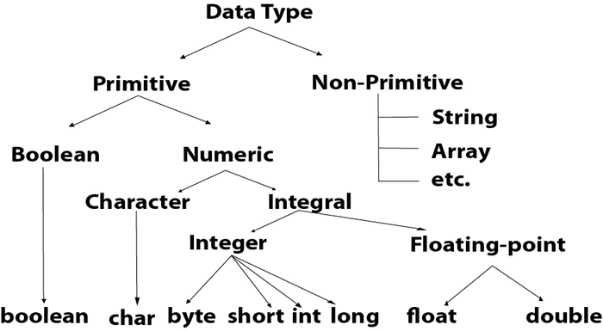

A **Wrapper class** is a class which contains the**primitive data types** (**int, char, short, byte, etc)**. In other words, wrapper classes provide a way to use **primitive data types** **(int, char, short, byte, etc) as objects**. These wrapper classes come under**package** java.lang;

# Wrapper classes in Java (Integer,Long,Double,…..)

The **wrapper class in Java** provides the mechanism to convert primitive into object and object into primitive.

Since J2SE 5.0, **autoboxing** and **unboxing** feature convert primitives into objects and objects into primitives automatically. The automatic conversion of **primitive into an object is known as autoboxing** and vice-versa unboxing.

## <https://www.javatpoint.com/wrapper-class-in-java>

<https://www.tutorialspoint.com/why-do-we-need-a-wrapper-class-in-java>

## Why we need Wrapper Class

* **Data** **structures** in the Collection framework such as **ArrayList and Vector**store only the objects (reference types) and not the**primitive types.**

# Operators in Java

**Operator** in Java is a symbol which is used to perform operations. For example: +, -, \*, / etc.

There are many types of operators in Java which are given below:

Ex:  **x==y** //(return true or false) To check equal or not

Ex : **x != y** // Not equals

Ex : **x>y && z<x** // AND operator used to check two or more condition’s (it will be true when all the conditions are satisfied

Ex : **x>y || z<x** //OR operator is used to check two or more condition’s (if any one condition is satisfied then it will be true

**Ternary Operator**

[**https://www.geeksforgeeks.org/java-ternary-operator-with-examples/**](https://www.geeksforgeeks.org/java-ternary-operator-with-examples/)

variable = Expression1 **?** Expression2**:** Expression3

num1 = 10;

num2 = 20;

res=(num1>num2) **?** (num1+num2)**:**(num1-num2)

below sample code to compare if else with ternary

**int** m=101;

**if**(m==10) {

m=m+5;

}

**else** {

m=m+10;

}

System.***out***.println(m);

====================================================

**m= m==10 ?m+5:m+10;**

System.***out***.println(m);

**Post and Pre-incriment**

int i=10;

int b=i++; // post-increment (it means i value 10 will be assigned first to the b then i value will be increase by 1

int b=++i; // pre-increment (it means i value will be incremented by 1 then it will assign to b it means both i and b value will be same

# Java static keyword

The **static keyword** in [Java](https://www.javatpoint.com/java-tutorial) is used for memory management mainly. We can apply static keyword with [variables](https://www.javatpoint.com/java-variables), methods, blocks and [nested classes](https://www.javatpoint.com/java-inner-class). The static keyword belongs to the class than an instance of the class.

If you declare any variable as static, it is known as a static variable.

* **The static variable** can be used to refer to the common property of all objects for example, the company name of employees, college name of students, etc.
* The static variable gets memory only once in the class area at the time of class loading.
* It makes your program **memory efficient** (i.e., it saves memory).

If you apply static keyword with any method, it is known as **static method**.

* A static method belongs to the class.
* A static method can be invoked without the need for creating an instance of a class.

# this keyword in java

this is a **reference variable** that refers to the current object.

1. this can be used to refer current class instance variable.
2. this() can be used to invoke current class constructor.

# Super Keyword in Java

The **super** keyword in Java is a reference variable which is used to refer immediate parent class object.

1. super can be used to refer immediate parent class instance variable.
2. super() can be used to invoke immediate parent class constructor.

## Static block

* The **static blocks**are executed at the time of **class loading**.
* The **static blocks** are executed before running the**main () method**.
* The **static blocks don't have any name** in its prototype.
* If we want any logic that needs to be executed at the time of class loading that logic needs to placed inside the **static block** so that it will be executed at the time of class loading.
* static { “I am in static block”}

Instance Block :

Instance block is similar to a constructor. It is called once for each object and can be used to call any logic during object creation every time and also we can set initial values for instance variables

{“I am in instance block”}

# Final Keyword In Java

The **final keyword** in java is used to restrict the user. The java final keyword can be used in many context. Final can be:

1. Variable : If you make any variable as final, you cannot change the value of final variable(It will be constant).
2. Method : If you make any method as final, you cannot override it.
3. Class: If you make any class as final, you cannot extend it.

# Java Package

A **java package** is a group of similar types of classes, interfaces and sub-packages.

Package in java can be categorized in two form, built-in package and user-defined package.

There are many built-in packages such as java, lang, awt, javax, swing, net, io, util, sql etc

1. Java package is used to categorize the classes and interfaces so that they can be easily maintained.

## **How to access package from another package?**

There are three ways to access the package from outside the package.

1. import package.\*; // import com.sbi\*
2. import package.classname; // import com.sbi.accounts.UserAccounts
3. fully qualified name. // com.sbi.accounts.UserAccounts

# Access Modifiers in Java

The access modifiers in Java specifies the accessibility or scope of a field, method, constructor, or class. We can change the access level of fields, constructors, methods, and class by applying the access modifier on it.

There are four types of Java access modifiers:

1. **Private**: The access level of a private modifier is only within the class. It cannot be accessed from outside the class.
2. **Default**: The access level of a default modifier is only within the package. It cannot be accessed from outside the package. If you do not specify any access level, it will be the default.
3. **Protected**: The access level of a protected modifier is within the package and outside the package through child class. If you do not make the child class, it cannot be accessed from outside the package.
4. **Public**: The access level of a public modifier is everywhere. It can be accessed from within the class, outside the class, within the package and outside the package.

OOPS:

**The main building blocks of oops are,**

**1. Inheritance 2. Polymorphism 3. Abstraction 4. Encapsulation**

**Encapsulation:-**

The process of binding the data and code as a single unit is called encapsulation.

We can create a fully encapsulated class in Java by making all the data members of the class private. Now we can use setter and getter methods to set and get the data in it.

The **Java Bean** class or pojo or model class is the example of a fully encapsulated class.

### **Advantage of Encapsulation in Java**

By providing only a setter or getter method, you can make the class **read-only or write-only**.

It is a way to achieve **data hiding** in Java because other class will not be able to access the data through the private data members.

**Inheritance:-**

1. The process of acquiring properties (variables) & methods (behaviors) from one class to another class is called inheritance.

2. We are achieving inheritance concept by using extends keyword. Inheritance is also known as is-a relationship.

3. Extends keyword is providing relationship between two classes..

4. The main objective of inheritance is code extensibility whenever we are extending the class automatically code is reused.

5. In inheritance one class providing properties & another class is acquiring the properties.

6. In inheritance parent class is giving properties & Child is acquiring properties from Parent

### **Why use inheritance in java**

* For [Method Overriding](https://www.javatpoint.com/method-overriding-in-java) (so [runtime polymorphism](https://www.javatpoint.com/runtime-polymorphism-in-java) can be achieved).
* For Code Reusability.

To reduce length of the code and redundancy(duplicate) of the code & to improve re-usability of code sun people introduced inheritance concept.

1) in java if we are extending the class then it will be parent class , if we are not extending the class then object class will become parent class.

2) The root class of all java classes is “object” class.

3) Every java class contain parent class except object class.

4) Object class present in java.lang package and it contains 11 methods & all java classes able to use these 11 methods because Object class is root class of all java classes.

**Types of inheritance :-**

There are five types of inheritance in java,

1. Single inheritance 2. Multilevel inheritance 3. Hierarchical inheritance

4. Multiple inheritance 5. Hybrid Inheritance

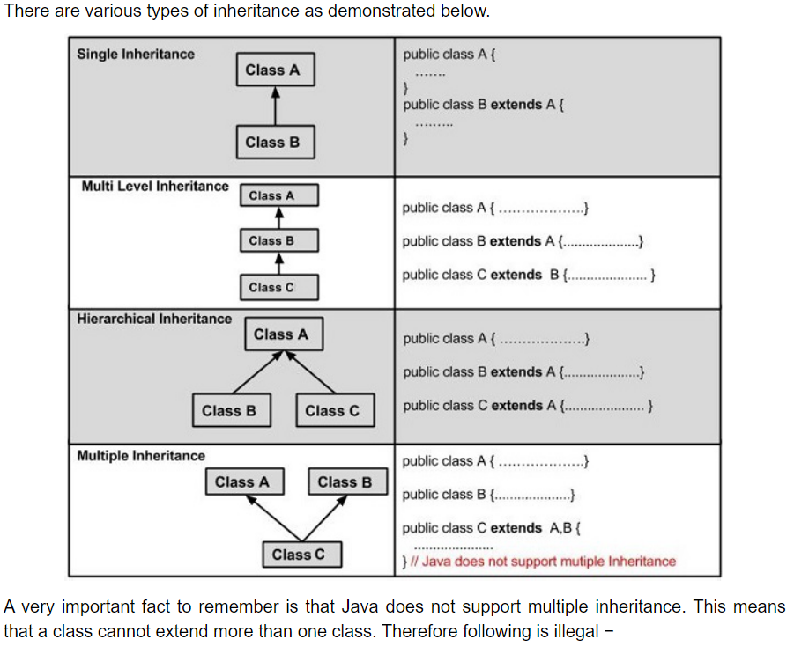

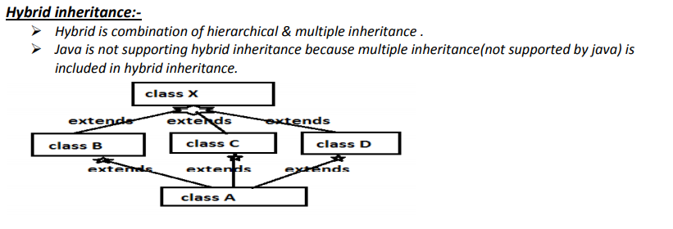

## **Why multiple inheritance is not supported in java? (Diamond problem)**

To reduce the complexity and simplify the language, multiple inheritance is not supported in java.

Consider a scenario where A, B, and C are three classes. The C class inherits A and B classes. If A and B classes have the same method and you call it from child class object, there will be ambiguity to call the method of A or B class.

 “Diamond Problem” where compiler can’t decide which superclass method to use.

Since compile-time errors are better than runtime errors, Java renders compile-time error if you inherit 2 classes. So whether you have same method or different, there will be compile time error.

## Association

**Association refers to the relationship between multiple objects**. It refers to how objects are related to each other and how they are using each other's functionality. Composition and aggregation are two types of association.

Association:- Ø Class A uses class B Ø When one object wants another object to perform services for it. Ø Relationship between teacher and student, number of students associated with one teacher or one student can associate with number of teachers. But there is no ownership and both objects have their own life cycles.

## Composition

The **composition is the strong type of association.** An association is said to composition if an Object owns another object and another object cannot exist without the owner object. Consider the case of Human having a heart. Here Human object contains the heart and heart cannot exist without Human.

Composition :- Ø Class A owns class B , it is a strong type of aggregation. There is no meaning of child without parent. Ø Order consists of list of items without order no meaning of items. or bank account consists of transaction history without bank account no meaning of transaction history or without student class no meaning of marks class. Ø Let’s take Example house contains multiple rooms, if we delete house object no meaning of room object hence the room object cannot exists without house object. Ø Relationship between question and answer, if there is no meaning of answer without question object hence the answer object cannot exist without question objects. Ø Relationship between student and marks, there is no meaning of marks object without student object.

## Aggregation

**Aggregation is a weak association**. An association is said to be aggregation if both Objects can exist independently. For example, a Team object and a Player object. The team contains multiple players but a player can exist without a team.

Aggregation:- Ø Class A has instance of class B is called aggregation. Ø Class A can exists without presence of class B . a university can exists without chancellor. Ø Take the relationship between teacher and department. A teacher may belongs to multiple departments hence teacher is a part of multiple departments but if we delete department object teacher object will not destroy

**Aggregation in Java (HAS-A relationship)**

If a class have an entity reference, it is known as Aggregation. Aggregation represents HAS-A relationship.

Consider a situation, Employee object contains many informations such as id, name, emailId etc. It contains one more object named address, which contains its own informations such as city, state, country, zipcode etc. as given below.

In such case, Employee has an entity reference address, so relationship is Employee HAS-A address.

### **Abstraction in Java**

**Abstraction** is a process of hiding the implementation details and showing only functionality to the user.

### **Ways to achieve Abstraction**

There are two ways to achieve abstraction in java

1. Abstract class (0 to 100%)
2. Interface (100%)

## **Abstract Class**

**If any abstract method inside the class that class must be abstract.**

* An abstract **class** must be declared with an **abstract** keyword.
* **Abstract method:** A **method which is declared as abstract** and does **not have implementation** is known as an abstract method.
* **Concrete Method:** concrete method means method with implementation
* It can have abstract and non-abstract methods(concrete).
* It cannot be instantiated.
* object creation is not possible. If we are trying to create object of abstract class compiler generate error message “class is abstract con not be instantiated”
* It can have [constructors](https://www.javatpoint.com/java-constructor) and static methods also. (even if we don’t create a object it contains constructor because a child class can call abstract class constructor by using super() from child class constructor.
* Child class will use extends keyword to implement abstract methods of abstract class
* It can have final methods which will force the subclass not to change the body of the method.
* The abstract class can also be used to provide some implementation of the [interface](https://www.javatpoint.com/interface-in-java). In such case, the end user may not be forced to override all the methods of the interface.

**Interface in Java**

The interface in Java is a mechanism to achieve [*abstraction*](https://www.javatpoint.com/abstract-class-in-java). There can be only abstract methods in the Java interface. It is used to achieve abstraction and multiple [inheritance in Java](https://www.javatpoint.com/inheritance-in-java).

The interface is **highlighting set of functionalities and hiding implementation’s**

If you don’t know anything about implementation just we have the **requirement specification** then declare that requirements by using **interface**.

If u know the implementation **but not completely** then we should go for **abstract classes.**

if you know the implementation **completely** then we should go for **concrete** **classes** (**Normal class** with all implemented methods (concrete methods).

* You cannot instantiate an interface.
* An interface does not contain any constructors.
* All of the methods in an interface are abstract.
* An interface **cannot contain instance fields**. The only fields that can appear in an interface must be declared both **static and final.**
* An interface is not extended by a class; it is implemented by a class.
* An interface can extend multiple interfaces.
* A Class can implement multiple interfaces
* All interface Methods are *implicitly public and abstract*.
* Interfaces can declare *only Constant*. Instance variables are not allowed. This means all variables inside the Interface must be public, static, final. Variables inside Interface are *implicitly public static final*.

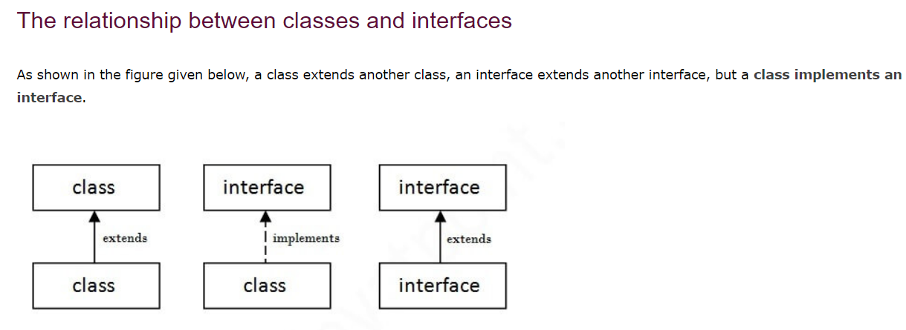

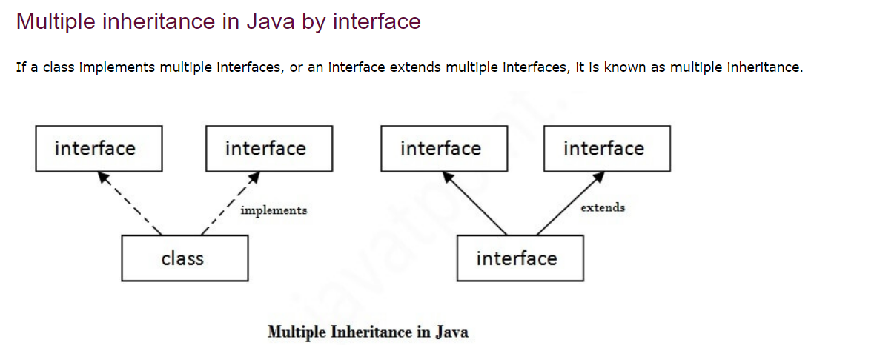

**Please Ignore below 2 points if you are using Java 7 version**

Java 8 interface changes include static methods and default methods with implementation in interfaces. Prior to Java 8, we could have only method declarations in the interfaces. But from Java 8, we can have **default methods** and **static methods** in the interfaces.

Why does default and static implemented methods introduced in java 8 ?

In reality, [default](http://www.java67.com/2017/08/default-methods-in-interface-multiple.html) or [defender methods](http://javarevisited.blogspot.sg/2014/07/default-defender-or-extension-method-of-Java8-example-tutorial.html#axzz4pp42TeHu) are introduced to maintain backward compatibility and the same time making Collection API more suitable to be used inside key Java 8 features like [lambda expressions](https://javarevisited.blogspot.sg/2014/02/10-example-of-lambda-expressions-in-java8.html).  
  
Without adding default methods, it wasn't possible to declare any new method on the existing interface in Java without breaking all classes which implement it, but because of the default method, you can now better evolve your API.  
  
They defend your code against implementing new methods hence they are also called defender methods.  
  
Read more: <https://www.java67.com/2017/08/difference-between-abstract-class-and-interface-in-java8.html#ixzz6rzfhEo5T>

Difference between Abstract Class and Interface

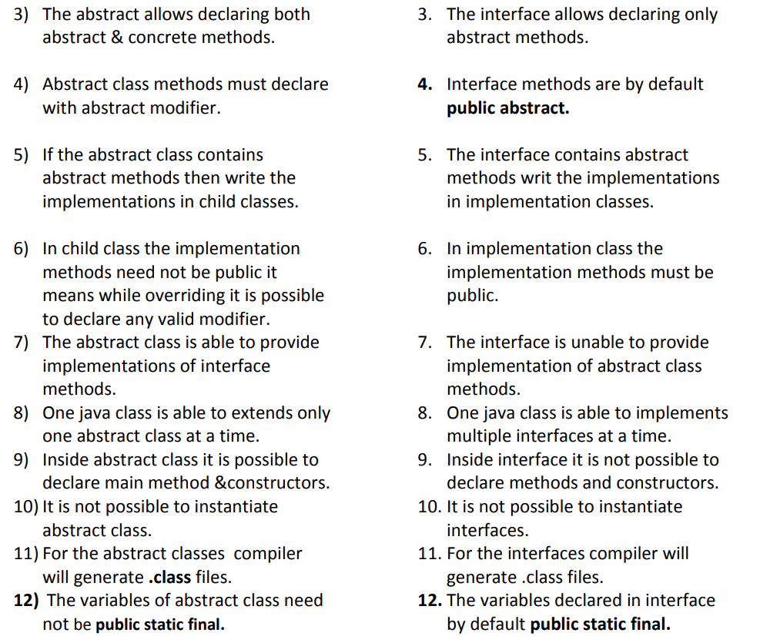

Polymorphism: -

The ability to appear in more forms is called polymorphism.

One thing can exhibit more than one form is called polymorphism.

One functionality with different actions is called polymorphism.

Polymorphism is a Greek word poly means many and morphism means forms.

The most common use of polymorphism in OOP occurs **when a parent class reference is used to refer to a child class object.**

**One Object Behaving in many forms is known as polymorphism**

There are two types of polymorphism in java,

* 1. **Compile time polymorphism / static binding / early binding**

Example :- **method overloading**.

* 1. **Runtime polymorphism /dynamic binding /late binding**.

Example :- **method overriding.**

**Compile time polymorphism [Method Overloading]:-**

1) If java class allows more than one method with same name but different number of arguments or same number of arguments but different data types those methods are called overloaded methods.

a. Same method name but different number of arguments.

**void m1(int a){ }**

**void m1(int a,int b){ }**

b. Same method name & same number of arguments but different data types.

**void m1(int a){ }**

**void m1(char ch){ }**

2) To achieve overloading concept one java class sufficient.

3) It is possible to overload any number of methods in single java class.

4)In method overloading it is possible to have different data types for overloaded method.

5) While overloading the methods check the **signature(methodname+parameters**) of the method but not return type.

**What is static polymorphism (or) compile-time polymorphism (or) early binding?**

• In overloading compiler is responsible to perform method resolution(decision) based on the reference type. Hence overloading is also considered as compile time polymorphism(or) staticpolymorphism (or)early biding

**Runtime polymorphism [Method Overriding]:-**

To achieve method overloading one java class sufficient but to achieve method **overriding we required two java classes with parent and child relationship.**

The method implementations already present in parent class,

a. If the child class required that implementation then access those implementations.

b. If the child class not required, parent class method implementations then override parent class method in child class to provide child specific implementations.

The sub class overrides super class method to provide sub class method implementations.

In overriding parent class method is called ===> overridden method

Child class method is called ===> overriding method

**What is runtime polymorphism (or) dynamic polymorphism (or) late binding?**

• In overriding method resolution is always takes care by JVM based on runtime object hence overriding is also considered as runtime polymorphism (or) dynamic polymorphism (or) late binding

**Parent p=Child();**

**p.display()** **// during runtime jvm will first check display method in child class if it is available ok or else it will go to parent class display method, here discission has been taken during runtime**

**While overriding methods must follow these rules:-**

1) **Overridden method signature & overriding method signatures must be same.**

2) The return types of overridden method & overriding method must be same (at primitive level).

3) While overriding it is possible to change return type by using co-variant return types concept.

4) Final methods can’t override.

**5) Static method can’t override** but method hiding possible.

6) Private methods can’t override.

7) While overriding it is not possible to maintain same level permission or increasing order but not decreasing.

**Co-Varient:**

Before java 1.5 version it is not possible to override the method by changing return type but form java 5 versions it is possible to override the method by changing return type by using co-variant return type’s concept.

While overriding methods it is possible to change the return type of overridden method & overriding methods at class level by using co-variant return type concept but not primitive level.

**The return type of overriding method is must be sub-type of overridden method return type this is called covariant return types**.

Note :while overriding methods it is possible to change return type at class-level but not primitive level.

**Exceptions in Java**

**What is an Exception?**

An exception is an **unwanted or unexpected event**, that **disrupts the normal flow** of the program execution (program’s instructions).we will get all the exceptions at runtime. **Note:** during compile time we will get only compile time errors not exceptions.

### **Why an exception occurs?**

There can be several reasons that can cause a program to throw exception. For example: Opening a **non-existing file** in your program, Network connection problem, **bad input data provided by user** etc.

## **What is Exception Handling**

Exception Handling is a mechanism to handle runtime errors such as NullPointerException,ArithmeticException,ClassNotFoundException, IOException, SQLException etc. we can handle exceptions by using **try-catch blocks** and **throws** keyword

**Try-Catch is best way to handle exceptions**

The core advantage of exception handling is to maintain the normal flow of the application.

There are mainly two types of exceptions: checked and unchecked. Here, an error is considered as the unchecked exception. According to Oracle, there are three types of exceptions:

1. Checked Exception
2. Unchecked Exception
3. Error

**Checked exceptions** − A checked exception is an exception that is checked (notified) by the compiler at compilation-time, these are also called as compile time exceptions. These exceptions cannot simply be ignored, the programmer should take care of (handle) these exceptions. when we try to access external resource like file from operating system or connecting to data base or any external system from our java application there is high chance of getting exception as the resource may available or not, so to avoid this kind of known problems or expected exception’s java compiler will suggest us to handle exceptions before running program.

**For example**, if you use FileReader class in your program to read data from a file, if the file specified in its constructor doesn't exist, then a FileNotFoundException occurs, and the compiler prompts the programmer to handle the exception.

**Unchecked exceptions** − An unchecked exception is an exception that occurs at the time of execution. These are also called as Runtime Exceptions. These include programming bugs, such as logic errors or improper use of an API. Runtime exceptions are ignored at the time of compilation.

**For example**, if you have declared an array of size 5 in your program, and trying to call the 6th element of the array then an ArrayIndexOutOfBoundsExceptionexception occurs.

**Errors** − The error indicates a problem that mainly occurs due to the lack of system resources and our application should not catch these types of problems. Some of the **examples** of errors are system crash error and out of memory error, stackoverflow error etc . Errors mostly occur at runtime that's they belong to an unchecked type.

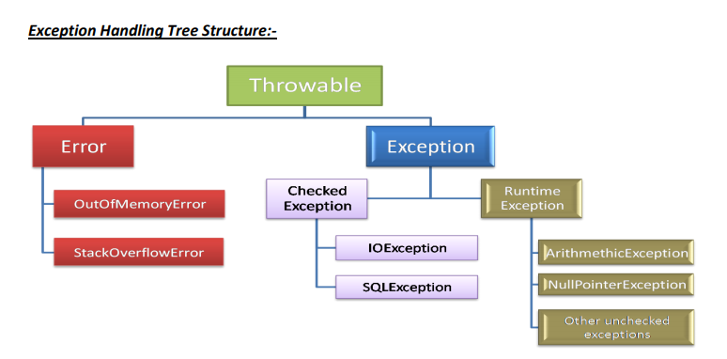

The **java.lang.Throwable** class is the superclass of all errors and exceptions in the Java language. Only objects that are instances of this class (or one of its subclasses) are thrown by the Java Virtual Machine or can be thrown by the Java throw statement.

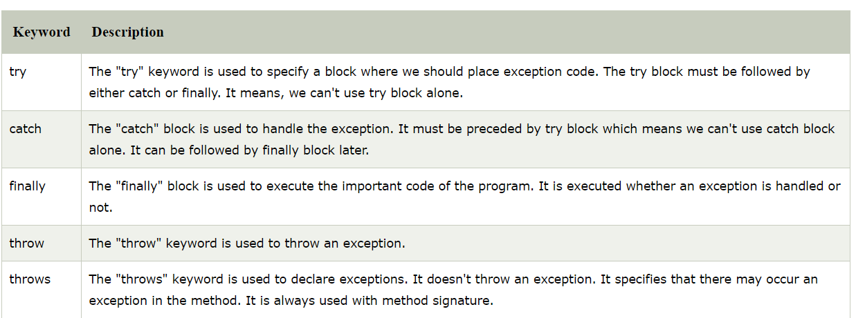

**Throws keyword** is used to delegate the responsibilities of exception handling to caller method. By using throws keyword, we can supress the compile time error of checked exceptions. We can write the throws keyword at method declaration level. The caller method has to handle the exception using a try-catch block. If no method handles exception using try catch and delegates to main method it will be delegated to JVM then JVM will throw exception then program will terminate abnormally.so try catch is best way to handle exception.

**“Throws” keyword required only checked exceptions**. Usage of throws for unchecked exception there is no use

**Java finally block** is a block that is used to execute important code such as closing connection, stream etc (clean up code ).

Java finally block is always executed whether exception is handled or not.

Java finally block follows try or catch block.

Explain exception handling keywords?

1) **Try**: To maintain risky code.

2) **Catch**: To maintain handling code.

3) **Finally**: To maintain clean-up code.

4) **Throw**: To handover our created exception object to the JVM manually.

5) **Throws**: To delegate responsibility of exception handling to the caller method.

**Is try with multiple catch block is possible?**

Try with multiple catch blocks: The way of handling an exception is varied from exception to exception hence for every exception raise a separate catch block is required that is try with multiple catch blocks is possible and recommended to use.

**In which situation finally block will not executed?**

· There is only one situation where the finally block won’t be executed is whenever we are using System.exit(0) method.

**If return statement present inside try is finally block will be executed?**

· Even though return statement present in try or catch blocks first finally block will be executed and after that only return statement will be considered that is finally block dominates return statement.

# Java Custom Exception

If you are creating your own Exception that is known as custom exception or user-defined exception. Java custom exceptions are used to customize the exception according to user need.

By the help of custom exception, you can have your own exception and message.

The main reasons for introducing custom exceptions are:

* Business logic exceptions – Exceptions that are specific to the business logic and workflow. These help the application users or the developers understand what the exact problem is

## Writing your own exception class

Now, let’s see how to create a custom exception in action. Here are the steps:

* Create a new class whose name should end with Exception like ClassNameException. This is a convention to differentiate an exception class from regular ones.
* Make the class extends one of the exceptions which are subtypes of the java.lang.Exception class. Generally, a custom exception class always extends directly from the **Exception class.**
* Create a constructor with a String parameter which is the detail message of the exception. In this constructor, simply call the super constructor and pass the message.

**public** **class** **IncorrectFileNameException** **extends** **Exception** {

**public** **IncorrectFileNameException**(String errorMessage) {

**super**(errorMessage);

}

}

----

**try** (Scanner file = **new** Scanner(**new** File(fileName))) {

**if** (file.hasNextLine())

**return** file.nextLine();

} **catch** (FileNotFoundException e) {

**if** (!isCorrectFileName(fileName)) {

**throw** **new** IncorrectFileNameException("Incorrect filename : " + fileName ); } //... }

**Try with multiple catch blocks**

try {

//risky code

}

Catch(ArithmeticException){

System.out.println(e.getMessage());

}

Catch(NullPonterException){

System.out.println(e.getMessage());

}

**Catching multiple exceptions with single catch block**

try{

// risky code

}

catch(ArithmeticException | ArrayIndexOutOfBoundsException e){

System.out.println(e.getMessage());

}

# Java 7 Catch Multiple Exceptions

Java allows you to catch multiple type exceptions in a single catch block. It was introduced in Java 7 and helps to optimize code.

You can use vertical bar or pipe symbol (|) to separate multiple exceptions in catch block.

1. **try**{
2. **int** array[] = newint[10];
3. array[10] = 30/0;
4. }
5. **catch**(ArithmeticException | ArrayIndexOutOfBoundsException e){
6. System.out.println(e.getMessage());
7. }

# The try-with-resources statement

In Java, the try-with-resources statement is a try statement that declares one or more resources. The resource is as an object that must be closed after finishing the program. The try-with-resources statement ensures that each resource is closed at the end of the statement execution.

You can pass any object that implements java.lang.AutoCloseable, which includes all objects which implement java.io.Closeable.

The following example writes a string into a file. It uses an instance of FileOutputStream to write data into the file. FileOutputStream is a resource that must be closed after the program is finished with it. So, in this example, closing of resource is done by itself try.

// Using try-with-resources

**try**(FileOutputStream fileOutputStream =newFileOutputStream("/java7-new-features/src/abc.txt")){

String msg = "Welcome to javaTpoint!";

**byte** byteArray[] = msg.getBytes(); //converting string into byte array

fileOutputStream.write(byteArray);

System.out.println("Message written to file successfuly!");

}**catch**(Exception exception){

       System.out.println(exception);

}

=================================================

      // Using try-with-resources

**// Using multiple resources**

**try**(

        FileOutputStream fileOutputStream =**new** FileOutputStream("/java7-new-features/src/abc.txt");

        InputStream input = **new** FileInputStream("/java7-new-features/src/abc.txt")){

        // -----------------------------Code to write data into file--------------------------------------------//

        String msg = "Welcome to javaTpoint!";

**byte** byteArray[] = msg.getBytes();  // Converting string into byte array

        fileOutputStream.write(byteArray);  // Writing  data into file

        System.out.println("------------Data written into file--------------");

        System.out.println(msg);

        // -----------------------------Code to read data from file---------------------------------------------//

        // Creating input stream instance

        DataInputStream inst = **new** DataInputStream(input);

**int** data = input.available();

        // Returns an estimate of the number of bytes that can be read from this input stream.

**byte**[] byteArray2 = **new** **byte**[data]; //

        inst.read(byteArray2);

        String str = **new** String(byteArray2); // passing byte array into String constructor

        System.out.println("------------Data read from file--------------");

        System.out.println(str); // display file data

}**catch**(Exception exception){

       System.out.println(exception);

}

# Multithreading in Java

1) **Thread is nothing but separate path of sequential execution.**

2) The independent execution technical name is called thread.

3) Whenever different parts of the program executed simultaneously that each and every part is called thread.

4) The thread is light weight process because whenever we are creating thread it is not occupying the separate memory it uses the same memory. Whenever the memory is shared means it is not consuming more memory.

5**) Executing more than one thread a time is called multithreading**

When a java program started one Thread is running immediately that thread is called main thread of your program

**A thread can be created in two ways:-**

**1) By extending Thread class.**

**2) By implementing java.lang.Runnable interface**

**Which Approach is Best and Why ?**

**First approach**: - If we use first approach by extending Thread class, we can extend only Thread class, we cannot extend other classes (we cannot extend multiple classes)

(so if we want to implement thread concept and also if you want to achieve inheritance (extend with other classes) we cannot achieve.

**Second approach: - (Best Approach)**

1) By implementing the Runnable interface, our child class can implement thread concept and also, we can extend any other class (parent class).

**public** **class** Child **extends** Parent **implements** Runnable{

**First approach to create thread extending Thread class:-**

**Step 1:-** Our normal java class will become Thread class whenever we are extending predefined Thread class.

class MyThread **extends Thread** {

};

**Step 2:-** override the run() method to write the business logic of the Thread( run() method present in Thread class.

class MyThread extends Thread {

public void run() {

System.out.println("business logic of the thread");

System.***out***.println(Thread.*currentThread*().getName());

}

}

**Step 3:-**Create user defined Thread class object.

MyThread t=new MyThread();

**Step 4:-**Start the Thread by using start() method of Thread class.

**t.start();**

**Flow of execution:-** 1) Whenever we are calling **t.start()** method then JVM will search start() method in the MyThread class since not available so JVM will execute parent class(Thread) start() method. Thread class start() method responsibilities

a. User defined thread is registered into Thread Scheduler then only decide new Thread is created.

b. The Thread class start() automatically calls run() to execute logics of user defined Thread

**Second approach to create thread implementing Runnable interface:-**

Step 1:-our normal java class will become Thread class whenever we are implementing Runnable interface.

class MyClass implements Runnable{

};

Step2: override run method to write logic of Thread.

class MyClass implements Runnable

{ public void run()

{ System.out.println("Rattaiah from SravyaInfotech");

System.out.println("body of the thread");

}

}

Step 3:- Creating a object.

**MyClass obj=new MyClass();**

Step 4:- Creates a Thread class object.

After new Thread is created it is not started running until we are calling start() method.

So whenever we are calling start method that start() method call run() method then the new

Thread execution started.

**Thread t=new Thread(obj);**

**t.start();**

creation of Thread implementing Runnable interface :-

class MyThread implements Runnable

{ public void run()

{ //business logic of user defined Thread

for (int i=0;i<10;i++)

{ System.out.println("userdefined Thread");

}

}

};

class ThreadDemo

{ public static void main(String[] args) //main thread started

{ MyThread r=new MyThread(); //MyThread is created

Thread t=new Thread(r);

t.start(); //MyThread execution started

//business logic of main Thread

for (int i=0;i<10;i++)

{ System.out.println("Main Thread");

}

}

};

**Thread Life cycle stages are:-**

* 1. New 2) Ready 3) Running state 4) Blocked / waiting / non-running mode 5) Dead state

**New** :- MyThread t=new MyThread();

**Ready** :- t.start()

**Running state**:- If thread scheduler allocates CPU for particular thread. Thread goes to running state The Thread is running state means the run() is executed.

**Blocked State**:- If the running thread got interrupted of goes to sleeping state at that moment it goes to the blocked state**.**

**Dead State**:-If the business logic of the project is completed means run() over thread goes dead state

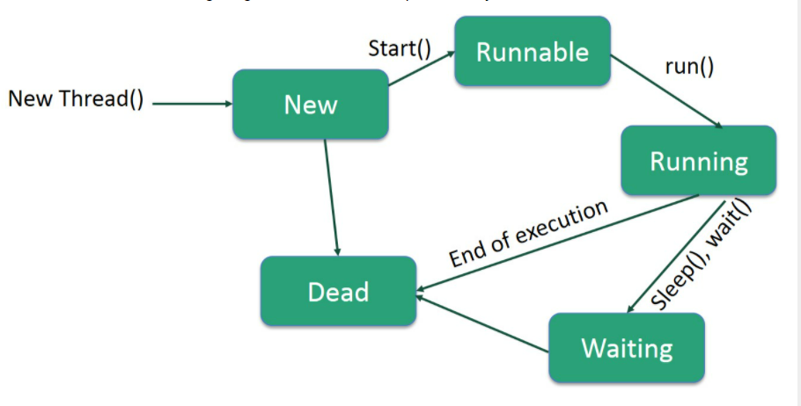

**Difference between t.start() and t.run():-**

• In the case of t.start(), Thread class start() is executed a new thread will be created that

is responsible for the execution of run() method.

• But in the case of t.run() method, no new thread will be created and the run() is

executed like a normal method call by the main thread.

Note :- Here we are not overriding the run() method so thread class run method is executed which is

having empty implementation so we are not getting any output.

**Thread Priorities:-**

1. Every Thread in java has some priority. It may be default priority provided by

the JVM or customized priority provided by the programmer.

2. The valid range of thread priorities is 1 – 10. Where one is lowest priority and 10

is highest priority.

3. The default priority of main thread is 5. The priority of child thread is inherited

from the parent.

5. Thread Scheduler will use priorities while allocating processor the thread which

is having highest priority will get chance first and the thread which is having low

priority.

6. If two threads having the same priority then we can’t expect exact execution

order it depends upon Thread Scheduler.

7. The thread which is having low priority has to wait until completion of high

priority threads.

8. Three constant values for the thread priority.

a. MIN\_PRIORITY = 1

b. NORM\_PRIORITY = 5

c. MAX\_PRIORITY = 10

Thread class defines the following methods to get and set priority of a Thread.

Public final int getPriority()

Public final void setPriority(int priority)

Here ‘priority’ indicates a number which is in the allowed range of 1 – 10. Otherwise we will get

Runtime exception saying “IllegalArgumentException”.

**Java.lang.Thread.yield():-**

❖ **Yield()** method causes to pause current executing Thread for giving the chance for

waiting threads of same priority or high priority.

❖ If there are no waiting threads or all threads are having low priority then the same

thread will continue its execution once again.

**Thread.yield();**

**Java.lang.Thread.join() method:-**

➢ **Join method** allows one thread to wait for the completion of another thread.

t.join(); ---> here t is a Thread Object whose thread is currently running.

➢ Join() is used to stop the execution of the thread until completion of some other Thread.

➢

**if a t1,t2 are two threads when we use , t2.join() at that situation t1 must wait until completion of the t2**

**thread.**

**Thread Safety**: Thread safe means when two are more threads trying to access a shared resource (any variable or object data), content of that resource should not get modified

One way to achieve thread safety is by using Synchronized methods or blocks

Other way is by making a class as immutable

**Synchronized :-**

• Synchronized modifier is the modifier applicable for methods but not for classes and variables.

• If a method or a block declared as synchronized then at a time **only one Thread is allowed to operate on that method**

• The main **advantage** of synchronized modifier is **we can resolve data inconsistency** problems.

• But the main **disadvantage** of synchronized modifier **is it increases the waiting time of the Thread and effects performance of the system**. Hence if there is no specific requirement it isnever recommended to use.

• The main purpose of this modifier is to reduce the data inconsistence problems.

**Non-synchronized methods**

void m1()

{ **non-synchronized method any number of threads can access**

}

Every thread accessing simultaneously

Thread 1 Thread 2 Thread 3---------Thread N

1) In the above case multiple threads are accessing the same methods hence we are getting data inconsistency problems. These methods are not thread safe methods.

2) But in this case multiple threads are executing so the performance of the application will be increased.

Synchronized methods

synchronized void m2()

{

Synchronized method only one thread is allow to access.

}

Only one thread allowed to access

Thread 1 Thread 2 Thread 3---------Thread N

1) In the above case only one thread is allow to operate on particular method so the data

inconsistency problems will be reduced.

2) Only one thread is allowed to access so the performance of the application will be reduced.

3) If we are using above approach there is no multithreading concept.

Hence it is not recommended to use the synchronized modifier in the multithreading

Programming

**Daemon threads**:- The threads which are executed at background is called daemon threads. **Ex:-** garbage collector, Thread Schedular. default exceptional handler.

**Non-daemon threads**:- The threads which are executed fore ground is called non-daemon threads. Ex:- normal java application.

# Deadlock in java

Deadlock in java is a part of multithreading. Deadlock can occur in a situation when a thread is waiting for an object lock, that is acquired by another thread and second thread is waiting for an object lock that is acquired by first thread. Since, both threads are waiting for each other to release the lock, the condition is called deadlock.

**Volatile:** - · Volatile modifier is also applicable only for variables but not for methods and classes.

· If the values of a variable keep on changing such type of variables we have to declare with volatile modifier.

· If a variable declared as a volatile then for every Thread a separate local copy will be created.

· Every intermediate modification performed by that Thread will take place in local copy instead of master copy.

· Once the value got finalized just before terminating the Thread the master copy value will be updated with the local stable value. The main advantage of volatile modifier is we can resolve the data inconsistency problem.

· But the main disadvantage is creating and maintaining a separate copy for every Thread

· Increases the complexity of the programming and effects performance of the system

Inter-thread communication in Java

**Inter-thread communication** or **Co-operation** is all about allowing synchronized threads to communicate with each other.

Cooperation (Inter-thread communication) is a mechanism in which a thread is paused running in its critical section and another thread is allowed to enter (or lock) in the same critical section to be executed. It is implemented by following methods of **Object class**:

<https://www.javatpoint.com/inter-thread-communication-example>

* wait()
* notify()
* notifyAll()

synchronized void withdraw(){

//there is no balance to withdraw

Wait(); //then current thread will pause and release lock

}

synchronized void deposit(){

//deposit the money

notify(); //then this thread will notify waiting thread to start

//in case of notify all it will notify all waiting threads

}

Example:

going to withdraw...15000

Less balance;current balance is::10000 waiting for deposit... //Wait();

going to deposit...10000

deposit completed... 10000 //notify()

withdraw completed...15000

current balance is... 5000

### **1) wait() method**

Causes current thread to release the lock and wait until either another thread invokes the notify() method or the notifyAll() method for this object, or a specified amount of time has elapsed.

### **2) notify() method**

Wakes up a single thread that is waiting on this object's monitor. If any threads are waiting on this object, one of them is chosen to be awakened. The choice is arbitrary and occurs at the discretion of the implementation. Syntax:

public final void notify()

### **3) notifyAll() method**

Wakes up all threads that are waiting on this object's monitor. Syntax:

public final void notifyAll()

### **Why wait(), notify() and notifyAll() methods are defined in Object class not Thread class?**

It is because they are related to lock and object has a lock.

### **Difference between wait and sleep?**

Let's see the important differences between wait and sleep methods.

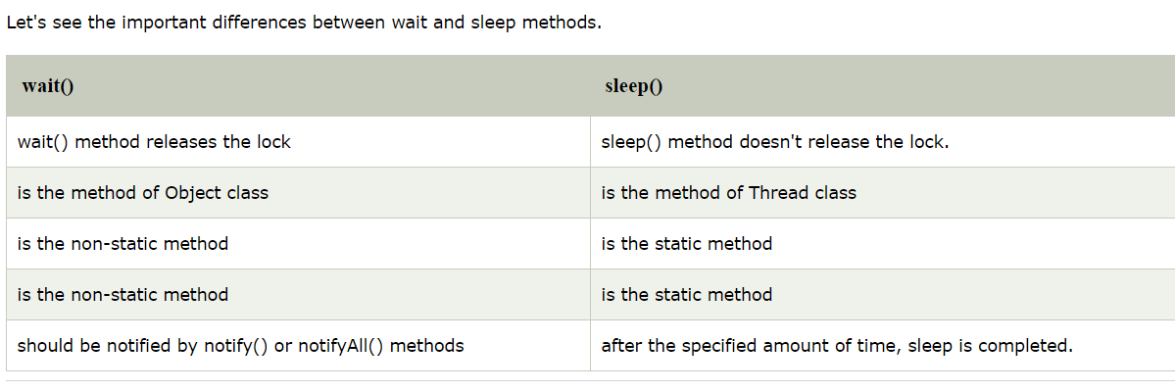

**Arrays** : Arrays are used to represent group of elements as a single entity but these elements are homogeneous & fixed size.

The size of Array is fixed it means once we created Array it is not possible to increase and decrease the size.

Array in java is index based first element of the array stored at 0 index.

Advantages of array: - Instead of declaring individual variables we can declare group of elements by using array it reduces length of the code.

We can store the group of objects easily & we are able to retrieve the data easily.

We can access the random elements present in the any location based on index.

Array is able to hold reference variables of other types

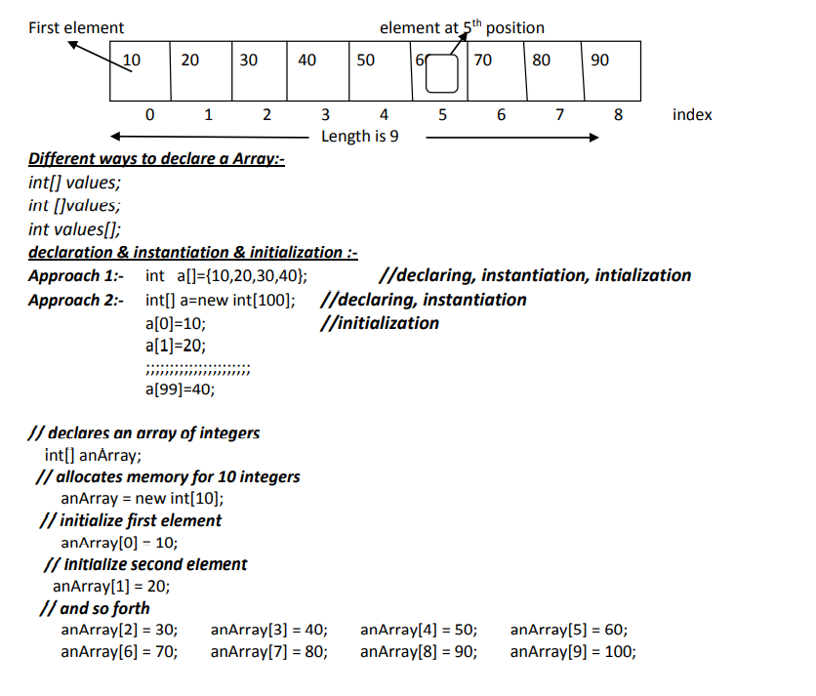

# Collection in Java

Importance of collection: -

The main objective of collection framework is to represent **group of objects as a single entity.**

In java Collection framework provide **very good architecture to store and manipulate the group of objects.**

Collection API contains group of classes and interfaces that makes it easier to handle group of objects.

Collection are providing flexibility to store, retrieve, and manipulate data

All collection framework classes and interfaces are present in **java.util package.**

The root interface of Collection framework is **Collection.**

**Collection vs Collections: -**

**Collection** is interface it is used to represent group of objects as a single entity.

**Collections is utility class** it contains methods to perform operations.

**Arrays vs Collection**:- Both Arrays and Collections are used to represent group of objects as a single entity but the differences are as shown below.

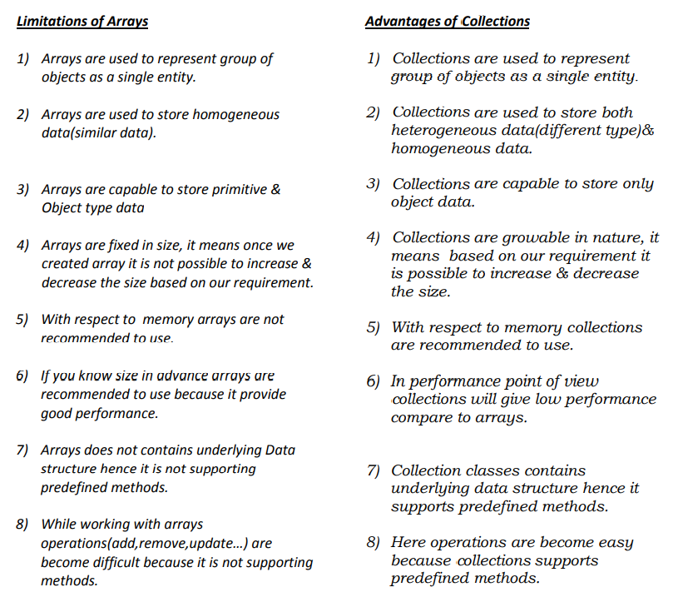

Java Collection framework provides many interfaces (Set, List, Queue, Deque) and classes ([ArrayList](https://www.javatpoint.com/java-arraylist), Vector, [LinkedList](https://www.javatpoint.com/java-linkedlist), [PriorityQueue](https://www.javatpoint.com/java-priorityqueue), HashSet, LinkedHashSet, TreeSet).

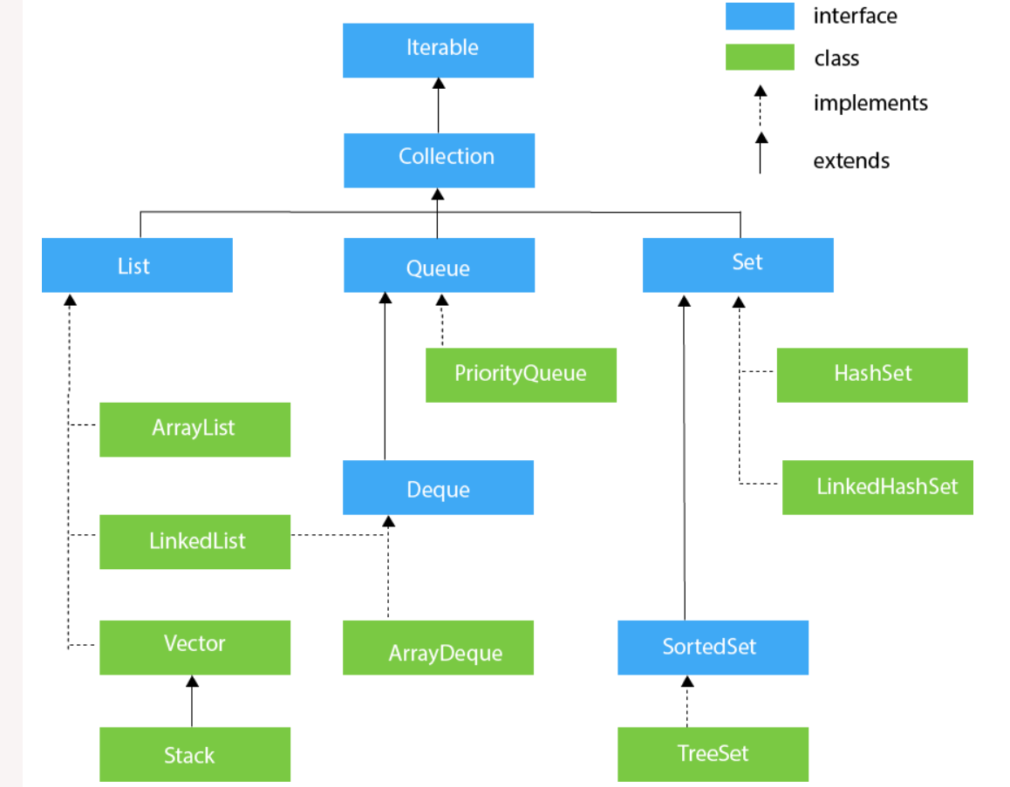

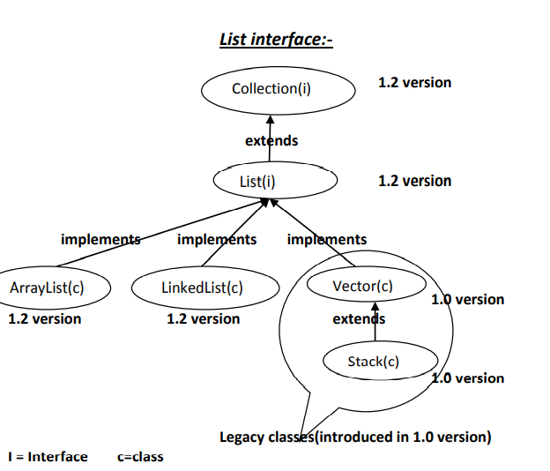

**List interface common Features: -**

1) All list class allows heterogeneous data.

2) All List interface implementation classes allows null insertion.

3) All classes allows duplicate objects.

4) All classes preserved insertion order

**ArrayList Characteristics: -**

1) ArrayList Introduced in 1.2 version.

2) ArrayList stores Heterogeneous objects(different types).

3) In ArrayList it is possible to insert Null objects.

4) Duplicate objects are allowed.

5) ArrayList preserved Insertion order it means whatever the order we inserted the data in the same way output will be printed.

6) ArrayList methods are **non-synchronized methods.**

7) The under-laying data structure is growable array.

8) By using cursor we are able to retrieve the data from ArrayList : **Iterator , ListIterator**

**Manipulation(add or remove) with ArrayList is slow because if we add or remove a new element there will be a lot of shifting operations need to be performed ,Array list is only good to retrieve data .**

**Basic operations of ArrayList**

**add()** to add the objects into ArrayList & by default it add the data at last but it is possible to insert the data at specified index.

**remove()** it removes Objects from ArrayList based on Object & index. (for the remove(10) method if we are passing integer value that is always treated as index )

**get()** to get a specific object from List based on Object index, if we give get(2) we get object of 2nd index

**size()** to find the size of ArrayList.

**isEmpty()** to check the objects are available or not.

**Clear()** to remove all objects from ArrayList.

# How to Iterate List in Java

* 1. **By Using for each loop (enhanced for loop)**
  2. **Cursors**

what is a Java Cursor? A Java Cursor is an Iterator, which is used to iterate or traverse or retrieve a Collection or Stream object’s elements one by one.

Java supports the following four different cursors.

* Enumeration
* Iterator
* ListIterator

# Enumeration

To retrieve the elements one by one or (iterate) enumerator is used.  It can be applied only to the legacy classes. like [Vector](https://www.geeksforgeeks.org/java-util-vector-class-java/), [HashTable](https://www.geeksforgeeks.org/hashtable-in-java/" \t "_blank), [Stack](https://www.geeksforgeeks.org/stack-class-in-java/), etc.

Enumeration<Integer> e = v.elements(); // here v is data with legacy obj vector

while (e.hasMoreElements())

{ Integer i = e.nextElement();

System.out.println(i);

}

### **Iterator:**

[Java provides an interface Iterator](https://www.javatpoint.com/java-iterator) to **iterate** over the Collections, such as List, Map, etc. It contains two key methods next() and hasNaxt() that allows us to perform an iteration over the List.

**next():** The next() method perform the iteration in forward order. It returns the next element in the List. It throws **NoSuchElementException** if the iteration does not contain the next element in the List. This method may be called repeatedly to iterate through the list, or intermixed with calls to previous() to go back and forth.

**hasNext():** The hasNext() method helps us to find the last element of the List. It checks if the List has the next element or not. If the hasNext() method gets the element during traversing in the forward direction, returns true, else returns false and terminate the execution.

### **ListIterator**

The [ListIterator](https://www.javatpoint.com/java-listiterator) is also an interface that belongs to java.util package. It extends **Iterator<E>** interface. It allows us to iterate over the List either in forward or backward order. The forward iteration over the List provides the same mechanism, as used by the Iterator. We use the next() and hasNext() method of the Iterator interface to iterate over the List.

ArrayList<String> al =new ArrayList<String>();

al.add("teja");

al.add("abc");

al.add("xyz");

ListIterator<String> lstr = al.listIterator();

System.out.println("printing data forward direction");

while(lstr.hasNext())

{ System.out.println(lstr.next());

}

System.out.println("printing data backward direction");

while(lstr.hasPrevious())

{ System.out.println(lstr.previous());

}

|  |  |  |
| --- | --- | --- |
| **Enumeration** | **Iterator** | **ListIterator** |
| This is part of **Legacy collection** introduced in **Java 1.0** version | This is part of **Collection framework** introduced in **Java 1.2** version | This is part of **Collection framework** introduced in **Java 1.2** version |
| Using **Enumeration interface**, we can enumerate only **legacy classes** like Hashtable or Vector or Properties | **Iterator interface** is applicable for **every collection classes** like ArrayList, HashSet or Hashtable | **ListIterator interface** is applicable only for **List objects** like ArrayList or LinkedList or Vector |
| We can enumerate legacy collection items only in **FORWARD direction** | Here, too we can iterate through collection items only in **FORWARD direction** | But with ListIterator, we can iterate through list items either in **FORWARD**or **BACKWARD directions** |
| That is, it is **unidirectional** or single directional cursor | That is, it is **unidirectional** or single directional cursor | That is, it is **bi-directional** cursor |
| Using **Enumeration interface**, we can enumerate **to read or get element/object** from legacy collection | Using **Iterator interface**, we can **read** as well as **remove** collection items, while iterating | **Addition or replacement** of new objects is possible alongside **read and remove** operation in **ListIterator interface** |
| To get an **Enumeration object**, we can use **elements()** method of any **legacy collection** class  **For example,**  Vector v = new Vector();  Enumeration e = v.elements(); | To get an **Iterator object**, we can use **iterator()** method of any **collection** class  **For example,**  Iterator itr = col.iterator();  Where col = any collection class | To get a **ListIterator object**, we can use **listIterator()** method of any **List** classes  **For example,**  ListIterator ltr = list.listIterator();  Where list = any List objects |
| Enumeration interface has **2 important methods** to enumerate through legacy collection objects  **boolean hasMoreElements();**  **Object nextElement();** | Iterator interface has **3 important methods** to iterate through any collection objects  **boolean hasNext();**  **Object next();**  **void remove();** | ListIterator interface has **9 important methods** to iterate through any List objects  Read here, for details of **[ListIterator methods](http://www.benchresources.net/listiterator-interface-in-java/)** |

### **Best practice:**

#### **Enumeration interface:**

* Use this cursor only with legacy collection, to work with thread-safe environment

#### **Iterator interface:**

* This is very popular among 3 cursors, as it is applicable for any collection class

#### **ListIterator interface:**

* Again, this is applicable only for List objects.
* Use this cursor, to benefit from iterating through List items in both directions
* i.e.; both FORWARD & BACKWARD directions

Explain about Fail-fast and fail safe iterator or ConcurrentModificationException:

When you iterate any List or Set or Map data, while iterating if you try to add or remove data from collection object (it means modifying data) then you will get ConcurrentModificationException which is also known as failfast. To avoid this we can use below

CopyOnWriteArrayList; //for ArrayList

ConcurrentHashMap // for Map

Above classes are failsafe and thread safe(synchronized), it means if we use above Instead of ArrayList or map while iterating it will internally create a separate copy and it will iterate on that copy it will not modify original , at last if in case of modifications in data after iterating it will copy the modified data into original copy

Refer below link

List<Integer> a=**new** ArrayList<Integer>();

a.add(123);

a.add(456);

a.add(987);

**for**(Integer x:a) {

a.add(56789); // Here we get ConcurrentModificationException

System.***out***.println(x);

}

List<Integer> a=**new** CopyOnWriteArrayList<Integer>(); // we will not get exception if we use this instead of ArrayList

<https://javaconceptoftheday.com/fail-fast-and-fail-safe-iterators-in-java-with-examples/>

**Sample Code Example how to create a ArrayList**

//with out generics

List l=**new** ArrayList<>();

l.add("teja");

l.add(123);

l.add("abc");

// here with generics it will allow only string type to make sure it is type safe

List<String> ls=**new** ArrayList<String>();

ls.add("raviteja");

ls.add("test");

ls.add("xyz");

Employee emp=**new** Employee();

emp.setEmployeeID(123);

emp.setEmployeeName("teja");

emp.setDesignation("manager");

emp.setCompany("HCL");

Employee emp2=**new** Employee();

emp2.setEmployeeID(456);

emp2.setEmployeeName("usha");

emp2.setDesignation("dev");

emp2.setCompany("HCl");

List<Employee> empList=**new** ArrayList<Employee>();

empList.add(emp);

empList.add(emp2);

**for**(Employee e:empList) {

System.***out***.println(e.getEmployeeID() +" "+ e.getEmployeeName() +" "+ e.getDesignation() +" " +e.getCompany());

}

Iterator<Employee> it=empList.iterator();

**while**(it.hasNext()) {

//hasNext is a method which will check whether next element is present or not if yes it will return true

System.***out***.println(it.next());

//Employee eee=it.next();

//System.out.println(eee.getEmployeeID());

}

ListIterator<Employee> lit=empList.listIterator();

**while** (lit.hasNext()) {

System.***out***.println(lit.next());

}

**Sorting data by using sort() method of Collections class**:- we are able to sort ArrayList data by using sort() method of Collections class and by default it perform ascending order

//sorting ArrayList in ascending order

Collections.sort(al); // Here al is Array list object in which we added over data

System.out.println("ArrayList data after sorting ascending order");

for (String str1 :al)

{ System.out.println(str1);

}

//**sorting ArrayList in decending order**

Collections.sort(Collections.reverseOrder());

System.out.println("ArrayList data after sorting descending order");

for (String str2 :al)

{ System.out.println(str2);

}

# LinkedList

# Java LinkedList class uses a doubly linked list to store the elements. It provides a linked-list data structure.

# Manipulation with LinkedList is **faster** than ArrayList because it uses a doubly linked list if we add or remove any element only one node gets effected, so no shifting is required in memory. LinkedList is good for insertion and deletion of elements and it is not for retrieval of data because, while retrieving it needs to check each node address which will take more time.

1. List<String> al2=**new** LinkedList<String>();//creating linkedlist
2. al2.add("Teja");//adding object in linkedlist
3. al2.add("Usha");
4. al2.add("Ravi");
5. al2.add("Divya");

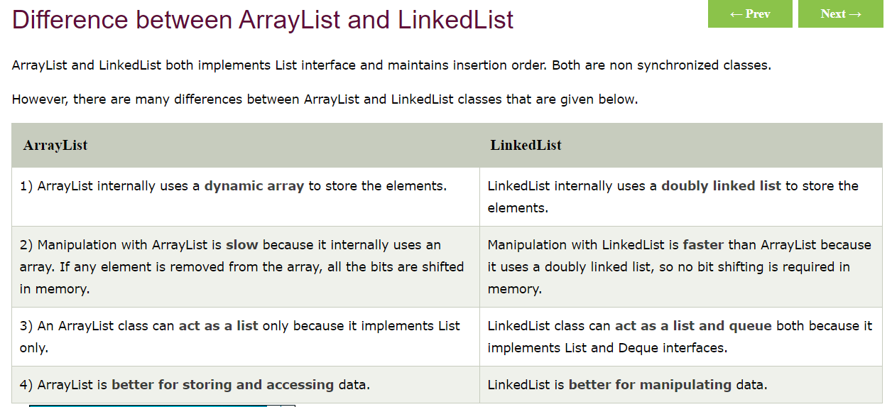

**Explain about ArrayList class?**

**ArrayList:**

1) The underlying data structure is resizable array (or) growable array.

2) Duplicate objects are allowed.

3) Insertion order preserved.

4) Heterogeneous objects are allowed.

5) Null insertion is possible.

6) If our frequent operation is retrieval operation then Array list is good choice and it is not good for insertion and deletion because it need to do lot of shifting operations while inserting and deleting, so that it will take more time then performance will be decreased

**Explain about LinkedList Class?**

**LinkedList:**

1) The underlying data structure is double LinkedList

2) If our frequent operation is insertion (or) deletion in the middle then LinkedList is the

best choice.

3) If our frequent operation is retrieval operation then LinkedList is worst choice.

4) Duplicate objects are allowed.

5) Insertion order is preserved.

6) Heterogeneous objects are allowed.

7) Null insertion is possible.

**Explain about Vector Class?**

**Vector:**

1) The underlying data structure is resizable array (or) growable array.

2) Duplicate objects are allowed.

3) Insertion order is preserved.

4) Heterogeneous objects are allowed.

5) Null insertion is possible.

6) Every method present in **Vector is synchronized and hence Vector is Thread safe.**

**SET Interface**

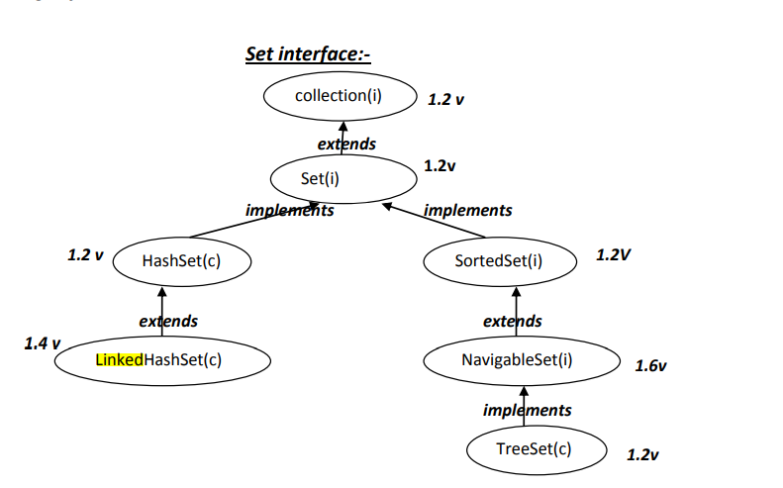

**HashSet:**

1) The underlying data structure is Hashtable.

2) Insertion order is not preserved and it is based on hash code of the objects.

3) Duplicate objects are not allowed.

4) If we are trying to insert duplicate objects we won’t get compile time error and runtime

error add() method simply returns false.

5) Heterogeneous objects are allowed.

6) Null insertion is possible.

**If we are trying to insert duplicate values in Set what will happen?**

• If we are trying to insert duplicate objects we won’t get any compile time error and

runtime error add() method simply returns false, it means duplicate values will not be added

**Explain about TreeSet?**

**TreeSet:**

1) The underlying data structure is balanced tree.

2) Duplicate objects are not allowed.

3) Insertion order is not preserved and it is based on some sorting order of objects.

4) Heterogeneous objects are not allowed if we are trying to insert heterogeneous objects

then we will get ClassCastException.

5) Null insertion is possible(only once)

**What is difference between Set and List interfaces?**

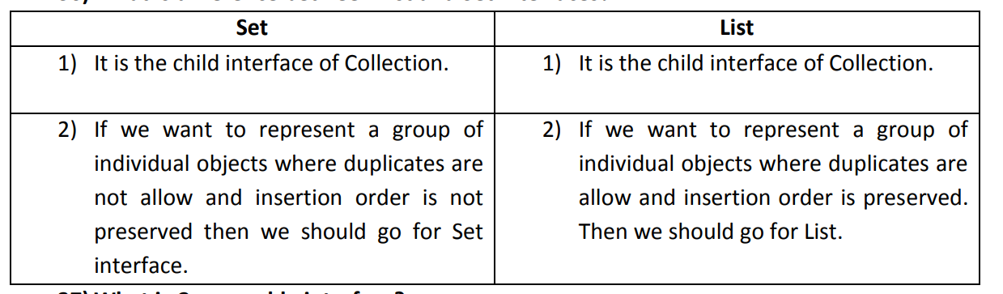

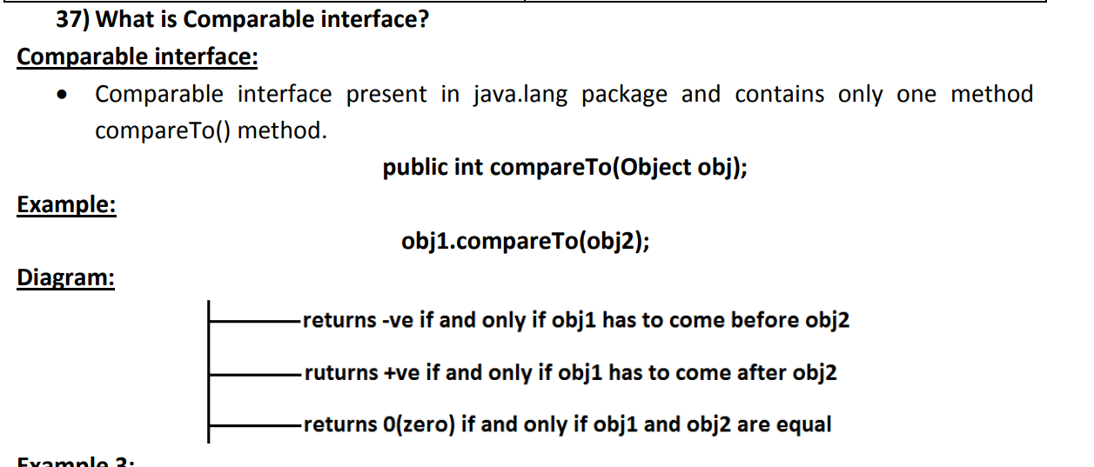

**· If we are depending on default natural sorting order then internally JVM will use compareTo() method to arrange objects in sorting order**

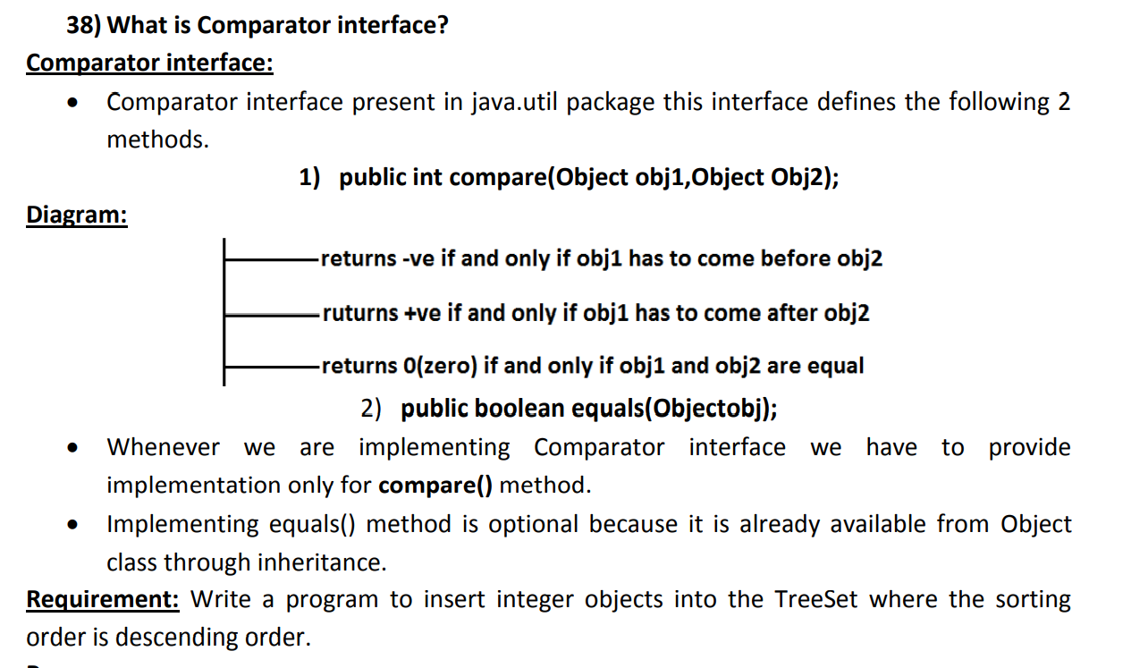

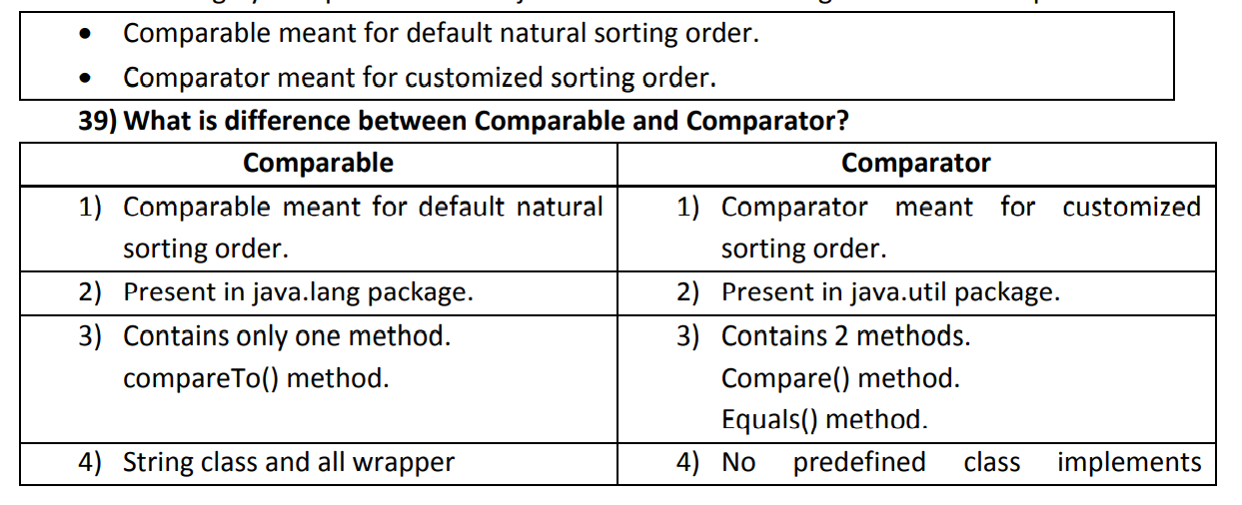

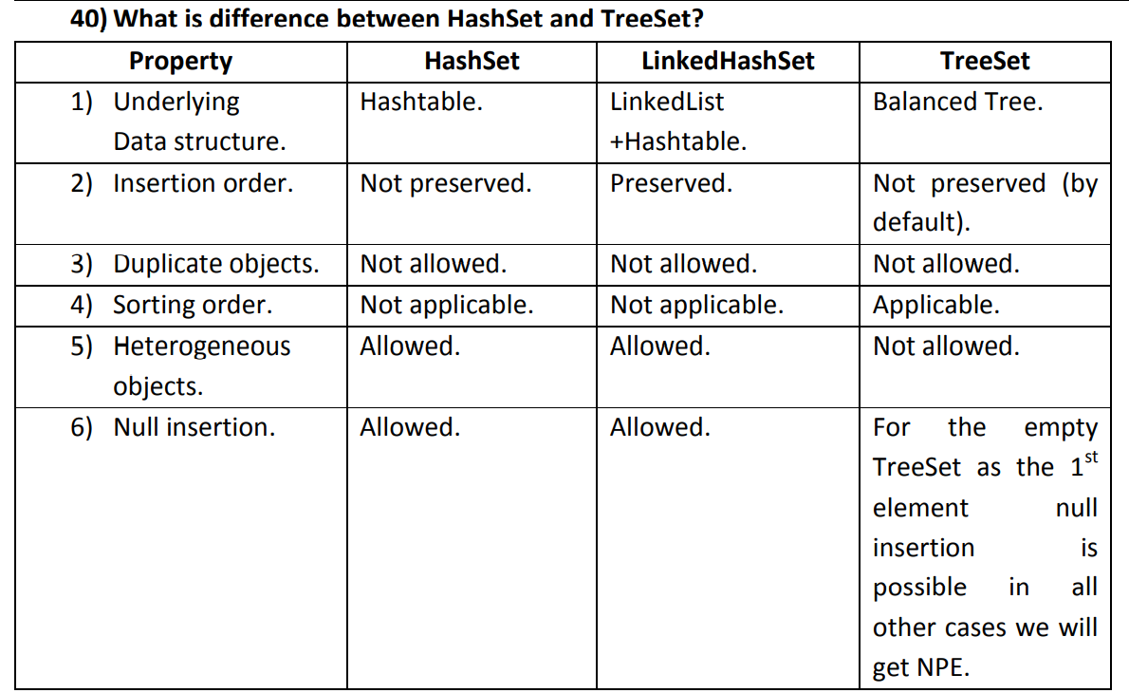

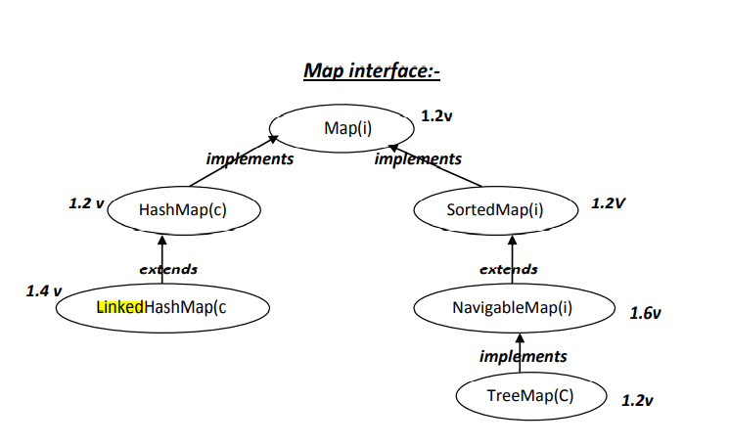

**HashMap:**

1) The underlying data structure is Hashtable.

2) Duplicate keys are not allowed but values can be duplicated.

3) Insertion order is not preserved and it is based on hash code of the keys.

4) Heterogeneous objects are allowed for both key and value.

5) Null is allowed for keys(only once) and for values(any number).

43) Explain about LinkedHashMap?

1) It is the child class of HashMap.

2) LinkedHashMap is exactly same as HashMap except the following differences

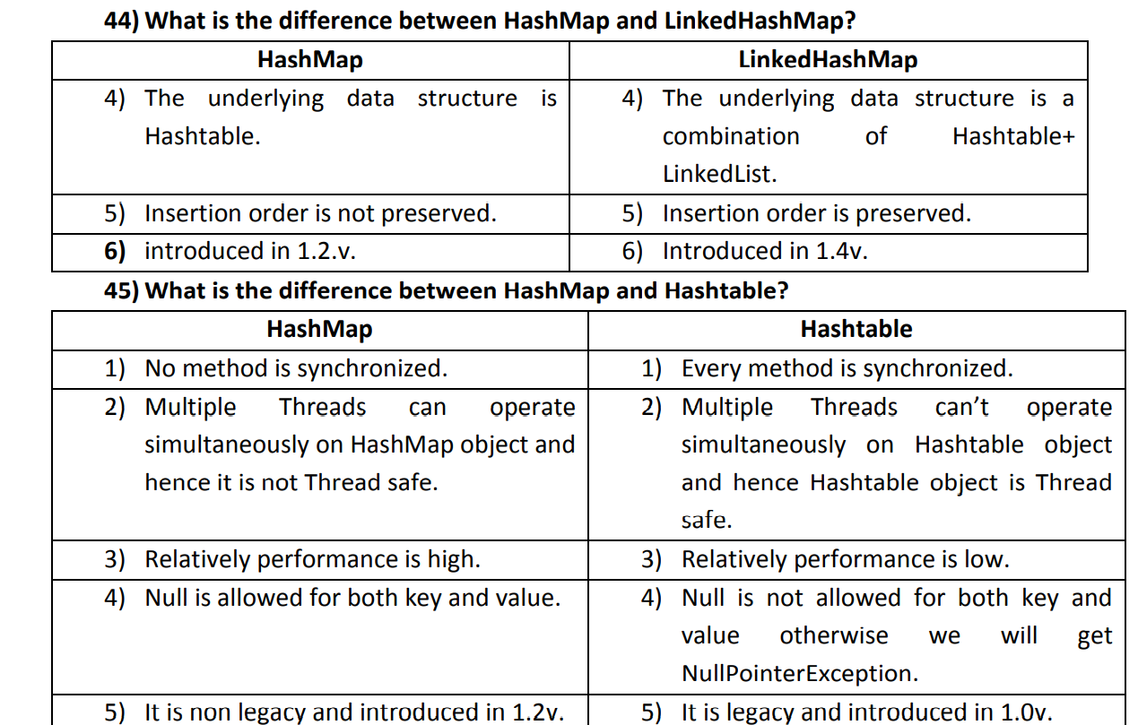

50) What is TreeMap?

**TreeMap:**

1) The underlying data structure is RED-BLACK Tree.

2) Duplicate keys are not allowed but values can be duplicated.

3) Insertion order is not preserved and all entries will be inserted according to some

sorting order of keys.

4) If we are depending on default natural sorting order keys should be homogeneous and

Comparable otherwise we will get ClassCastException.

**If we want to add our own objects to treemap then we must implement comparable or comparator and we need to implement compareTo or compare method**

5) If we are defining our own sorting order by Comparator then keys can be heterogeneous

and non Comparable.

6) There are no restrictions on values they can be heterogeneous and non Comparable.

7) For the empty TreeMap as first entry null key is allowed but after inserting that entry if

we are trying to insert any other entry we will get NullPointerException.

8) For the non empty TreeMap if we are trying to insert an entry with null key we will get

NullPointerException.

9) There are no restrictions for null values.

**What is Hashtable?**

Hashtable:

The important things to learn about Java Hashtable class are:

It is similar to HashMap, but it is synchronized while HashMap is not [synchronized](https://howtodoinjava.com/java/multi-threading/what-is-thread-safety/).

It does not accept null key or value.

It does not accept duplicate keys. If we try to put a duplicate key then old value will be replaced with new value

It stores key-value pairs in hash table data structure which internally maintains an array of nodes buckets . Each index of array may be referred as a bucket.

Insertion order is not preserved and it is based on hash code of the keys.

Null key (or) null value is not allowed if we try to put will get NullPointerException.

Code Syntax is same a hashmap

HashMap<Integer,String> mymap=new HashMap<Integer,String>();//Creating HashMap

mymap.put(1,"Mango"); //Put elements in Map

mymap.put(2,"Apple");

mymap.put(3,"Banana");

mymap.put(4,"Grapes");

System.out.println("Iterating Hashmap...");

for(Map.Entry m : mymap.entrySet()){

System.out.println(m.getKey()+" "+m.getValue());

}

**get(Object key)** : It returns the value to which the specified key is mapped. Returns null if no such key is found.

Mymap.get(3); // here 3 is key we will get Banana as value

# Working of HashMap in Java:

# Or explain about hashing technique:

# Hashing is the process of converting an object into an integer value by using hashcode method.

# HashMap contains an array of the nodes,. It uses an array and LinkedList data structure internally for storing Key and Value. There are four fields in HashMap.

# Working of HashMap in Java

# 

# By Default Hashmap size is 16, so internally 16 Buckets will be created (Array of nodes will be created), it will increase size automatically if we insert more than 16.

# Whenever we try to put a key value in a hashmap, first hashcode will be calculated for the key based on hashcode it will calculate the index to store the key and value at particular index in a bucket.

Index = hashcode(Key) & (n-1)

Example: Index = 2657860 & (16-1) = 4  // here index is 4

**Hash Collision:**

If we try to insert a duplicate key then hashcode & index will be calculated and while placing that key value in particular index, there will be already a key and value as we are trying to insert a duplicate key, then old key will be compared with new duplicate key by using equals method if both keys are same then new value will be updated ,If two key’s are different but hashcode is same for both the key’s then it will compare old key with new key and if its false(keys are different) then it will create a new node in that index only.

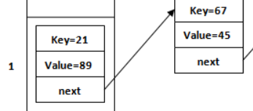

**If two key’s are same then hashcode should be same.**

**If two key’s are different there is a chance to get same hashcode.(very rare cases).**

**Note: if we try to put a null key then by default it will placed at 0th index**

**Why do we need to override hashcode and equals method ?**

**If we try to insert our own object as key we need to override hashcode and equals method in our own class, why because if we don’t override then even if two objects are same but still we may get different hashcode, then if we try to add same key (our own objects as key) it will allow duplicate keys which is not a good one ( as we know hashmap should not allow duplicate keys) to make this possible we must override our own hashcode and equals method.**

The following table summarizes the principal classes in Java collections framework for quick reference:

* **D:** Duplicate elements is allowed?
* **O:** Elements are ordered?
* **S:** Elements are sorted?
* **TS:** The collection is thread-safe? (synchronized or not)

|  |  |  |  |  |
| --- | --- | --- | --- | --- |
| **Main collection classes** | **D** | **O** | **S** | **TS** |
| **ArrayList** | **Yes** | **Yes** | **No** | **No** |
| **LinkedList** | **Yes** | **Yes** | **No** | **No** |
| **Vector** | **Yes** | **Yes** | **No** | **Yes** |
| **HashSet** | **No** | **No** | **No** | **No** |
| **LinkedHashSet** | **No** | **Yes** | **No** | **No** |
| **TreeSet** | **No** | ---- | **Yes** | **No** |
| **HashMap** | **No** | **No** | **No** | **No** |
| **LinkedHashMap** | **No** | **Yes** | **No** | **No** |
| **Hashtable** | **No** | **No** | **No** | **Yes** |
| **TreeMap** | **No** | ----- | **Yes** | **No** |

From this table we can conclude the following characteristics of the main collections in Java Collection Frameworks:

* + All lists allow duplicate elements which are ordered by index.
  + All sets and maps do not allow duplicate elements.
  + All list elements are not sorted.
  + Generally, sets and maps do not sort its elements, except TreeSet and TreeMap – which sort elements by natural order or by a comparator.
  + Generally, elements within sets and maps are not ordered, except for:
    - * LinkedHashSet and LinkedHashMap have elements ordered by insertion order.
      * TreeSet and TreeMap have elements ordered by natural order or by a comparator.
  + There are only two collections are thread-safe: Vectorand Hastable. The rest is not thread-safe.

**How can you make any List or Set or Map type of collection to a Synchronized version ?**

Collections.*synchronizedCollection*(a);// to make any collection class to sync

Collections.synchronizedList(**ls**)// to make List as synchronized

Collections.synchronizedSet(**se**) // to make Set as synchronized

Collections.synchronizedMap(**ma**) //// to make map as synchronized

In all above cases we need to pass respective collection object like ArrayList object etc….

# Immutable String in Java

In java, **string objects are immutable**. Immutable simply means unmodifiable or unchangeable.

Once string object is created its data or state can't be changed but a new string object is created.

 String s="Sachin";  first s will be pointing to Sachine

   s= s+“Tendulkar”  after concatenation instead of modifying Sachine a new object will be created and s reference will be changed and it will point to Sachin Tendulkar

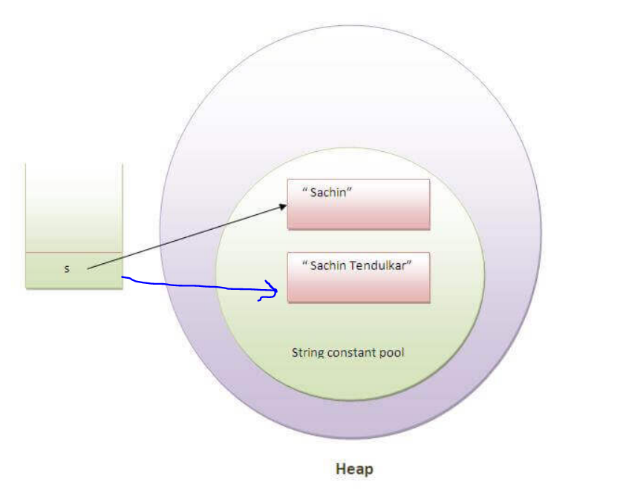

### **Why string objects are immutable in java?**

|  |
| --- |
| Because java uses the concept of string literal. //String s=”teja”;  String literals are stored inside heap area in String constant pool  Why we use String constant pool (SCP) because if we create one string literal it will be placed  Inside string constant pool, if you try to create same one more string literal it will not create  A new string object it will just point the reference to same old object.    Why String is Immutable ?  Suppose there are 5 reference variables, all refers to one object "teja".  If one reference variable changes the value of the object, it will be affected to all  the reference variables. That is why string objects are immutable in java.  **How to create Immutable class?**  1.The class must be declared as final (So that child classes can’t be created)  2.Properties in the class must be declared as private and final (So that direct access is not allowed And we can’t change the value of it after object creation)    3.A parametrized constructor should initialize all the fields  (So that Properties can’t be modified with object reference)  4.There should be only getter methods and no setter methods (to avoid setting object data we  Avoid setter methods)   * **public** **final** **class** Employee{ * **private final** String pancardNumber; * **public** Employee(String pancardNumber){ * **this**.pancardNumber=pancardNumber; * } * **public** String getPancardNumber(){ * **return** pancardNumber; * } * }  **How to create Singleton design pattern?** Singleton means only one object will be created  A class must ensure that only single instance should be created and single object can be used by all other classes.  To create the singleton class, we need to have static member of class, private constructor and static factory method.   * **Static member:** It gets memory only once because of static, it contains the instance of the Singleton class.(Object) * **Private constructor:** It will prevent to instantiate the Singleton class from outside the class. * **Static factory method:** Factory method means just a simple method which will create a object and it will return same object. * Here we make factory method as static because * As we made constructor as private others cannot access a instance method without object creation and its reference. So we make this method as static so that others can access by using class name reference.   **Lazy Instantiation**   * **Public class** JDBCSingleton { * //Step 1 * // create a JDBCSingleton class. * //static member holds only one instance of the JDBCSingleton class. * **private** **static** JDBCSingleton jdbc=null; * //JDBCSingleton prevents the instantiation from any other class. * **private** JDBCSingleton() {  }  * //Now we are providing gloabal point of access. * **public** **static** JDBCSingleton getInstance() { * **if** (jdbc==**null**) * { * jdbc=**new**  JDBCSingleton(); * } * **return** jdbc; * }   There are two forms of singleton design pattern   * **Early(eager) Instantiation:** creation of instance at load time. * **Lazy Instantiation:** creation of instance when required.   In Above case we have created using **Lazy Instantiation**  **Below code is Eager example:**  **// here object initialized eagerly during class loading**   **private** **static** JDBCSingleton jdbc= new JDBCSingleton();   * **private** JDBCSingleton() {  }  //private constructor * **public** **static** JDBCSingleton getInstance() {   //factory method * **return** jdbc;  }   **Usage of Singleton**  Singleton classes are used for logging, driver objects, caching and thread pool, database connections.  **Use case:** Instead of creating a new connection object every time for each user,  We can use singleton patter so that only one connection object gets created and every one can use same connection.so that it Saves memory because object is not created at each request. Only single instance is reused again and again.  **Difference between == and .equals() method in Java:**  **==** operator is used for address comparison (reference of object)  **.equals** method is used to compare content of the object (it is Object class method)  **Note:** By default .equals method will be override in all wrapper classes and String class.  If you want to compare content of your own object **ex:** employee object then you must override equals method.  String s="usha";// String literal  String x="usha";  System.***out***.println(s==x); // true because both s and x are pointing to same address as it uses String constant pool concept  System.***out***.println(s.equals(x)); // True because both String content are same    String sx=**new** String("usha");  String sy=**new** String("usha");  System.***out***.println(sx==sy); // false because here we are creating string object by using new key word we will different address for each object  System.***out***.println(sx.equals(sy)); // true because content of two objects is same      String ab=**new** String("usha");  String bc="usha";  System.***out***.println(ab==bc);// false because ab is String object and bc is string lieral so address will be different  System.***out***.println(ab.equals(bc)); //true because content is same      String cd="usha";  String de="USHA";  System.***out***.println(cd==de); // false because one is upper case other is in lowercase both content and address will be different  System.***out***.println(cd.equals(de)); // false content is different uppercase and lower case  System.***out***.println(cd.equalsIgnoreCase(de)); //true as it will ignore case while content comparison      **Java JDBC**  JDBC stands for Java Database Connectivity. JDBC is a Java API to connect and execute the query with the database. It is a part of JavaSE (Java Standard Edition). JDBC API uses JDBC drivers to connect with the database. There are four types of JDBC drivers:   * JDBC-ODBC Bridge Driver, * Native Driver, * Network Protocol Driver, and * **Thin Driver (We use type-4 Thin Driver)**     JDBC Driver: if we want to communicate from our java application to database, we need to some mediator to convert all java related object to sql , so we need a Driver  JDBC Driver is a jar file which contains packages and classes related to connect from java to database  The **java.sql** package contains classes and interfaces for JDBC API.  Our Java will provide specification’s it means interfaces with abstract methods inside java.sql package and implementations will be provided by database specific vendors like Oracle ,db2 mysql. So if you use mysql database then you need to download mysql connector or Driver and place in your applications buildpath.  There are 5 steps to connect any java application with the database using JDBC. These steps are as follows:   * Register the Driver class * Create connection * Create statement or PreparedStatement * Execute queries * Close connection * Note:Driver class name url and port name will be different for each database * here for mysql driver is Class.forName("com.mysql.jdbc.Driver");   But for oracle its different for the oracle driver class is **oracle.jdbc.driver.OracleDriver**.  url will be jdbc:oracle:thin:@localhost:1521:myjava   * [***Statement***](https://javaconceptoftheday.com/java-jdbc-tutorial-sql-create-insert-select-update-delete-examples/)  –  **Used to execute normal SQL queries.** * **class** MysqlCon{ * **public** **static** **void** main(String args[]){ * **try**{ * Class.forName("com.mysql.jdbc.Driver"); * Connection con=DriverManager.getConnection( * "jdbc:mysql://localhost:3306/myjava","root","root"); * //here myjava is database name, root is username and password * **Statement** stmt=**con.createStatement**(); * ResultSet rs=stmt.executeQuery("select \* from emp"); * **while**(rs.next()) * System.out.println(rs.getInt(1)+"  "+rs.getString(2)+"  "+rs.getString(3)); * con.close(); * }**catch**(Exception e){ System.out.println(e);} * } * }   [***PreparedStatement***](https://javaconceptoftheday.com/preparedstatement-in-java/)  –  **Used to execute dynamic or parameterized SQL queries.**  // **Use same below for insert delete and update just change query**   1. PreparedStatement stmt=con.prepareStatement("insert into Emp values(?,?)"); 2. stmt.setInt(1,101);//1 specifies the first parameter in the query 3. stmt.setString(2,"Teja"); 5. **int** i=stmt.executeUpdate(); 6. System.out.println(i+" records inserted");   // **Use below for retrieval of data (Select query)**   1. PreparedStatement stmt=con.prepareStatement("select \* from emp"); 2. ResultSet rs=stmt.executeQuery(); 3. **while**(rs.next()){ 4. System.out.println(rs.getInt(1)+" "+rs.getString(2));   }  ***[CallableStatement](https://javaconceptoftheday.com/java-callablestatement-stored-procedures-in-out-parameters-examples/" \t "_blank)***  –  **Used to execute the stored procedures.  (not required)** [Difference Between Statement Vs PreparedStatement Vs CallableStatement In Java](https://javaconceptoftheday.com/statement-vs-preparedstatement-vs-callablestatement-in-java/) Difference Between Statement Vs PreparedStatement Vs CallableStatement In Java |
| Introduction to Web: Web consists of billions of Users(clients) and servers connected through wires and wireless networks. The user uses web browser to send request to the server. The server often sends response to the browser with a set of instructions written in HTML(HyperText Markup Language). All browsers know how to display HTML page to the users (client).  When you open your chrome(client) and enter any url like [www.gmail.com](http://www.gmail.com) and enter the request will go to the gmail server  And then gmail server will process the request and it will send response in html format and then you will get login page.  What is a server ?  Server is nothing but a software like Tomcat, Jboss, Wildfly, WebSphere, glassfish which will be running in machine(computer), these are web and application servers. In the same way we can have other type of servers like database servers which will be used for data base like oracle server and, mysql server these are used to manage data base.  Now let us observe the flow Development to Deployment of application into production:  Assume You are a developer and you have developed a gmail application using java, once you complete your development and testing to make application accessible to everyone in internet you have to convert your code into a war format (war -web archive) it is nothing but like zipping all your class files, xmls and other configuration information and images into a single executable format war. To run this application, you need a machine with java installed and any one server like tomcat.  We need to place our war file inside the webapps  Inside tomcat software there will be a bin folder if you run startup script tomcat server will be started in your machine, you can access that based on your machine ip address and port number by default tomcat port number is 8080, by using tomcat deployment manager screen you can deploy the war file.  Other way of deployment is just copy you ear and place inside the tomcat webapps folder then start your server by using startup script  You can automate the complete deployment process using some other tools like Jenkins  Once the application is deployed into server it will be up and running, as we know for every machine there will be a IP address and many ports will we will enable the port number and IP address, so that every one can access the application from any where over internet. To access the application user need’s to remember ip address and port number but its very difficult to a user to remember ip address so, here we get a concept know as DNS , Domain name system , it is just like a phone book of internet where will map our ip address to url name. so when a user send request to that url then DNS server will check the ip address associated with that name  Example : http://www.gmail.com =192.168.157.14  All the above explanation is in case if we deploy in a machine to expose app over internet.  If you are doing in your local machine then your local ip address will be 127.0. 0.1 or localhost and for tomcat port number will be 8080  <http://localhost:8080>  you can follow same as above process to deploy war in your local machine  In local environment case we have our browser(client) and tomcat server in your same machine  While developing web based projects using IDE like eclipse we can configure server to Eclipse IDE so that while we are developing code we can easily test our application is working fine or not, after completion of our development we can generate a war file from our code and we can deploy.  Web request and response  client and server functioning  Static-WebApplications: content will be same or common for all users it will not change. Any simple website with just html  Dynamic WebApplications: Content will be changed dynamically based on the user example : Gmail, facebook, etc…  We can develop Dynamic web applications using java (Servlets & JSP, Spring MVC etc) we can develop using other language’s also like php, python etc…  When we send request from our browser will be using http protocol http means hyper text transfer protocol,( protocol means set of rules or defined between two communication parties it means rules to follow between browser and server) server will read the request and it will produce a response page and send back to browser.  Servlets are the Java programs that runs on the Java-enabled web server or application server. They are used to handle the request obtained from the browser and process the request, produce the response data, then send response back response to browser.  Servlet can be described in many ways.   * Servlet is a technology which is used to create a web application. * Servlet is a class that extends the capabilities of the servers and responds to the incoming requests. It can respond to any requests. * Servlet is a web component that is deployed on the server to create a dynamic web page.   We can Create servlets by using annotations or xml based configurations  In older versions up to servlets 2.9 version servlets based applications were developed using xml based configuration only but in servlet 3.0 version they have introduced servlet annotations The Servlet API 3.0 introduces a new package called javax.servlet.annotation which provides annotation types which can be used for annotating a servlet class. The annotations can replace equivalent XML configuration in the web deployment descriptor file (web.xml) such as servlet declaration and servlet mapping. Servlet containers(tomcat) will process the annotated classes at deployment time.  First, we will discuss about older version (servlets up to 2.9)  Below image is Project structure of older version servlets with web.xml The Deployment Descriptor: web.xml Java web applications use a deployment descriptor file to determine how URLs map to servlets, and other application configuration information. This file is named web.xml, and resides  under the WEB-INF/ directory. web.xml is part of the servlet standard for web applications.    Servlet url Mapping in web.xml  Here in below xml servlet tag <servlet> contains servlet name and corresponding java class (also known as servlet class)  And we have servlet-mapping tag which contains url pattern and servlet name. So when ever we get any request with this url  <http://localhost:8080/sampleservlet/login> it will check url pattern /login and corresponding servlet and then it will go to that java class  <servlet>  <servlet-name>login</servlet-name> //step 3  <servlet-class>com.sample.servlet.login</servlet-class> //step 4  </servlet>  <servlet-mapping>  <servlet-name>login</servlet-name> //step 2  <url-pattern>/login</url-pattern> //step 1  </servlet-mapping>  Note : default welcome page will be index.html it doesn’t required any mapping information  From Servlet 3.0 version we don’t need to create any web.xml file with servlet mapping. We can do anything with annotations  @WebServlet("/login")  Instead of configuring mapping url information in web.xml we can use @webservelt annotation directly on our servlet class so that when ever we get a request our server will check the @webservelt annotation with appropriate url mapping then that class will be executed. Steps to create a servlet Class: There are three ways to create the servlet.   1. By implementing the Servlet interface 2. By extending the GenericServlet class (this is an abstract class will implement Servlet, ServletConfig interfaces) 3. By extending the HttpServlet class (this class will extends GenericServlet)  |  | | --- | | Difference Between GenericServlet and HttpServlet Generic Servlet is protocol independent **(i.e)** it can handle all types of protocols like **http, ftp, smtp** etc this can be used for general purpose  Generic Servlet supports only service() method. Extending class must override public abstract void service(ServletRequest req,ServletResponse res ) method.  In Generic Servlet case if you send get type or post type any request it will go to service method only, here we cannot execute our logic based on request type, it means we should execute get all employee data for get type of request and we need to save employee data for post type of request, so to overcome this problems we got a new class that is HttpServelt class.  HttpServlet is class is dependent. It supports only http protocol.  HttpServlet overrides service() method of Generic Servlet and provides callback on doXXX(HttpServletRequest request, HttpServletResponse) method whenever it receives HTTP request, it supports doGet(), doPost(), doPut(), doDelete(), doHead(), doTrace(), doOptions() methods.  If we extend our class with HtttpServelt class as we know HtttpServelt class extends GenericServelt class internally HttpServlet class will override service method and inside service method a logic will be written like based on user type of request it should go to appropriate method like doPost or doGet method like that.  We should override doGet and doPost method and we should write our own logic for those methods in our class  The HttpServlet class is widely used to create the servlet because it provides methods to handle http requests such as doGet(), doPost, doHead() etc. | | In this example we are going to create a servlet that extends the HttpServlet class. In this example, we are inheriting the HttpServlet class and providing the implementation of the doGet() method. Notice that get request is the default request.   1. public class DemoServlet extends HttpServlet{ 2. public void doGet(HttpServletRequest req,HttpServletResponse res) 3. throws ServletException,IOException 4. { 5. res.setContentType("text/html");//setting the content type 6. PrintWriter pw=res.getWriter();//get the stream to write the data 8. //writing html in the stream 9. pw.println("<html><body>"); 10. pw.println("Welcome to servlet"); 11. pw.println("</body></html>"); 13. pw.close();//closing the stream 14. }}  HTTP Methods HTTP request can be made using a variety of methods, but the ones you will use most often are Get and Post. The method name tells the server the kind of request that is being made, and how the rest of the message will be formatted.  HTTP Get type method will be used when we need data from server , example get all employee data ,get request is not good for sending form data like user registration from data or login data because it is not secured because data is exposed in URL  Example : <http://localhost:8080/myapp/login?userid=teja&password=teja>  In the above case if we send form data using get all the sensitive information will be exposed in url which is not good, so we have to use only post type method to send any form data to make application secured.  HTTP Post Method request is secured because data is not exposed in URL. Data will be sent inside request body.  By default if you call any url like [www.gmail.com](http://www.gmail.com) it will be http get type request.  We use post type method when we want to send some information to server like registration form data or login form data etc. if use post method data will be sent to server securely inside request body.  In Below 1st html form we dint mention form action type its get or post then if we don’t mention by default it will be a get method  <form action="login">  <label>User Name::</label>  <input type="text" name="username">  <label>Password::</label>  <input type="password" name="password">  <button type="submit">Login</button>  if we submit the form as it is a get type by default data will be exposed in url  http://localhost:8080/MyFirstServlet/login?username=teja&password=123  ====================  <body>  <form action="login" method="post">  <label>User Name::</label>  <input type="text" name="username">  <label>Password::</label>  <input type="password" name="password">  <button type="submit">Login</button>  Servlet Life Cycle?  A servlet life cycle can be defined as the entire process from its creation till the destruction. The following are the paths followed by a servlet.   * The servlet is initialized by calling the init() method. * The servlet calls service() method to process a client's request. * The servlet is terminated by calling the destroy() method. * Finally, servlet is garbage collected by the garbage collector of the JVM.  How web container(server) handles the servlet request? The web container(server) is responsible to handle the request. Let's see how it handles the request.   * maps the request with the servlet in the web.xml file, or @webservelt annotation * creates request and response objects for this request * calls the service method * The service method calls the doGet or doPost method depending on the type of request. * The doGet method generates the response and it is passed to the client. * After sending the response, the web container deletes the request and response objects.   Servlet mainly works by using two objects  (HttpServletRequest request, HttpServletResponse response)  When ever we send a request, we can read the user submitted form data with request object  String name=request.getParameter("name");  We can send response back by using setting our response to response object  PrintWriter out=response.getWriter();  out.println("<h1>Welcome to my Page </h1>");  public void doPost(HttpServletRequest request, HttpServletResponse response) throws ServletException, IOException {  response.setContentType("text/html");  PrintWriter out=response.getWriter();    String name=request.getParameter("name");  String password=request.getParameter("password");  String email=request.getParameter("email");  String country=request.getParameter("country");  System.out.println(name +" "+password +" "+email +" "+country);  }  public void doGet(HttpServletRequest request, HttpServletResponse response) throws ServletException, IOException {  PrintWriter out=response.getWriter();  out.println("<h1>Employees List</h1>");  } |  Session Tracking in Servlets Session simply means a particular interval of time.  Session Tracking is a way to maintain state (data) of an user. It is also known as session management in servlet.  Http protocol is a stateless so we need to maintain state using session tracking techniques. Each time user requests to the server, server treats the request as the new request. So we need to maintain the state of an user to recognize to particular user.  In general words, when every we send a request to server it will not store any user information, because http protocol is stateless it means server will not maintain(store) any state of information in server, so every request will be treated as new request. But in some cases we need to remember the user information, like to display username in all pages or to avoid multiple users login with same username at same time etc… to achieve this requirement to store user information in server side we use session concept with httpSession Object.  String name=request.getParameter("userName");  // we are reading user input from the request object    HttpSession session=request.getSession();   // creating a session object   session.setAttribute("usname",name);  //here usname is key and name is the value  in the above process we have set the username to session object, so the server can remember the user, now to retrieve the session we use below  HttpSession session=request.getSession(false);  // if we give false it will not create a new session object , it will just call existing session object     String name=(String)session.getAttribute("usname");  // getting value with key         out.print("Hello "+name);  if we want to remove that particular session object from server, then just use invalidate method  session.**invalidate() // remove particular session object from server**  we use this in logout functionality.  **Spring Framework** What is Spring Framework and how it works? **Spring Framework** is an open-source framework for building web applications with Java as a programming language.it also offers support for various frameworks such as hibernate, struts, tapestry, and JSF. Why do we use Spring in Java?  * Works on POJOs (Plain Old Java Object) which makes your application lightweight. * Provides predefined templates for JDBC, Hibernate, JPA etc., thus reducing your effort of writing too much code. * Because of dependency injection feature, your code becomes loosely coupled. * Using Spring Framework, the development of Java Enterprise Edition (JEE) applications became faster. * It provides declarative support for transactions, validation, caching and formatting.  **Spring Framework Architecture** Spring Architecture - Spring Framework Tutorial - Edureka!         Modules of Spring FrameworkCore ContainerThis container has the following four modules :1. Spring Core: This module is the core of the Spring Framework. It provides an implementation for features like IoC (Inversion of Control) and Dependency Injection with a singleton design pattern.2. Spring Bean: This module provides an implementation for the factory design pattern through BeanFactory.3. Spring Context: This module is built on the solid base provided by the Core and the Beans modules and is a medium to access any object defined and configured.4. Spring Expression Languages (SpEL): This module is an extension to expression language supported by Java server pages. It provides a powerful expression language for querying and manipulating an object graph, at runtime.Spring Data Access/ IntegrationIt consists of the following five modules:1. JDBC: This module provides JDBC abstraction layer which eliminates the need of repetitive and unnecessary exception handling overhead.2. ORM: ORM stands for Object Relational Mapping. This module provides consistency/ portability to our code regardless of data access technologies based on object oriented mapping concept.3. OXM: OXM stands for Object XML Mappers. It is used to convert the objects into XML format and vice versa. The Spring OXM provides an uniform API to access any of these OXM frameworks.4. JMS: JMS stands for Java Messaging Service. This module contains features for producing and consuming messages among various clients.5. Transaction: This module supports programmatic and declarative transaction management for classes that implement special interfaces and for all your POJOs. All the enterprise level transaction implementation concepts can be implemented in Spring by using this module. **Spring Web**  Web layer includes the following modules:   1. **Web**: This module using servlet listeners and a web-oriented application context, provides basic web-oriented integration features like multi-part file upload functionality and the initialization of the IoC container. 2. **Web-Servlet**: This module contains **Model-View-Controller** (MVC) based implementation for web applications. It provides all other features of MVC, including UI tags and data validations. 3. **Web-Socket:**This module provides support for WebSocket based and two-way communication between the client and the server in web applications. 4. **Web-Portlet:**This module is also known as the Spring-MVC-Portlet module. It provides the support for Spring-based Portlets and mirrors the functionality of a Web-Servlet module.   **Aspect-Oriented Programming (AOP)**  AOP language is a **powerful** **tool** that allows developers to add enterprise functionality to the application such as transaction, security etc. It allows us to **write less code and separate the code logic. AOP uses cross-cutting concerns.**  **Pre-Introduction to IOC:**  In an object-oriented design, classes should be designed in a loosely coupled way. Loosely coupled means changes in one class should not force other classes to change, loosely coupled applications are easily maintainable. Tightly Coupled Problem: It means one class, is depending on other class, if we change any code in one class other class also need to changeExample: **public** **static** **void** main(String[] args) { // This is a MainStart Class  Manager m=**new** Manager();  m.dowork();  }  **public** **class** **Manager** {  //private TL tl;    **public** **void** dowork() {  System.***out***.println("Manager Started working");  **TL tl=new TL();**  **tl.dowork();**  } In the Above Case manager needs to create a TL object , then only with TL object reference manager can call dowork() method of TL class.So here Manager is Depending on TL , which means tight coupling it means if TL object changes anything then manager also needs to change code,To make this loosely coupled we use IOC principle or (pattern)Inversion of Control (IoC) is a design principleAs Name Suggests Inversion of control it means instead of, we create and manage the objects, spring framework(Spring container) will take responsibility of objects creation and managing the objects.Here in Spring Frame Work Spring IOC container will take the responsibility of Object Creation, Injection and Managing objects,Note: In Spring objects are also known as beans The IoC container is responsible to instantiate, configure and assemble the objects. The IoC container gets information’s from the XML file or through annotations and works accordingly. The main tasks performed by IoC container are:   * to instantiate the application class * to configure the object * to assemble the dependencies between the objects   **There are two types of IoC containers. They are:**   1. **BeanFactory (Interface)** 2. **ApplicationContext (Interface)**   **BeanFactory and Appplication are also known as Spring IOC Containers which are responsible for Bean creation and injection, entire bean life cycle is managed by IOC Containers, bean life cycle means bean instantiation, setting properties ,Injecting Dependencies, at last destroying beans.** **Difference between BeanFactory and the ApplicationContext** The org.springframework.beans.factory.**BeanFactory** and the org.springframework.context.**ApplicationContext** interfaces acts as the IoC container. The ApplicationContext interface is built on top of the BeanFactory interface, it means ApplicationContex interface extends BeanFactory Interface. So all the Beanfactory abstract methods will be part of applicationContext also ApplicationContext adds some extra functionality than BeanFactory such as simple integration with Spring's AOP, message resource handling (for I18N), event propagation, application layer specific context (e.g. WebApplicationContext) for web application. **So it is better to use ApplicationContext than BeanFactory.**  **BeanFactory and ApplicationContext interfaces are implemented by classes like** ClassPathXmlApplicationContext, AnnotationConfigApplicationContext, WebApplicationContext is a Interface extended by ApplicationContext WebApplicationContext is used to for Web Applications, some of implemented classes are  [AnnotationConfigWebApplicationContext](https://docs.spring.io/spring-framework/docs/current/javadoc-api/org/springframework/web/context/support/AnnotationConfigWebApplicationContext.html), [XmlWebApplicationContext](https://docs.spring.io/spring-framework/docs/current/javadoc-api/org/springframework/web/context/support/XmlWebApplicationContext.html) |
| **Using BeanFactory** The XmlBeanFactory is the implementation class for the BeanFactory interface. To use the BeanFactory, we need to create the instance of XmlBeanFactory class as given below:   1. Resource resource=**new** ClassPathResource("spring-config.xml"); 2. BeanFactory factory=**new** XmlBeanFactory(resource);   The constructor of XmlBeanFactory class receives the Resource object so we need to pass the resource object to create the object of BeanFactory. **Using ApplicationContext** The ClassPathXmlApplicationContext class is the implementation class of ApplicationContext interface. We need to instantiate the ClassPathXmlApplicationContext class to use the ApplicationContext as given below:   1. ApplicationContext context = 2. **new** ClassPathXmlApplicationContext("spring-config.xml");   The constructor of ClassPathXmlApplicationContext class receives xml file name in string, so we can pass the name of the xml file to create the instance of ApplicationContext.  If we are using Annotation based configuration then we can follow as below  ApplicationContext context = **new** AnnotationConfigApplicationContext(**Main**.**class**);  Here we passed **main.class** class as a parameter to AnnotationConfigApplicationContext constructor, main class is the class where we have componentscan annotation componentscan will scan all packages and classes with annotations like @component,@controller@service@Repository@Bean,@autowired and provide information to Applicationcontext, then based on annotations applicationcontext will create beans and inject the beans.  **// Use Below code get all beans created by applicationContext**  ApplicationContext context = **new** AnnotationConfigApplicationContext(**Main**.**class**);    /\* String[] allBeanNames = context.getBeanDefinitionNames();  for(String beanName : allBeanNames) {  System.out.println(beanName); } \*/ |
| *Dependency Injection* Dependency Injection is **a fundamental aspect of the Spring framework**, through which the Spring container "**injecting one objects into other objects** .  This allows for loose coupling of components and the responsibility of managing components(Objects) onto the IOC container. |
| *Dependency Injection Types:***Two ways to perform Dependency Injection in Spring framework** Spring framework provides two ways to inject dependency   * By Setter method * By Constructor   **By Setter method:**  Spring Setter Injection is nothing but injecting the Bean Dependencies using the *Setter* methods on an Object. in Setter Injection, the object is created first and then the dependency is injected.  Here we are creating Developer object first, then we are setting object to TL setter method, in the same way we are doing for TL and Manager as below.  Developer dev=**new** Developer();  TL tl=**new** TL();  tl.**setDev**(dev);  Manager man=**new** Manager();  man.**setTl**(tl);  man.dowork(); Above code is just a normal core java examplein case of spring we need to first create Manager, TL, Developer class thenManager class should contain TL object type reference, and TL should contain Developer type reference and all the classes should contain setter getter methods Then create a xml configuration fileas below here create beans and inject one bean to other by using **ref keyword.**  <bean id=*"****mydev****"* class=*"com.teja.spring.setterinjection.Developer"*>  </bean>  <bean id=*"****mytl****"* class=*"com.teja.spring.setterinjection.TL"*>  <property name=*"dev"* **ref**=*"****mydev****"*></property>  </bean>  <bean id=*"mymanager"* class=*"com.teja.spring.setterinjection.Manager"*>  <property name=*"company"* value=*"my compnay is HCL"*></property>  <property name=*"tl"* **ref**=*"****mytl****"*></property> </bean>Then load the above config class as below **With Bean Factory**  Resource resource=**new** ClassPathResource("setter-injection-spring.xml");  BeanFactory factory=**new** ~~XmlBeanFactory~~(resource);  Manager manager=(Manager)factory.getBean("mymanager");  manager.dowork();  **below with applicationContext**  // ApplicationContext context=new ClassPathXmlApplicationContext("setter-injection-spring.xml");  // Manager managerapp= (Manager) context.getBean("mymanager");  // managerapp.dowork();    **By Constructor Injection:**  In Constructor injection Dependencies will be injected with the help of constructors. Here we need to create a parameterised constructor in a class to pass the dependency objects  Here we are creating Developer object first then we are passing that object to TL constructor in the same way for Manager.  Developer dev=**new** Developer();  TL tl=**new** TL(dev);  Manager man=**new** Manager(tl);  man.dowork();  **Above is just normal java code**  **In Spring to create a constructor injection first we need create Manager class which should contain a parameterised constructor with accepts TL type of Object, In the Same way we need to Create a parameterised constructor for TL and Developer.**  **Then create a spring configuration file and create bean’s as below here as we are using constructor injection we use constructor-arg tag and ref keyword to inject**  <bean id=*"mydev"* class=*"com.teja.spring.construtorinjection.Developer"*></bean>  <bean id=*"mytl"* class=*"com.teja.spring.construtorinjection.TL"*>  <**constructor-arg ref=*"mydev"*></constructor-arg**>  </bean>  <bean id=*"mymanager"* class=*"com.teja.spring.construtorinjection.Manager"*>  **<constructor-arg ref=*"mytl"*></constructor-arg>**  <constructor-arg value=*"iam working in hcl"* type=*"java.lang.String"*></constructor-arg>  </bean> Then we will load above xml configuration file with applicationContext to create and inject beansDifference between Setter and Constructor Injection in Spring framework Setter Injection uses setter methods and Constructor Injection uses Constructor’s to inject dependency’sAnother difference between setter vs constructor injection in Spring and one of the drawbacks of setter injection is that it does not ensures [dependency Injection](http://javarevisited.blogspot.sg/2012/03/10-object-oriented-design-principles.html). You cannot guarantee that certain dependency is injected or not, which means you may have an object with incomplete dependency. It means in Setter injection it will not check we have set the dependency or not, so there is a chance that dependency will not inject (but we have a solution for this we can use @required annotation on setter method to check bean injected during configuration itself ). But in case of Constructor injection, we must pass the object to the constructor parameters during object creation itself, so it constructor injection will guarantee the injection.Some times if we use constructor injection, we may get circular dependency problem. It means Class A object is depending on Class B object and B object is Depending on A , in this case if we use constructor injection we need to pass B object to class A constructor and we need to Pass A Object to Class B constructor, here we cannot pass B object to Class A constructor because to create class B object in the class B it requires Class A object , it will be a cyclic no object gets created then we get exception.If Object A and B are dependent each other i.e A is depends ob B and vice-versa. Spring throws ObjectCurrentlyInCreationException while creating objects of A and B bcz A object cannot be created until B is created and vice-versa. So spring can resolve circular dependencies through setter-injection. Objects constructed before setter methods invoked. |
| In Summary, both Setter Injection and Constructor Injection have their own advantages and disadvantages. Which one is Best ?Use Setter injection when a number of dependencies are more or you need readability. Use Constructor Injection when Object must be created with all of its dependency.**@Required Annotation** The @Required annotation in spring is a method-level annotation applied to the setter method of a bean property and thus making the setter-injection mandatory. **This annotation indicates that the required bean property must be injected with a value at the configuration time**. Otherwise an exception of type BeanInitializationException is thrown.  **@Required**  **public void setTl(TL tl) {**  **this.tl = tl;**  **}**  The above code indicates it is mandatory to inject tl object in xml autowire with setter injection, there are some chance’s to miss bean injection with setter, so to indicate it is mandatory to inject we use @Required **@Qualifier**There may be a situation when you create more than one bean of the same type and want to wire only one of them with a property. In such cases, you can use the @Qualifier annotation along with @Autowired to remove the confusion by specifying which exact bean will be wired. Following is an example to show the use of @Qualifier annotation.@AutowiredDeveloper developer; **<bean id=*"Dev1"* class=*"com.teja.spring.setterinjection.Developer"*></bean>**  **<bean id=*"Dev2"* class=*"com.teja.spring.setterinjection.Developer"*></bean>**  Here We have two objects Dev1 and Dev2 both are of same type Developer class  So when we try to inject developer object bases on Class Type we have two objects of same type then spring doesn’t know to inject which one so to make sure only one object qualifying for injection we need to mention @qualifer(beanname-to-inject) with autowired  **@Autowired**  **@Qualifier(Dev2)**  **Developer developer** **@Lazy** This annotation is used on component classes. By default all autowired dependencies are created and configured at startup. But if you want to initialize a bean lazily, you can use @Lazy annotation over the class. This means that the bean will be created and initialized only when it is first requested for. You can also use this annotation on @Configuration classes. This indicates that all @Bean methods within that @Configuration should be lazily initialized. Autowiring in SpringAutowiring feature of spring framework enables you to inject the object dependency implicitly. It internally uses setter or constructor injection. It means we don’t need to use any ref key word to inject just we need to mention autowire in xml tag to the bean, then spring will take care of injecting bean. If we use annotation based configuration then just use @autowired on the property.  **Xml based autowiring**  <bean id="dev" class="com.teja.spring.autowire.Developer"></bean>  <bean id="tl" class="com.teja.spring.autowire.TL" **autowire="byName">** </bean>  <bean id="manager" class="com.teja.spring.autowire.Manager" **autowire="byName">** </bean>  Annotation Based Autowiring  @Component  **public** **class** Manager {    **@Autowired**  **private TL tl; }** **@Autowired** @Autowired annotation is applied on fields, setter methods, and constructors. The @Autowired annotation injects object dependency implicitly. It internally uses setter or constructor injection. **Autowiring Modes** **1.By Name**  The byName mode injects the object dependency according to name of the bean. In such case, **property name and bean name must be same.** It internally calls setter method.  <!-- By default first it will try to autowire based on class type then if there are more classes of same type then it go for by name  //when it try to auto wire if there is interface instead of class then autowire will be done for there implemented class  -->    <!--AUTOWIRE **BY NAME IT MEANS BEAN ID AND PRPOERTY REFERENCE NAME IN THE CLASS MUST BE SAME** (INJECTION USES SETTERS-GETTERS) -->  <!--  <bean id="**dev**" class="com.teja.spring.autowire.Developer"></bean>  <bean id="tl" class="com.teja.spring.autowire.TL" autowire="byName"> </bean>  <bean id="manager" class="com.teja.spring.autowire.Manager" autowire="byName"> </bean>    -->  **2.ByType:**  The byType mode injects the object dependency according to type. So property name and bean name can be different. It internally calls setter method.  <!--**AUTOWIRE BY TYPE MEANS BEAN TYPE AND PRPOERTY TYPE IN THE CLASS MUST BE SAME** (INJECTION USES SETTERS-GETTERS) -->    <bean id=*"mydev"* class=*"com.teja.spring.autowire.****Developer****"*></bean>  <bean id=*"mytl"* class=*"com.teja.spring.autowire.TL"* autowire=*"byType"*> </bean>  <bean id=*"manager"* class=*"com.teja.spring.autowire.****Manager****"* autowire=*"byType"* > </bean>  **By using constructor**  The constructor mode injects the dependency by calling the constructor of the class. It calls the constructor having large number of parameters.  <!--**AUTOWIRE BY CONSTRUCTOR MEANS CLASS MUST HAVE ARGUMENT COMSTUCTOR BASED ON CONSTRUCTOR AUTOWIRE WILL BE DONE** -->  <!—NOTE in the class we must add argument constructors -->  <!--  <bean id="devcons" class="com.teja.spring.autowire.Developer"></bean>  <bean id="tlcons" class="com.teja.spring.autowire.TL" autowire="constructor"> </bean>  <bean id="manager" class="com.teja.spring.autowire.Manager" autowire="constructor"> </bean>  -->  **NO autowire:**  It is the default autowiring mode. It means no autowiring bydefault.  **If We use @Autowired annotation on a property autowire will be done by which type byType or byName ?**  When ever we use @Autowired annotation on a property first spring will try to autowire based on byType only , if we have two or more beans of same type then it will check based on bean name it means byName. **What are different Spring Bean Scopes?** The beans in spring container can be created in five **bean scopes**.  **singleton**: This bean scope is default and it enforces the container to have only one instance per spring container irrespective of how much time you request for its instance. This singleton behavior is maintained by bean factory itself.  <bean id=*"mydev"* class=*"com.teja.spring.autowire.Developer"* **scope = *"singleton"***  ></bean>  **@Bean**  **@Scope("singleton")**  **public** Person **personobj**() {  **return** **new** Person(); }  **Prototype**: This bean scope just reverses the behavior of singleton scope and produces a new instance each and every time a bean is requested.  <bean id=*"mydev"* class=*"com.teja.spring.autowire.Developer"* **scope** = *"****prototype****"* ></bean>  **Request**: With this bean scope, a new bean instance will be created for each web request made by client. As soon as request completes, bean will be out of scope and garbage collected.  **Session**: Just like request scope, this ensures one instance of bean per user session. As soon as user ends its session, bean is out of scope.  **Global-session**: global-session is something which is connected to Portlet applications. When your application works in Portlet container it is built of some amount of portlets. Each portlet has its own session, but if your want to store variables global for all portlets in your application than you should store them in global-session. This scope doesn’t have any special effect different from session scope in Servlet based applications. **In how many ways, you can configure Spring into our application?** **You can configure spring into your application in 3 ways:**   1. XML Based Configuration 2. Annotation-based configuration 3. Java-based configuration   **XML Based Configuration** In xml based configuration all the beans are specified in a xml file, which are typically in an XML format. These configuration files usually start with <beans> tag and contain a lot of bean definitions AND application specific configuration options. **Example:**  <**bean id=*"mydev"* class=*"com.teja.spring.setterinjection.Developer"*>** </bean> |
|  |
| ApplicationContext context=new ClassPathXmlApplicationContext("setter-injection-spring.xml");  Manager managerapp= (Manager) context.getBean("mymanager");  managerapp.dowork();  Here we are loading the bean definitions or configurations from xml through application context, then application context will take care of creating beans and autowire(inject) |

we need to put above bean in xml file, and give it to ApplicationContext then application context will create a bean (Object)

**Annotation-based configuration:**

Starting from Spring 2.5 it became possible to create beans and configure the dependency injection using annotations. So instead of using XML to describe a bean.

We can use annotations on classes like @component,@Controller,@ service ,@repository to create beans and to inject we can use @autowired

We can also use **annotations with xml** file also example here in below case we use xml but we don’t configure beans but we just give component scan in xml.

**<context:component-scan base-package=*"com.teja.spring.core.annotaions"* />**

ApplicationContext context = **new** ClassPathXmlApplicationContext("annotaionscan.xml");

Manager man = (Manager) context.getBean("manager");

man.dowork();

whenever we load xml file with applicationContext, it read the xml file and inside that xml file we have component scan with base package **<context:component-scan**, then application context will scan for all the annotations like @component @controller @service @reposiory @bean @configuration then application context will create beans whenever it finds @autowired it will inject the beans

**Java-based configuration**

Java-based configuration option enables you to write most of your Spring configuration without XML but with the help of few Java-based annotations explained in this chapter.

## @Configuration & @Bean Annotations

Annotating a class with the @Configuration indicates that the class can be used by the Spring IoC container as **a source of bean definitions.** The @Bean annotation tells Spring that a method annotated with @Bean will return an object that should be registered as a bean in the Spring application context. The simplest possible @Configuration class would be as follows

Configuration

public class HelloAppConfig {

@Bean

public HelloApp helloAppObj(){

return **new HelloApp();**

}

}

.We can also configure spring application with pure java without any xml in below way

Here we need to load our class which contains @component scan with **AnnotationConfigApplicationContext then application context will scan all the base packages then applicationContext will create bean and inject them**

**@ComponentScan**

**public** **class** Main {

**public** **static** **void** main(String[] args) {

**ApplicationContext context = new AnnotationConfigApplicationContext(Main.class);**

Manager man = (Manager) context.getBean("manager");

man.dowork();

}

**Spring Annotations:**

1. **@Configuration:** Used to indicate that a class declares one or more **@Bean** methods. These classes are processed by the Spring container to generate bean definitions.
2. **@Bean:** Indicates that a method produces a bean to be managed by the Spring container.

When ever we use use @configuration on a class and @Bean on a method which returns a object then that object will be registered with application context.

1. **@Configuration**
2. **public** **class** AppConfig {
3. **@Bean**
4. **public** Manager manager() {
5. **return** **new** Manager();
6. }

**@ComponentScan**

**@ComponentScan enables Spring to scan for things like configurations, @component,@controllers, @services,@repository,@autowired and other annotaions we define**. With the help of component scan applicationcontext will scan all bases packages and it will create beans and inject beans based on annotations.

In particular, the @ComponentScan annotation is used with @Configuration annotation to specify the package for Spring to scan for components:

**@Configuration**

**@ComponentScan**

**public** **class** **Myapp** **{**

**}**

If you want to scan different packages use below format

@ComponentScan**({**"com.javaprogramto.packagee.one", "com.javaprogramto.packagee.two**"})**

If you want to do component scan with xml bases configuration you can use below annotation **<context:component-scan base-package="com.teja.spring.core.annotaions" />**

@component is generic (general purpose) annotation to create beans for a class, @Contoller,@service,@repository are also used to create beans only but there is a special purpose of each annotation like if use @contoller on a class then bean will be created for that class and also we can easily understand it is a controller class in spring mvc and also ApplicationContext with DispatcherServlet will look for @RequestMapping on classes that are annotated using @Controller so that request mapping url can be properly registered. In the same way @service annotation on a class indicates it is a service layer class all business logic will be presented in that and @Repositoy indicates it is a database layer and all the database exceptions can be handled by spring without try catch.

When ever component-scan happens all the base packages will be scanned and all the annotations information will be given to application context so that applicationContext will create the beans and inject and manage them.

### 

### **@Component**

This annotation is used on classes to indicate a Spring component (bean). It is a generic type annotation it means we can use on any class if we want to create a bean for that class. The @Component annotation marks the Java class as a bean or say component so that the component-scanning mechanism of Spring can add into the application context.

### **@Controller**

The @Controller annotation is used to indicate the class is a Spring controller and also bean will be created for that class. This annotation can be used to identify controllers for Spring MVC.

**Note:** We must use @controller annotation on controller class in spring mvc, if we use any other annotation like @component annotation, bean will be created but requestmapping url will not get register with application context which will give you page not found.

### **@Service**

This annotation is used on a class to indicate the class is a service class and also bean will be created for that class. The @Service marks a Java class that performs some service, such as execute business logic, perform calculations and call external APIs. This annotation is a specialized form of the @Component annotation intended to be used in the service layer.

### **@Repository**

This annotation is used on Java classes or interfaces to indicate the class is database related which directly access the database. We use this annotation on DAO classes or on database related classes or interfaces The @Repository annotation works as marker for any class that fulfills the role of repository or Data Access Object. This annotation has a automatic translation feature. For example, when an exception occurs in the @Repository there is a handler for that exception and there is no need to add a try catch block.

**@PropertySource**

**@PropertySource("classpath:mydb.properties") // use this when the property file is in classpath (means within java application under src folder).**

**@PropertySource("file:C:\\Teja-Naik\\mydb.properties")// use this when the property file is in external file system (our machine c-drive)**

**@PropertySource** annotation is used to provide properties file to Spring Environment. This annotation is used with @Configuration classes.

If we want to read any configuration or database configuration information from a property file, we need to load that property file using @propertySource annotation.

**Note**: We should not use database information or any sensitive data like password directly in code, we must configure all the configuration information in a property file then we should call that file and then we should use.

**How will you read properties from your application ?**

**Step :1** first create a property file under classpath(src folder) or else under resource folder in application example : mydb.properties.

**Step :2** add all the configuration information in property file with key and values like below.

TEJA\_DB\_DRIVER\_CLASS=com.mysql.jdbc.Driver

TEJA\_DB\_URL=jdbc:mysql://localhost:3306/my\_java

TEJA\_DB\_USERNAME=root

TEJA\_DB\_PASSWORD=root

**Step :3** use @PropertySource("classpath:mydb.properties") annotation with @configuration on top of our main class by using this annotation it will load property file.

**Step:4** use Environment obj reference and call getProperty method with key then it will give you the original value.

@Autowired

**private** Environment **env;**

DriverManagerDataSource dataSource = **new** DriverManagerDataSource();

dataSource.setDriverClassName(**env.getProperty**("TEJA\_DB\_DRIVER\_CLASS"));

dataSource.setUrl(env.getProperty("TEJA\_DB\_URL"));

dataSource.setUsername(env.getProperty("TEJA\_DB\_USERNAME"));

dataSource.setPassword(env.getProperty("TEJA\_DB\_PASSWORD"));

We can also use @value annotation to get particular property key-value

**@Value("${TEJA\_DB\_URL}")**

**String proptesturl;//**value of TEJA\_DB\_URL key will be set to proptesturl property

So here when we try to print System.out.Println(**proptesturl**) we will get the value for this key TEJA\_DB\_URL from property file.

**Output:** jdbc:mysql://localhost:3306/my\_java

**In Xml Based configuration also we can read the property files by using below**

<context:property-placeholder location=*"****classpath:mydb.properties****"*/>

<bean id=*"ds"* class=*"org.springframework.jdbc.datasource.DriverManagerDataSource"*>

<property name=*"driverClassName"* value=*"${TEJA\_DB\_DRIVER\_CLASS}"*></property>

<property name=*"url"* value=*"${TEJA\_DB\_URL}"*></property>

<property name=*"username"* value=*"${TEJA\_DB\_USERNAME}"*></property>

<property name=*"password"* value=*"${TEJA\_DB\_PASSWORD}"*></property>

</bean>

**Spring MVC**

Spring MVC is a spring module that is used to create web applications using the Spring framework. Spring provides a source module spring-webmvc to build MVC based web applications

## **What is MVC?**

The MVC is a design pattern used to create applications. The MVC stands for Model, View, and Controller. It consists of three components Model, View, and Controller.

**Why MVC Architecture?**

**Problem:** During, old approach of programming, the UI coding, business logic and applications data base code was written into a single file which creates lack of maintainability, testability as well as scalability of the application.

With the New way of MVC approach, it helps you create applications that separate the different aspects of the application (input logic, business logic, and UI logic), while providing a loose coupling between these elements. The pattern specifies where each kind of logic should be located in the application. The UI logic belongs in the view. Input logic belongs in the controller. Business logic belongs in the model. This separation helps you manage complexity when you build an application, because it enables you to focus on one aspect of the implementation at a time. For example, you can focus on the view without depending on the business logic.

Example : Front-end developer can develop UI pages JSP without depending on backend-developer and backend developer can concentrate more on business logic.

* **Model**- A model contains the data of the application. A data can be a single object or a collection of objects. Example if we want to display list of student details, we will get the List of student objects from database and we will put that in list object in model object.
* [**View:**](https://www.studytonight.com/tutorials/preview?subject=spring-framework&url=spring-mvc-view)  view is nothing but a JSP or HTML page. View is responsible for rendering(showing) the model data in UI or JSP Page. Although spring also supports other view technologies such as Apache Velocity, Thymeleaf and FreeMarker.
* **Controller:**  Controller is responsible for processing user requests and building an appropriate model and passes it to the view for rendering (showing in jsp). It is used to handle client requests in web applications. It receives a request from the user and sends the requested view after coordinating with models and the database. In the Spring application, a class that is marked with @Controller or @RestController annotation is treated as controller and can be used to handle requests and responses**.**
* **Front Controller** - In Spring Web MVC, the DispatcherServlet class(spring-provided-class) works as the front controller. It is responsible to manage the flow of the Spring MVC application. It is s used to handle all requests for the web application.

**General Flow of a Spring Application:**

When ever user send a request first request will come to web.xml (deployment descriptor), in web.xml we will be adding servlet mapping as any request that comes to the application should go to dispatcher servlet, here will be mapping with / (slash) symbol in servlet mapping , it means all the request should go to dispatcher servlet first.

<servlet>

<servlet-name>**spring**</servlet-name> **Step 3**

<servlet-class>

org.springframework.web.servlet.DispatcherServlet **Step 4**

</servlet-class>

<init-param>

<param-name>contextConfigLocation</param-name>

<param-value>/WEB-INF/spring-servlet.xml</param-value>

</init-param>

<load-on-startup>1</load-on-startup>

</servlet>

<servlet-mapping>

<servlet-name>**spring**</servlet-name> **Step 2**

<url-pattern>/</url-pattern> **Step 1**

</servlet-mapping>

Here in above config we mentioned as load-on-startup it means whenever tomcat is started load the dispatcher servlet class within 1 second

Then whenever dispatcher servlet is called, Dispatcher servlet internally class applicationContext, application context will try to load spring-configuration xml file this file name must be with our servlet mapping name-servelt.xml here in our case servlet name is spring so configuration file should be named as spring-servelt.xml, This xml is also known as spring configuration file or bean-definition file. So when ever applicationContext loads xml it will check for the bean configuration if it contains some of bean information like ViewResolver , mulipartresolver ,datasource information based on this it will create beans for that.

When ever applicationContext finds a component-scan tag it will scan all the base-package classes for all the annotations like @component @controller @service @repository @autowired @bean applicationContext will create beans for that classes and register the beans with applicationcontext and autowire the beans.

<context:component-scan base-package=*"com.firstapp"* />

If ApplicationContext finds <mvc:annotation-driven /> tag or @EnableWebMvc then all the requestmapping information will be registered with handlermapping class.

So when we send a request example /getallstudents request will go to dispatcher servlet then dispatcher servlet will contact handlermapping to get the information like to go to which controller class and which method need to be called, then controller will call service class getallstudents method then service class will call dao or repository class method from dao it will go to data base and get the data this data will be given back to controller in controller we will be setting this data in a model object and we will return logical view name it means just (viewuser) without .jsp then dispatcher servlet will check with view revolver to get view page name and path then dispatcher servlet will call the jsp and then model object data will be displayed in jsp.

**@GetMapping("viewuser")**

**public String viewuser(Model m) {**

**List<User> userlist = userService.getusers();**

**m.addAttribute("list", userlist); // here list is the key and userlist is values**

**return "viewuser";**

**}**

**Below Page is JSP page**

<c:forEach var=*"user"* items**=*"*${list}*"*>**

<tr>

<td>${user.id}</td>

<td>${user.name}</td>

<td>${user.password}</td>

<td>${user.email}</td>

<td>${user.country}</td>

<td><a href=*"edituser/*${user.id}*"*>Edit</a></td>

<td><a href=*"deleteuser/*${user.id}*"*>Delete</a></td>

<td><a href=*"editqueryuser?id=*${user.id}*"*>EditByQueryParam</a></td>

</tr>

</c:forEach>

**Spring MVC FLOW**

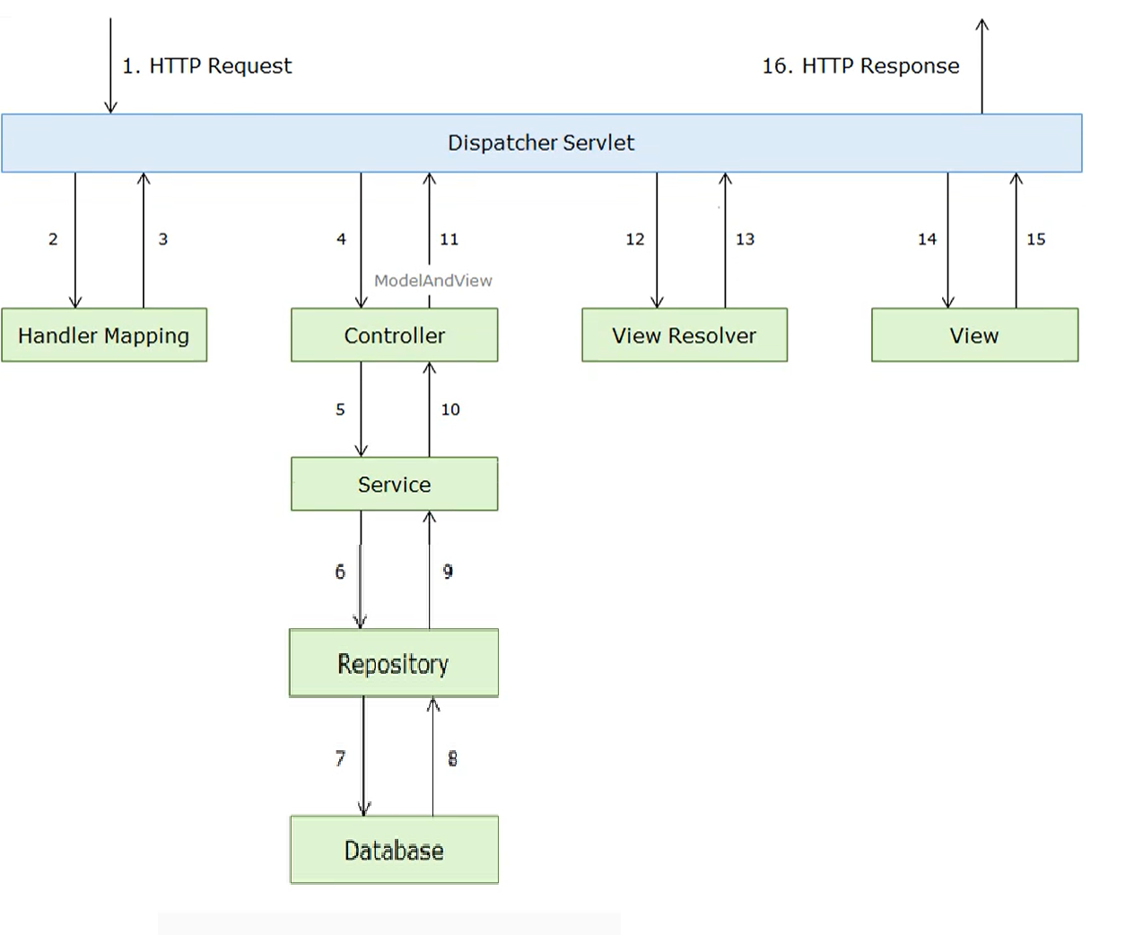

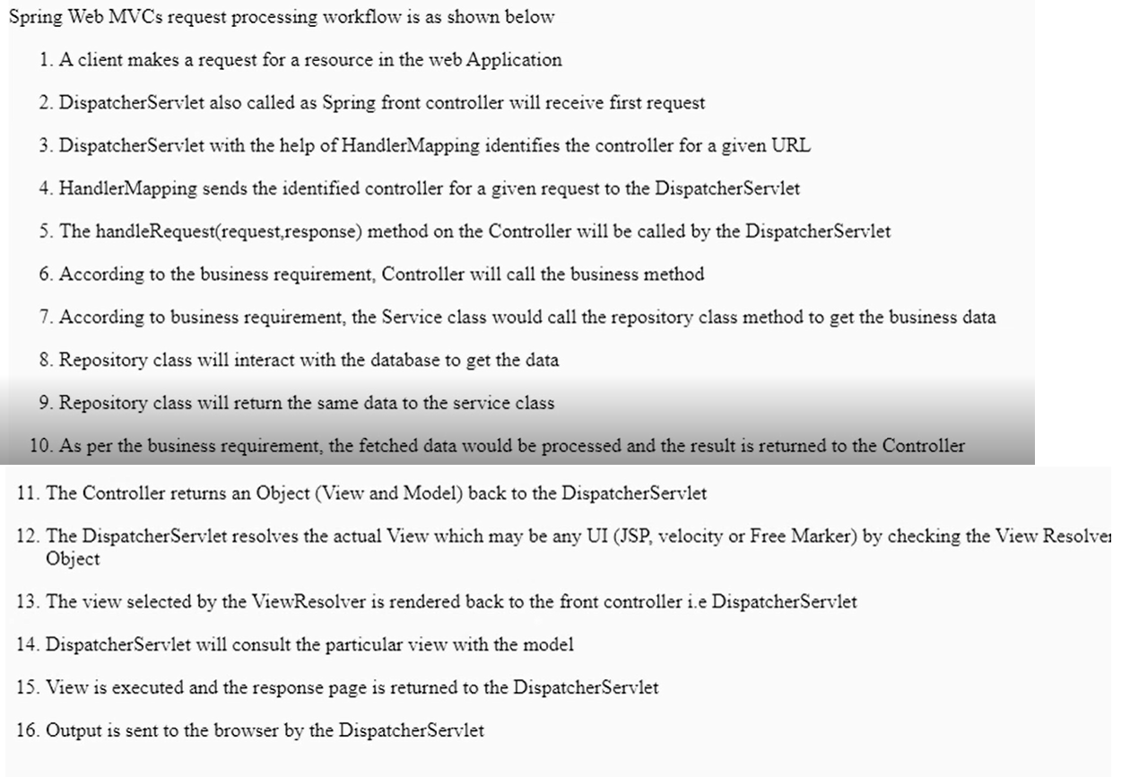

### **@RequestMapping**

**This annotation is used both at class and method level. The @RequestMapping annotation is used to map web requests onto specific handler classes and handler methods.** When @RequestMapping is used on class level it creates a base URI for which the controller will be used. When this annotation is used on methods it will give you the URI on which the handler methods will be executed. From this you can infer that the class level request mapping will remain the same whereas each handler method will have their own request mapping. Sometimes you may want to perform different operations based on the HTTP method used, even though the request URI may remain the same. In such situations, you can use the methodattribute of @RequestMapping with an HTTP method value to narrow down the HTTP methods in order to invoke the methods of your class.

**@RequestMapping(“myapp”)**

**@RequestMapping(value = "editsave", method = RequestMethod.*POST*)**

## **Composed @RequestMapping Variants**

Spring framework 4.3 introduced the following method-level new variants of @RequestMapping it means for example we don’t need to use like this @RequestMapping(value = "save**", method = RequestMethod.POST**) we can directly use **@PostMapping(save)**

**@GetMapping**

This annotation is used for mapping HTTP GET requests onto specific handler methods. @GetMapping is a composed annotation that acts as a shortcut for @RequestMapping(method = RequestMethod.GET)

### **@PostMapping**

This annotation is used for mapping HTTP POST requests onto specific handler methods. @PostMapping is a composed annotation that acts as a shortcut for @RequestMapping(method = RequestMethod.POST)

### **@PutMapping**

This annotation is used for mapping HTTP PUT requests onto specific handler methods. @PutMapping is a composed annotation that acts as a shortcut for @RequestMapping(method = RequestMethod.PUT)

### **@DeleteMapping**

This annotation is used for mapping HTTP DELETE requests onto specific handler methods. @DeleteMapping is a composed annotation that acts as a shortcut for @RequestMapping(method = RequestMethod.DELETE)

**When a user submit form data JSP how will you get that data in your controller or Explain about data binding in spring MVC ?**

**@ModelAttribute**

**Whenever we submit form data in a JSP, we can bind that form data with our bean (object) in our controller class by using @ModelAttribute.**

**@PostMapping("save")**

**public String saveuser(@ModelAttribute("user") User user) {**

**userService.saveUser(user);**

**}**

**How will you send data(model) from Controller to JSP ?**

**We can set data and send it to JSP in Three Ways**

* **Model**
* **ModelAndView**
* **ModelMap**

1. **Model**

**@GetMapping("tejatest")**

**public String tejatest(Model m) {**

**m.addAttribute("tejakey", "hello teja");**

**m.addAttribute("naikkey", "hello naik");**

**return "test"; // test is the JSP Page**

**}**

**m.addAttribute is a method in which we are passing key and value here tejakey is a key which we will be using in JSP to retrieve the value.**

**Here we are passing the value of string type in the same way you can pass any Object like user object or List of user objects etc…**

**NOTE: in JSP page to retrieve value we should use key like this ${sampleKEY}**

<body>

<h1> ${tejakey}</h1>

<h1> ${naikkey}</h1>

</body>

**@RequestMapping(value = "/dummyuser")**

**public String dummyuser(Model m) {**

**User user = userService.getUserById(100);**

**m.addAttribute("userkey", user);**

**return "dummyuserpage";**

**}**

**Here we are getting one User Object from data-base and we are setting key and value to model object, to display that model object in Jsp we need to use the key and property name here key is userkey and property are email and name**

**Note: properties in POJO and JSP must be same**

**<body>**

**<h1> ${userkey.name}</h1> // to retrieve a property value of a object with key**

**<h1> ${userkey.email}</h1>**

**</body>**

**@RequestMapping(value = "/getuserbyid/{id}")**

**public String getUserById(@PathVariable int id, Model m) {**

**User user = userService.getUserById(id);**

**m.addAttribute("command", user);**

**return "usereditform";**

**}**

**Here if we use command as key and value as a POJO Object and if the POJO Object properties and JSP form properties are same then our POJO Object data will Bind automatically in the form data. Command is default keyword used by spring.**

**Note: we can do this type of automatic Object to JSP binding with only form data**

<h1>Edit User</h1>

<form:form method=*"post"* action=*"/firstapp/editsave"*>

<table >

<tr>

<td></td>

<td><form:hidden path=*"id"* /></td>

</tr>

<tr>

<td>Name : </td>

<td><form:input path=*"name"* /></td>

</tr>

<tr>

<td>password :</td>

<td><form:input path=*"password"* /></td>

</tr>

<tr>

<td>Email :</td>

<td><form:input path=*"email"* /></td>

</tr>

<tr>

<td>Country :</td>

<td><form:input path=*"country"* /></td>

</tr>

<tr>

<td> </td>

<td><input type=*"submit"* value=*"Save"* /></td>

</tr>

</table>

</form:form>

**If we want to Show List of users in JSP use below**

**@GetMapping("viewuser")**

**public String viewuser(Model m) {**

**List<User> userlist = userService.getusers();**

**m.addAttribute("list", userlist);**

**return "viewuser";**

**}**

**Here list is key and userlist is list of Objects we can retrieve this list of objects by using key and we can iterate on jsp page**

<h1>User List</h1>

<table border=*"2"* width=*"70%"* cellpadding=*"2"*>

<tr><th>Id</th><th>Name</th><th>Password</th><th>Email</th><th>Country</th><th>Edit</th><th>Delete</th><th>EditByQueryParam</th></tr>

<c:forEach var=*"user"* items=*"*${list}*"*>

<tr>

<td>${user.id}</td>

<td>${user.name}</td>

<td>${user.password}</td>

<td>${user.email}</td>

<td>${user.country}</td>

<td><a href=*"edituser/*${user.id}*"*>Edit</a></td>

<td><a href=*"deleteuser/*${user.id}*"*>Delete</a></td>

<td><a href=*"editqueryuser?id=*${user.id}*"*>EditByQueryParam</a></td>

</tr>

</c:forEach>

</table>

ModelAndView:

In regular normal way we just set model data and return view as string but ,we can do same in another way by using modelandview object here we can set our object data by using addObject method and we can set our view by using setviewname method and we can return modelandview Object

**@GetMapping("testmodelview")**

**public ModelAndView testmodelview() {**

**ModelAndView mv=new ModelAndView();**

**mv.addObject("cmd", "hello this is a modelAndView Test page" );**

**mv.setViewName("test"); // test is JSP Page**

**return mv;**

**}**

**ModelMap:**

Another way of setting data by using ModelMap

@GetMapping("tejatest")

**public** String tejatest(**ModelMap** m) {

m.addAttribute("tejakey", "helloteja");

m.addAttribute("naikkey", "hello naik");

**return** "test";

}

**@PathVariable:**

we use @PathVariable annotation to extract specific values from a URI.

**Example: http://localhost:8080/myflightapp/getflightby/hyd/knl/25-05-2021**

**@GetMapping("getflightby/{source}/{destination}/{journeyDate}”)**

**public String searchFlights(@PathVariable String source,**

**@PathVariable String destination, @PathVariable String journeyDate) {**

**FlightbyrequestService(source,destination,journeydate); return “flightpage” }**

**@RequestParam**

**@RequestParam to extract query parameters, form the request url.**

**http://localhost:8080/redbus/getBusByBusNo?busno=8755&name=garuda**

**@GetMapping("getBusByNo")**

**public String getBusByIdName(@RequestParam String busno, @RequestParam String name) {**

**System.*out*.println(id +" "+ name);**

**return "testing sucess check your console";**

**}**

**If I want to get all buses of name garuda ,indra and express how will you write a url ? and how can you accept the multiple query parameters of same type variable ?**

<http://localhost:8080/firstapp/getbus?name=indra&garuda&express>

**or we can write like this as we have same variable name for all three**

<http://localhost:8080/firstapp/getbus?name=indra,garuda,express>

**Here we can say we are sending list or array of values in query parameters so in controller also when we write we need to add List or array of string type to accept multiple value of same variable name**

**@GetMapping("getbus")**

**public String getBusByNames(@RequestParam List<String> name) {**

**for(String busname:name) {**

**System.*out*.println(busname);**

**Return “busview”**

**}**

**Can we write url with combination of path variables and query param ?**

**Yes we can write**

<http://localhost:8080/firstapp/getbus/1025?name=hyd>

@GetMapping("getbus**/{busno}")**

**public String getBusById(@PathVariable String busno, @RequestParam String name) {**

**System.*out*.println(busno +" "+ name);**

**return "testing sucess check your console"; }**

# ViewResolver:

# ViewResolver helps to resolve logical view names with actual view names (example: here logical name is like home and actual view name is home.jsp).

# Why do we need to use viewresolver: view resolver helps us to use any view technology, with out changing the code in controllers. if in case we change the view technology in future just in xml.

# Spring provides view resolvers, which enable you to render models in a browser without tying you to a specific view technology. Out of the box, Spring enables you to use JSPs, Velocity templates and XSLT views,

**ViewResolver is an interface it has many implementations we use InternalResourceViewReolver with JSPs**

<!-- Resolves views selected for rendering by @Controllers to .jsp resources

in the /WEB-INF/views directory -->

**<bean class=*"org.springframework.web.servlet.view.InternalResourceViewResolver"*>**

**<property name=*"viewClass"* value=*"org.springframework.web.servlet.view.JstlView"*/>**

**<property name=*"prefix"* value=*"/WEB-INF/views/"* />**

**<property name=*"suffix"* value=*".jsp"* />**

**</bean>**

**Here we are giving prefix as path where all the JSP files are available and suffix as the extension of the file**

**File-Upload :**

File Upload is a common task, which we will be doing in Servlets or Spring MVC or Restful webservice. Here we will look in to Basic’s how to handle a file-upload task.

Spring uses MultipartResolver interface to handle the file uploads in web application, which is responsible for resolving multipart request(File Upload Request) , There are Two implementation for MultipartResolver  :.

1. CommonsMultipartResolver – commons-fileupload.jar
2. StandardServletMultipartResolver – Servlet 3.0 multipart request parsing.

We use CommonsMultipartResolver

First Step is we need to download commons-fileupload.jar dependency by using maven

<!-- https://mvnrepository.com/artifact/commons-fileupload/commons-fileupload -->

<dependency>

<groupId>commons-fileupload</groupId>

<artifactId>commons-fileupload</artifactId>

<version>1.3.3</version>

</dependency>

Step 2: we need to create a Bean for CommonsMultipartResolver in Spring-Configuration file (spring-servelt.xml) we can set some of the properties to the like maxupload file size limit and min size etc…

We can also configure same by using java configuration also

**XML Based Configuration**

<bean id=*"multipartResolver"*

class=*"org.springframework.web.multipart.commons.CommonsMultipartResolver"*>

<!-- max upload size in bytes -->

<property name=*"maxUploadSize"* value=*"20971520"* /> <!-- 20MB -->

<!-- max size of file in memory (in bytes) -->

<property name=*"maxInMemorySize"* value=*"1048576"* /> <!-- 1MB -->

</bean>

**Java Based configuration**

**@Bean**(name = "multipartResolver")

public CommonsMultipartResolver multipartResolver() {

CommonsMultipartResolver multipartResolver = new CommonsMultipartResolver();

multipartResolver.setMaxUploadSize(20971520);

return multipartResolver;

}

**Step 3:** We need to create a handler method of post type which accepts the file parameters as MultipartFile (File upload is MultipartFile type so we need use either MultipartFile interface or CommonsMultipartFile Object type to accept the file)

Here in the below we are using Array of commonsMultpartFile because we are trying to upload multiple files

**public String handleFileUpload( @RequestParam CommonsMultipartFile[] fileUpload) throws Exception {**

**if (fileUpload != null && fileUpload.length > 0) {**

**for (CommonsMultipartFile aFile : fileUpload){**

**System.*out*.println("Saving file: " + aFile.getOriginalFilename());**

**if (!aFile.getOriginalFilename().equals("")) {**

**aFile.transferTo(new File(saveDirectory + aFile.getOriginalFilename()));**

**}**

**}**

**}**

**// returns to the view "Result"**

**return "Result";**

**}**

**Step :4**

**Create a JSP file as below**

<center>

<h1>Spring MVC File Upload Demo</h1>

<form method=*"post"* action=*"uploadFile"* enctype=*"multipart/form-data"*>

<table border=*"0"*>

<tr>

<td>Description:</td>

<td><input type=*"text"* name=*"description"* size=*"50"*/></td>

</tr>

<tr>

<td>Pick file #1:</td>

<td><input type=*"file"* name=*"fileUpload"* size=*"50"* /></td>

</tr>

<tr>

<td>Pick file #2:</td>

<td><input type=*"file"* name=*"fileUpload"* size=*"50"* /></td>

</tr>

<tr>

<td colspan=*"2"* align=*"center"*><input type=*"submit"* value=*"Upload"* /></td>

</tr>

</table>

</form>

</center>

**Spring MVC Exception Handling**

Why do we need exception handling in spring MVC? In web application like Spring MVC when ever we get any exception by default exception will be throw‘n to server directly then server will give us 500 server error page as response with lot of exception information like exception stack trace information which cannot be understand by the user. So to make user to understand the situation we need to give a proper response page with appropriate information like reason for the exception and other information like support team information like contact details and any message which we want to show a user.

We can Handle exception controller based (each controller) or we can also handle exception globally (for all the controller’s)

1. **Controller Based** – We can define exception handler methods in our controller classes. All we need is to annotate this method with @ExceptionHandler annotation. This annotation takes Exception class as argument. So if we define one exception handler in a class ,it can handle all the exceptions that occur for all the request’s in that controller class only.

These exception handler methods are just like other request handler methods and we can create a error response object and send response to different error page.

**@ExceptionHandler(Exception.class)**

**public String MyExcpetionHandler(Exception ex,Model m) {**

**ErrorDetails errorDetails = new ErrorDetails(new Date(), ex.getMessage(), "500"); m.addAttribute("errorDetails",errorDetails);**

**return "error";**

**}**

Spring configuration will detect @ExceptionHandler this annotation and register the method as exception handler for **argument exception class and its subclasses**.

**when ever we get any exception in a particular controller spring will call exceptionhandler method then we will create our custom error object and we will set that to model and we will return our custom error page as response.**

1. **Global Exception Handler** –

Instead of handling exceptions on each controller we can handle exceptions globally for entire application by using annotation @ControllerAdvice , we need to create a class and on top of that class we need to use @ContollerAdice annotation and then we need to create a exceptionhandler method with annotation as **@ExceptionHandler(Exception.class)**

So when ever we get any exception in any class spring will directly call the exceptionhanlder method of a class annotated with @ControllerAdvice  .

Just create a new class and add @ControllerAdvice  annotation on top of class and use same above exceptionhanlder code.

We can also Handle 404 page not found error with our custom error page with appropriate message.

We need to add below code in web.xml so that when server get 404 error it will redirect to our error jsp page

<error-page>

<error-code>404</error-code>

<location>/WEB-INF/views/error.jsp</location>

</error-page>

# Web Services

* A web service is any piece of code or software that makes itself available over the internet and uses a standardized JSON or XML format data exchange between two systems or applications. Because xml or Json can be understandable by any programming language for example, a client invokes a web service by calling RESTAPI URL , then waits for a corresponding JSON or XML response. All the communication is in webservices are by using JSON or XML, web services provide interoperability it means it is not tied to any one programming language one application developed in one language can communicate with any other application developed in any language Java can talk with PHP or .NET Python etc…
* Use cases of webservices
* **Case 1:** I want to develop a beautiful application with very good UI(user-interface ) front-end screen, but we cannot do this with just JSP or HTMLwe may required some other front end technologies like AngularJS which will be used to develop only UI-frontend screens, but angular is just a frontend application which will show view on screen , it cannot perform any business logics. In this case we will develop a Restful application RestAPI which will give JSON data when we call a URL , so Angular(front-end) application will call that Restapi url and it will get JSON data , that JSON data will be shown in screen with angular as they want.
* **Case 2:** I want to develop a Web application which shows weather report based on location, for this if we want to track weather report we need sensors or some equipment like satellite to get temperature humidity etc.. but I cannot invest huge amount on this hardware. Solution for this is in this case we may have a big company like Google or some service provider where he can setup all the hardware or equipment to get all the weather information and store in his database in real-time like every min. We can pay some amount to the service provider to get weather information, but he will not give direct access to the database he will create a RestAPI(Producer application) which will give you only required information from his data base, he will just give you an **URL** , when we call that URL from our Restful application(Consumer) we will get required information in JSON format.
* **Case 3:** if you want to develop a application like Flipkart which should work on all platforms like web application, Android application, IOS, we cannot write our business logic separately for all three platforms so we will create a RESTAPI application which will expose a URL with this URL all the android or web applications, IOS can communicate and exchange only JSON data.
* **CASE 4:** if you want to book a bus ticket with redbus you can book private travel’s and also different RTC buses like APSRTC or TSRTC, here RedBUS is a different application and RTC is different application. If you want to get all RTC bus information from redbus you cannot access directly RTC bus application, redbus first need to contact RTC, like we need your application services to display and book rtc ticket’s through redbus app. Then RTC people will give their RESTAPI information like call this url to display bus information, use this url to book tickets.

Types of Web Services

There are mainly two types of web services.

1. SOAP web services. (it is Purely XML Based and legacy)
2. RESTful web services. (we can use JSON/XML it is latest)

## Java Web Services API

There are two main API's Specifications(interfaces) defined by Java JavaEE 6.

) **JAX-WS**: for SOAP web services. The are two ways to write JAX-WS application code: by RPC style and Document style. (XML based)

2) **JAX-RS**: for RESTful web services. There are mainly 2 implementations currently in use for creating JAX-RS application: **Jersey and RESTeasy.**

**Spring has its own implementation for Webservices**

**We use Spring-Restful webservices to create RESTful API.**

In general to develop a web-application we use spring framework, we can use same process to develop RESTAPI also, in normal Spring MVC application we will be having a VIEW page(JSP pages) but in RESTAPI we will not have any View pages we will just return JSON data, so to convert our JAVA Object’s into Json format we need some library like **jackson-databind ,** and we need to put some spring annotations like @responsebody along with request mapping url so that spring can identify to send the data back in JSON format in response. Later in new versions spring we use @RestContoller instead of @responsebody ,we can just use @RestContoller on top of the class, it indicates all the request will be converted into json.

**@responsebody:** response body annotation will tell spring framework to convert our Java object to JSON and send response in JSON format.

**@RestContoller is Combination of @Contoller+@RespnseBody annotations**

**@RequestBody:** @RequestBody, Spring will bind the incoming HTTP request body (JSON/XML data) to the method parameter. (In a simple word it just converts JSON data to Java Object and binds to our method parameter)

@PostMapping("saverest")

**public**String **saverest(@RequestBody User u)**.

While doing that, Spring will [behind the scenes] use HTTP Message converters to convert the HTTP request body JSON or XML data in to JAVA domain object based on **Accept** header present in request. Accept header means request type either JSON or XML type. Spring required JACKSON-DATA-BIND library to convert java object to JSON or vice versa.

**Restful webservice’s VS Spring MVC :** In spring MVC we will send(post) form data in JSP from, but in case of webservice we will be sending (post) data in JSON or XML format through some external application(angular) or postman tool. In Spring MVC we will get JSP page as response but in case of webservice we will get JSON data as response. Request and response flow will be same as spring MVC, but in webservice we don’t required view resolver as we are not having any views(JSP) in webservice, in Spring MVC we will be returning view(JSP) Pages. We can do all the tasks what ever we did in spring MVC with restful webservices but only difference will be we will be not having view pages in webservice’s.

In webservice terminology we will call a handler method **as resource or rest-end point or rest**

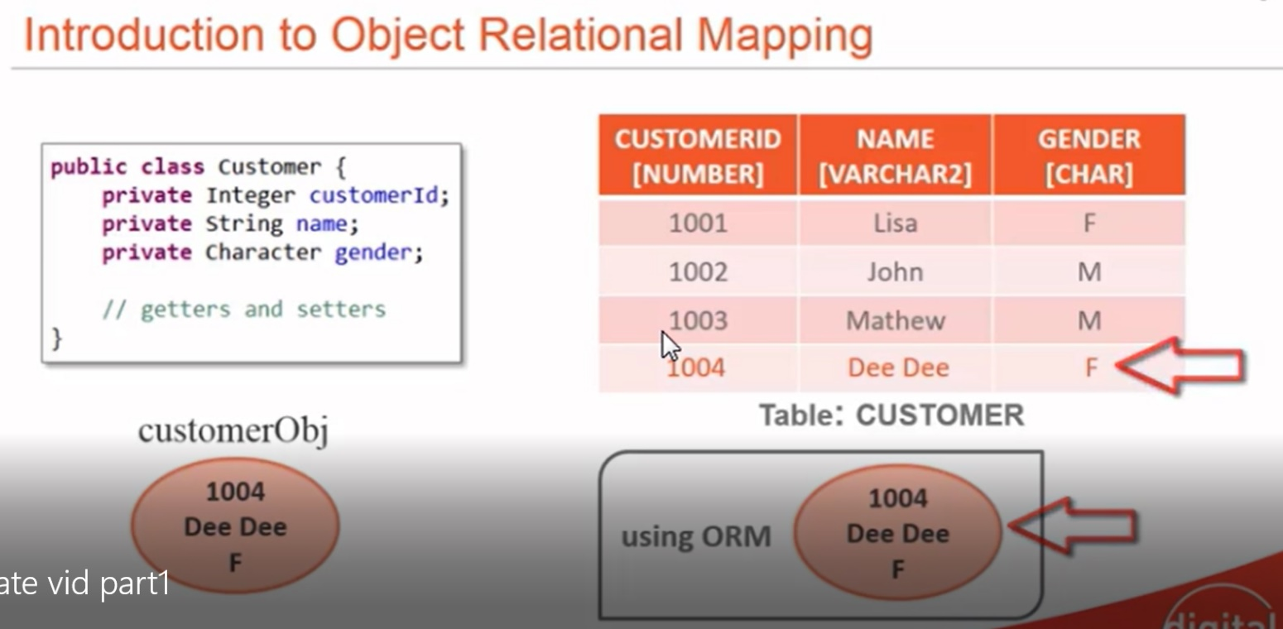

What is ORM?

ORM stands for **O**bject-**R**elational **M**apping (ORM) is a programming technique for converting(mapping) data between object oriented programming languages such as Java and relational databases. **(Mapping java Objects to database, to store in database)**

# What is JPA

The Java Persistence API (JPA) **is a specification of Java. It is used to persist data** between Java object and relational database. JPA acts as a bridge between object-oriented domain models and relational database systems.

As JPA is just a specification, it doesn't perform any operation by itself. It requires an implementation. So, ORM tools like Hibernate, TopLink and iBatis implements JPA specifications for data persistence.

## Hibernate Framework

Hibernate is a Java framework that simplifies the development of Java application to interact with the database. It is an open source, lightweight, **ORM (Object Relational Mapping) tool. Hibernate implements the specifications of JPA** (Java Persistence API) for data persistence.

## Advantages of Hibernate Framework

### **1) Open Source and Lightweight**

Hibernate framework is open source under the LGPL license and lightweight.

### **2) Fast Performance**

The performance of hibernate framework is fast because cache is internally used in hibernate framework. There are two types of cache in hibernate framework first level cache and second level cache. First level cache is enabled by default.

### **3) Database Independent Query**

HQL (Hibernate Query Language) is the object-oriented version of SQL. It generates the database independent queries. So you don't need to write database specific queries. Before Hibernate, if database is changed for the project, we need to change the SQL query as well that leads to the maintenance problem.

### **4) Automatic Table Creation**

Hibernate framework provides the facility to create the tables of the database automatically. So there is no need to create tables in the database manually.

### **5) Simplifies Complex Join**

Fetching data from multiple tables is easy in hibernate framework.

### **6) Provides Query Statistics and Database Status**

Hibernate supports Query cache and provide statistics about query and database status.

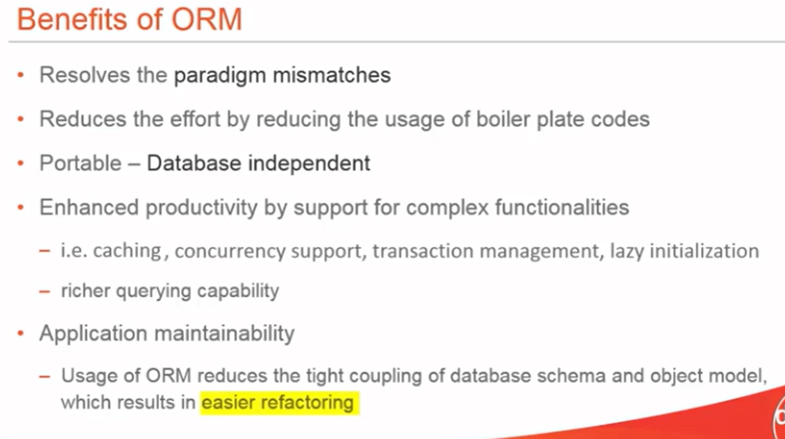

## JDBC vs Hibernate

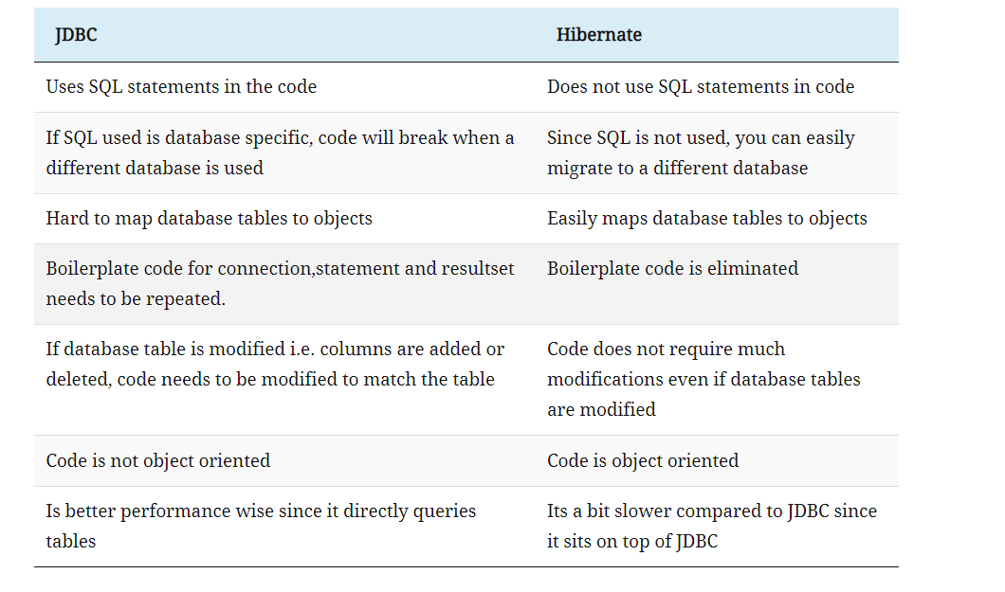

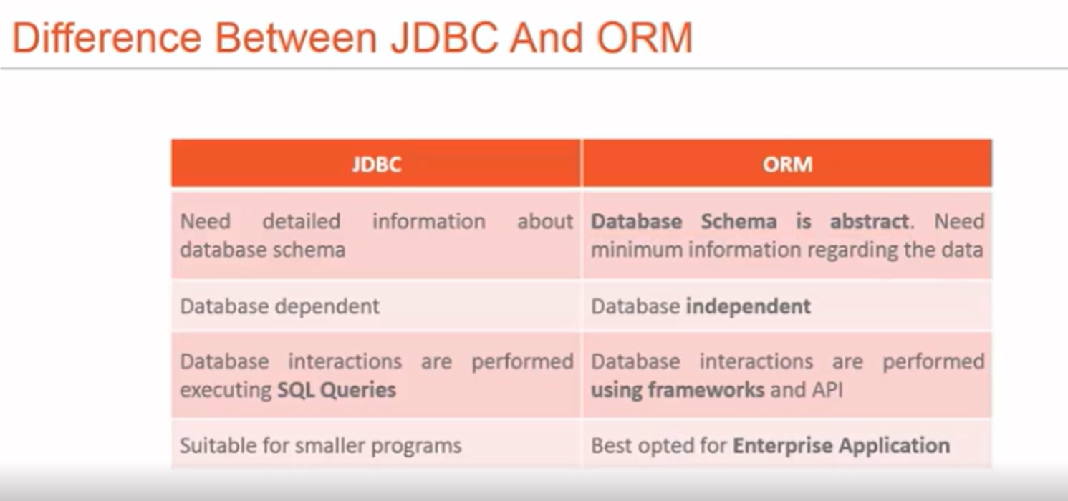

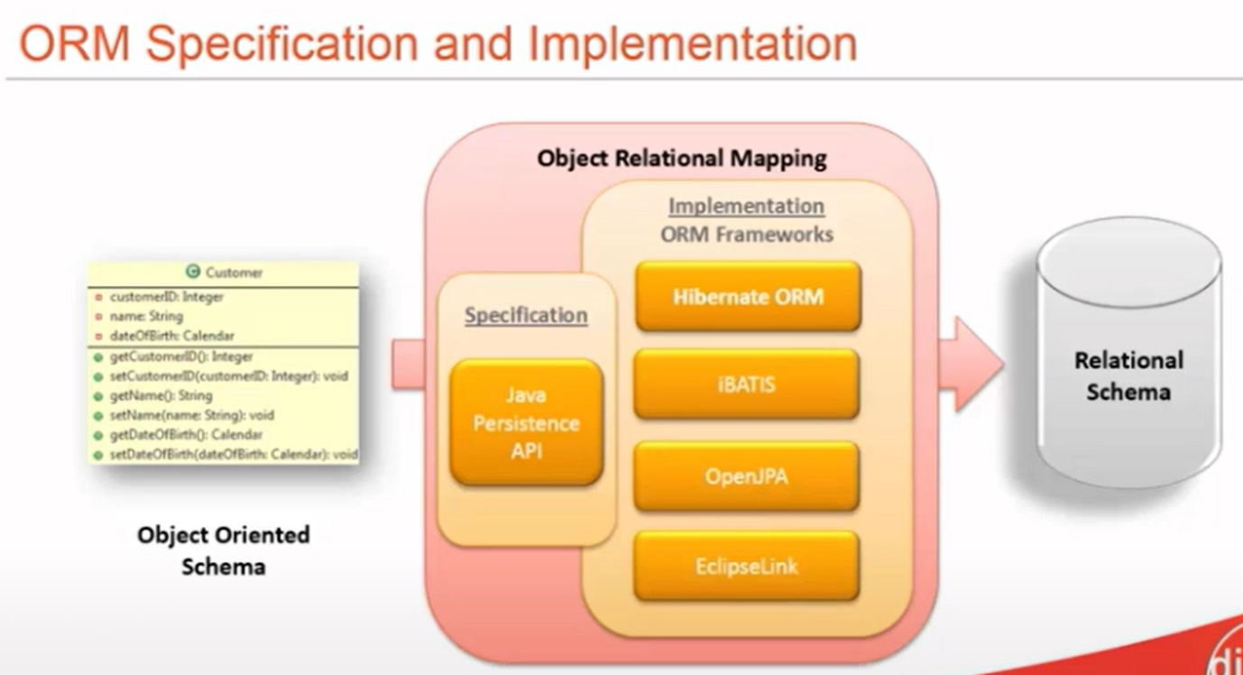

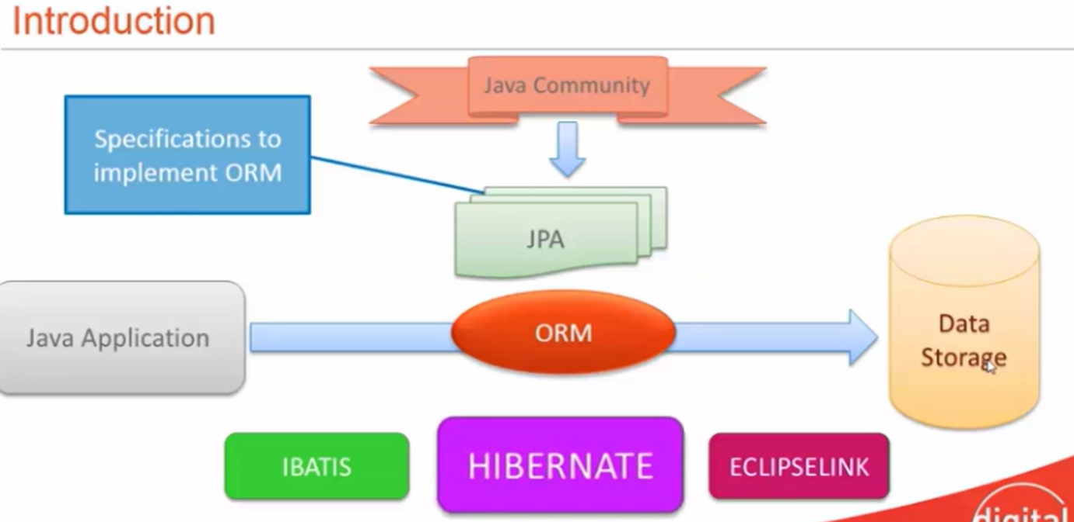

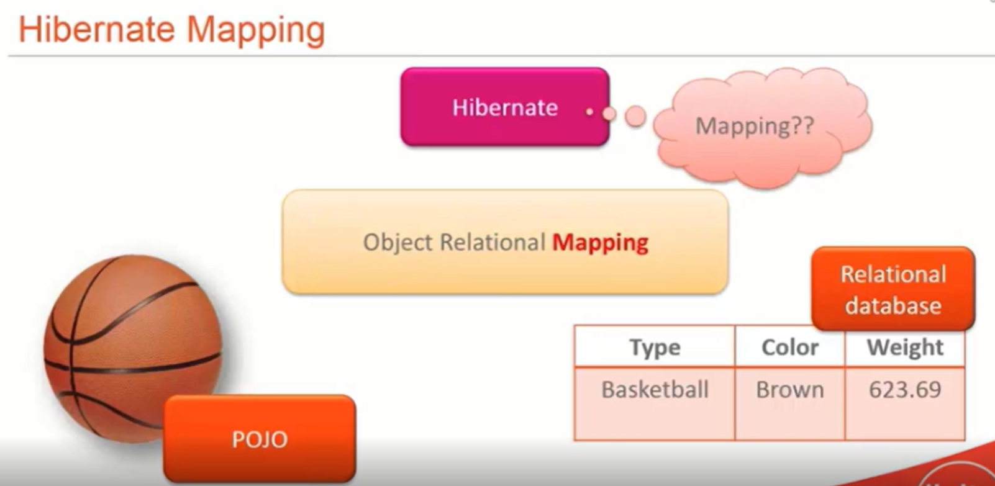

# Hibernate Architecture

The Hibernate architecture includes many objects such as persistent object, session factory, transaction factory, connection factory, session, transaction etc.

The Hibernate architecture is categorized in four layers.

* Java application layer (our java code)
* Hibernate framework layer (hibernate-jar’s)
* Backend api layer (JDBC, JNDI,JTA)-hibernate internally uses this concepts
* Database layer- (our database like mysql)
* 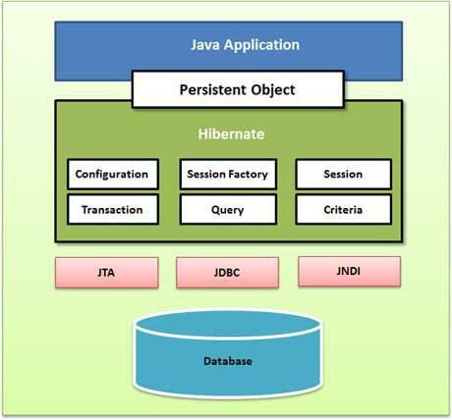

## Elements of Hibernate Architecture

## Configuration Object

The Configuration object is the first Hibernate object you create in any Hibernate application. It is usually created only once during application initialization. It represents a configuration or properties file required by the Hibernate.

Configuration cf=**new** Configuration().configure("hibernate.cfg.xml");

The Configuration object provides two keys components −

* **Database Connection** − This is handled through one or more configuration files supported by Hibernate. These files are **hibernate.properties and hibernate.cfg.xml.**
* **Class Mapping Setup(Entity class) or hbm,xml** − This component creates the connection between the Java classes and database tables.

## SessionFactory Object

Configuration object is used to create a SessionFactory object which in turn configures Hibernate for the application using the supplied configuration file and allows for a Session object to be instantiated. **The SessionFactory is a thread safe object and used by all the threads of an application.**

The SessionFactory is a heavyweight object; it is usually created during application start up and kept for later use. You would need one SessionFactory object per database using a separate configuration file. **So, if you are using multiple databases, then you would have to create multiple SessionFactory objects**.

## Session Object

A Session is used to get a physical connection with a database. The Session object is lightweight and designed to be instantiated each time an interaction is needed with the database. **Persistent objects are saved and retrieved through a Session object**.

The session objects should not be kept open for a long time because they are usually **not thread safe** and they should be created and destroyed them as needed.

## Transaction Object

A Transaction represents a unit of work with the database and most of the RDBMS supports transaction functionality. Transactions in Hibernate are handled by an underlying transaction manager and transaction (from JDBC or JTA).

This is an optional object and Hibernate applications may choose not to use this interface, instead managing transactions in their own application code.

## Query Object

Query objects use SQL or Hibernate Query Language (HQL) string to retrieve data from the database and create objects. A Query instance is used to bind query parameters, limit the number of results returned by the query, and finally to execute the query.

## Criteria Object

Criteria objects are used to create and execute object oriented criteria queries to retrieve objects.

**How to Configure Hibernate configuration to connect from a core java app to data base?**

We can configure in two ways by using java configuration or by using xml (hibernate.cfg.xml). Best way is by using xml, because if we use java-based configuration in future if we change database, then we need to change code which is not a good practice.

* Below is sample hibernate.cfg.xml

<?xml version=*"1.0"* encoding=*"UTF-8"*?>

<!DOCTYPE hibernate-configuration PUBLIC

"-//Hibernate/Hibernate Configuration DTD 3.0//EN"

"http://hibernate.sourceforge.net/hibernate-configuration-3.0.dtd">

<hibernate-configuration>

**<session-factory>**

<property name=*"hibernate.connection.driver\_class"*>com.mysql.jdbc.Driver</property>

<property name=*"hibernate.connection.url"*>jdbc:mysql://localhost:3306/my\_java</property>

<property name=*"hibernate.connection.username"*>root</property>

<property name=*"hibernate.connection.password"*>root</property>

<property name=*"show\_sql"*>true</property>

<property name=*"dialect"*>org.hibernate.dialect.MySQLDialect</property>

<property name=*"hibernate.hbm2ddl.auto"*>update</property>

<mapping class=*"hibpjo.person"*/>

<mapping class=*"hibpjo.passport"*/>

<mapping class=*"hibpjo.mobile"*/>

**</session-factory>**

* </hibernate-configuration>

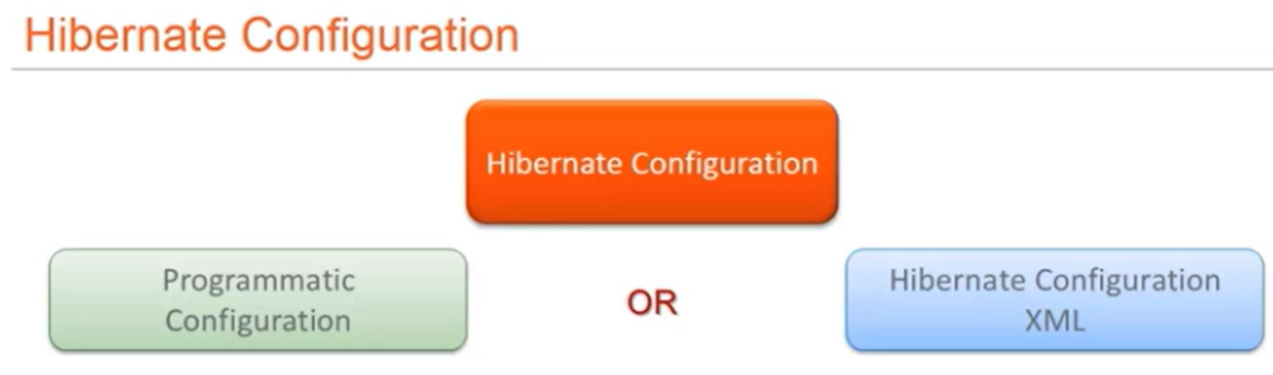

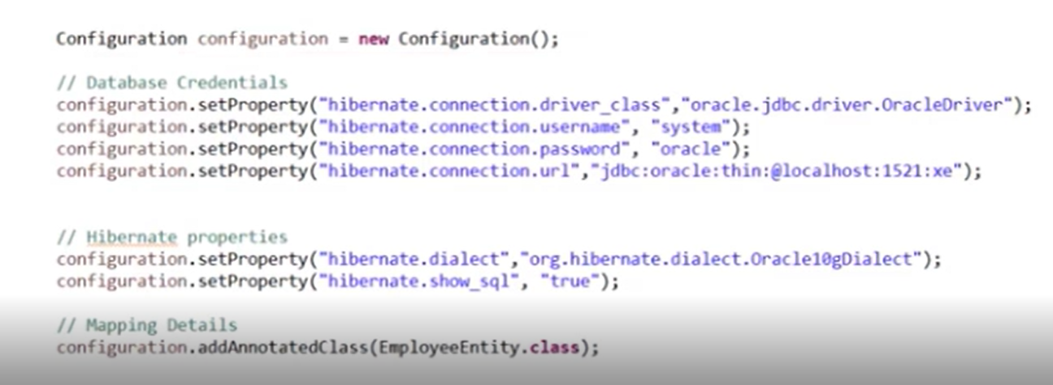

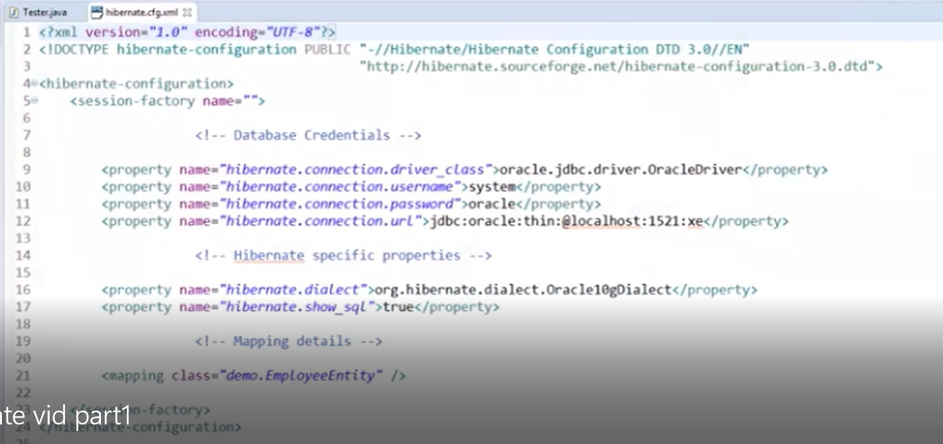

**hibernate.dialect:**

<property name=*"dialect"*>org.hibernate.dialect.MySQLDialect</property>

* This property makes Hibernate to generate the appropriate SQL Queries for the user specific database. Dialect value will be different for each database.

**hbm2ddl.auto:**

<property name=*"hibernate.hbm2ddl.auto"*>update</property>

hbm2ddl.auto–>create -Always create new schema

hbm2ddl.auto–>update -Update existing schema

**list of possible options are,**

* ***validate*:** validate the schema, makes no changes to the database.
* ***update***: update the schema.
* ***create*:** creates the schema, destroying previous data.
* ***create-drop*:** drop the schema when the SessionFactory is closed explicitly, typically when the application is stopped.
* ***none*:** does nothing with the schema, makes no changes to the database

**Show\_sql:**

<property name=*"show\_sql"*>true</property>

If we make show\_sql property as true it will show all the hibernate gernated queries in console or log file

Mapping Information:

<mapping class=*"hibpjo.person"*/>

We can do mapping in two ways

1. By using hbm.xml(hibernate mapping xml)

2.By Using annotations of javax.persistence package

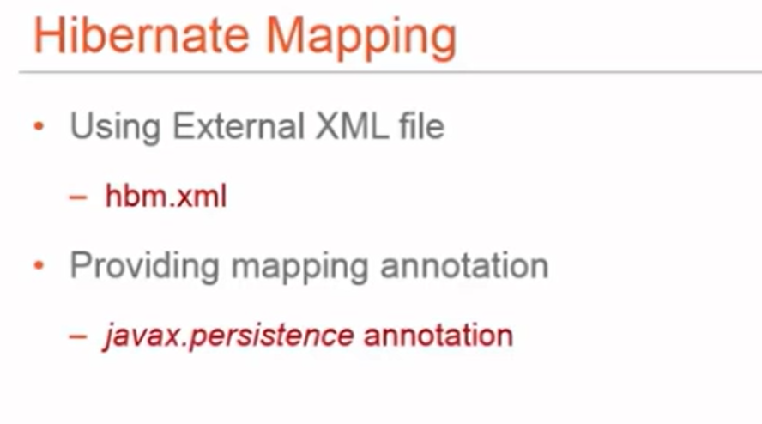

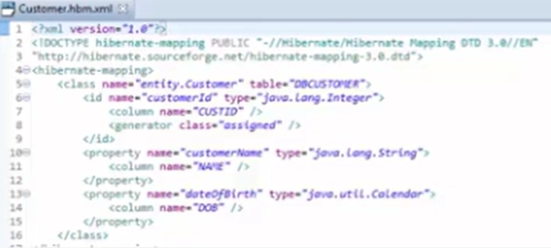

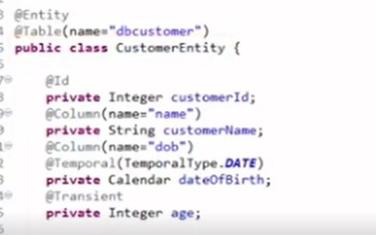

**@Entity** annotation marks this class as an entity.

Entities are nothing but POJOs representing data that can be persisted to the database.Every instance of an entity represents a row in the table.

**@Table** annotation specifies the table name where data of this entity is to be persisted. If you don't use @Table annotation, hibernate will use the class name as the table name by default.

@Table(name="STUDENT")

**@Id** annotation **marks the property as unique identifier** for this entity.

Entity must have a primary key which uniquely identifies it. [The @Id annotation](https://www.baeldung.com/hibernate-identifiers) defines the primary key. We can generate the identifiers in different ways which are specified by the @GeneratedValue annotation.

We can choose from four id generation strategies with the strategy element. The value can be AUTO, TABLE, SEQUENCE, or IDENTITY.

@Id

@GeneratedValue(strategy=GenerationType.AUTO)

**private** Long id;

If we specify GenerationType.AUTO, the JPA provider will use any strategy it wants to generate the identifiers.

JPA offers 4 different ways to generate primary key values:

1. *GenerationType.AUTO*: Hibernate selects the generation strategy based on the used dialect,
2. *GenerationType.IDENTITY*: Hibernate relies on an auto-incremented database column to generate the primary key,
3. *GenerationType.SEQUENCE*: Hibernate requests the primary key value from a database sequence,
4. *GenerationType.TABLE*: Hibernate uses a database table to simulate a sequence.

**@Column** annotation specifies the details of the database column for this property or field (**mapping java property as database column**). If @Column annotation is not specified, property name will be used as the column name by default.

**@Temporal** is a JPA annotation and generally specified only for persistent fields or properties of type java.util.Date and java.util.Calendar. Generally you use @Temporal annotation on the date or calendar field in entity class when you want to map date or time type of property to database specific sql type of data & time. If we use Hibernate 5 above versions @Temporal annotation is not required.

**@TRANSIENT** ANNOTATION IN JPA OR HIBERNATE IS USED TO INDICATE THAT A FIELD IS NOT TO BE PERSISTED OR IGNORE FIELDS TO SAVE IN THE DATABASE.  @TRANSIENT EXIST IN JAVAX.PERSISTENCE PACKAGE.

**In general, transient keyword use in core java**

**transient** is a variables modifier used in [serialization](http://quiz.geeksforgeeks.org/serialization-in-java/). At the time of serialization, if we don’t want to save value of a particular variable in a file or data base or network, then we use **transient** keyword. When JVM comes across **transient**keyword, it ignores original value of the variable and save default value of that variable data type.

// Making password transient for security

**private transient String password;**

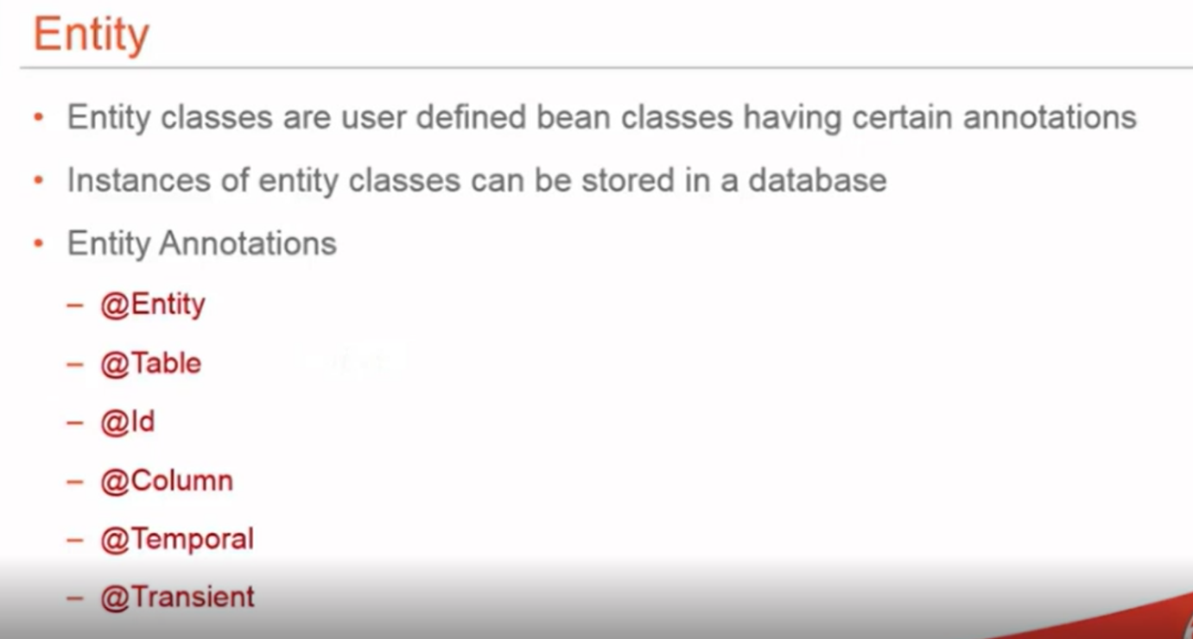

**Difference b/w entity class and pojo class ?**

Entity class is nothing but a normal pojo class which will be marked with @entity annotation and some other annotations like @table @column @id etc.. we will use entity class to persist and retrieve data from database.

Pojo class is nothing but which contains private properties or fields with public setters and getter methods. We use pojo class to set and get data and transfer pojo objects from one layer to other layer like from controller to service and repository etc… pojo class’s are also know as DTO (Data transfer objects ) or model class or bean class

**@entity annotaion will be present in which package ? why you use @entity annotation from javax.persistnce instead of hibernate package**

@entity,@table @column and all the annotations which we use in entity class should be from javax.persistence package , Because if we use these annotations from hibernate package in future if we change from hibernate to some other orm tool like toplink we need to change annotations again from hibernate to toplink , so to avoid this kind of issues we use JPA specific annotations as we know JPA is specification just like interface we can we JPA specific annotations which will be supported by all other orm implementations implemented by any other vendors.

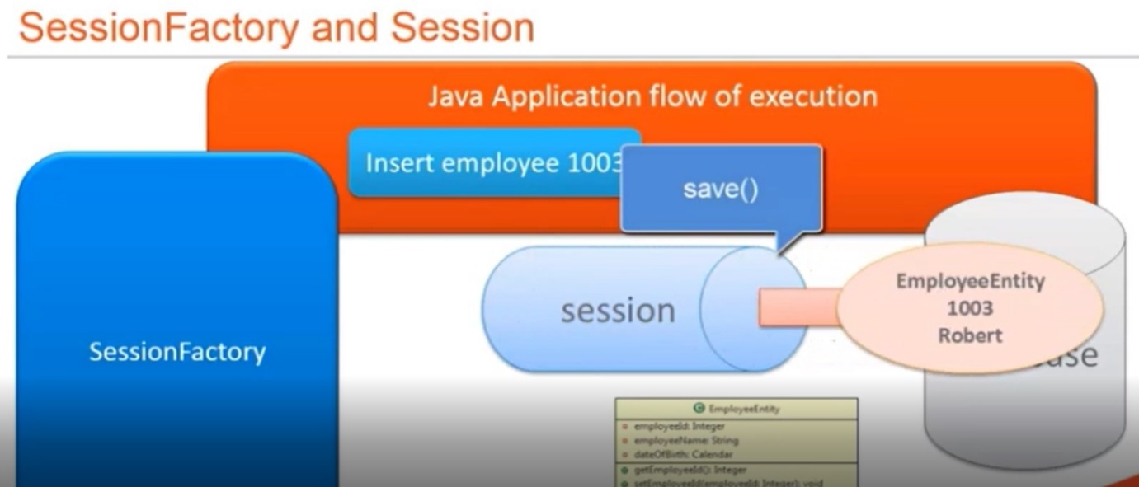

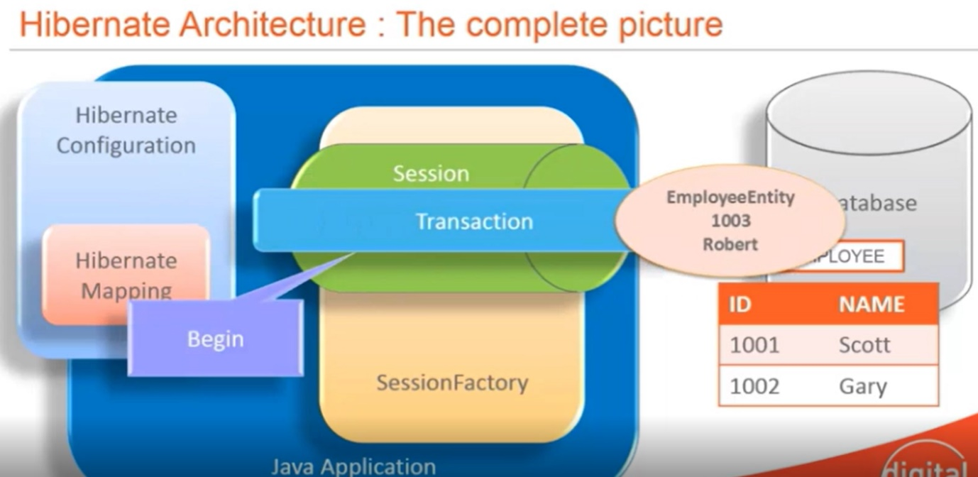

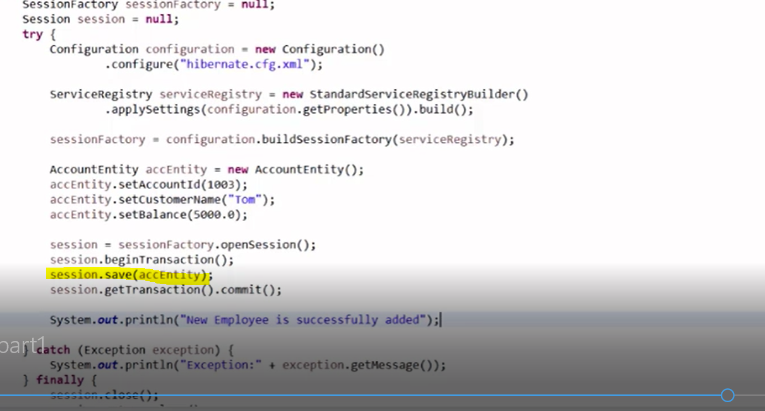

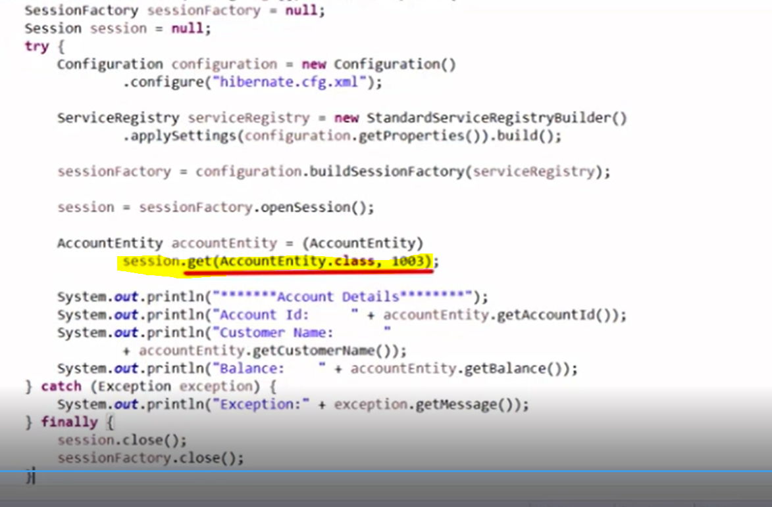

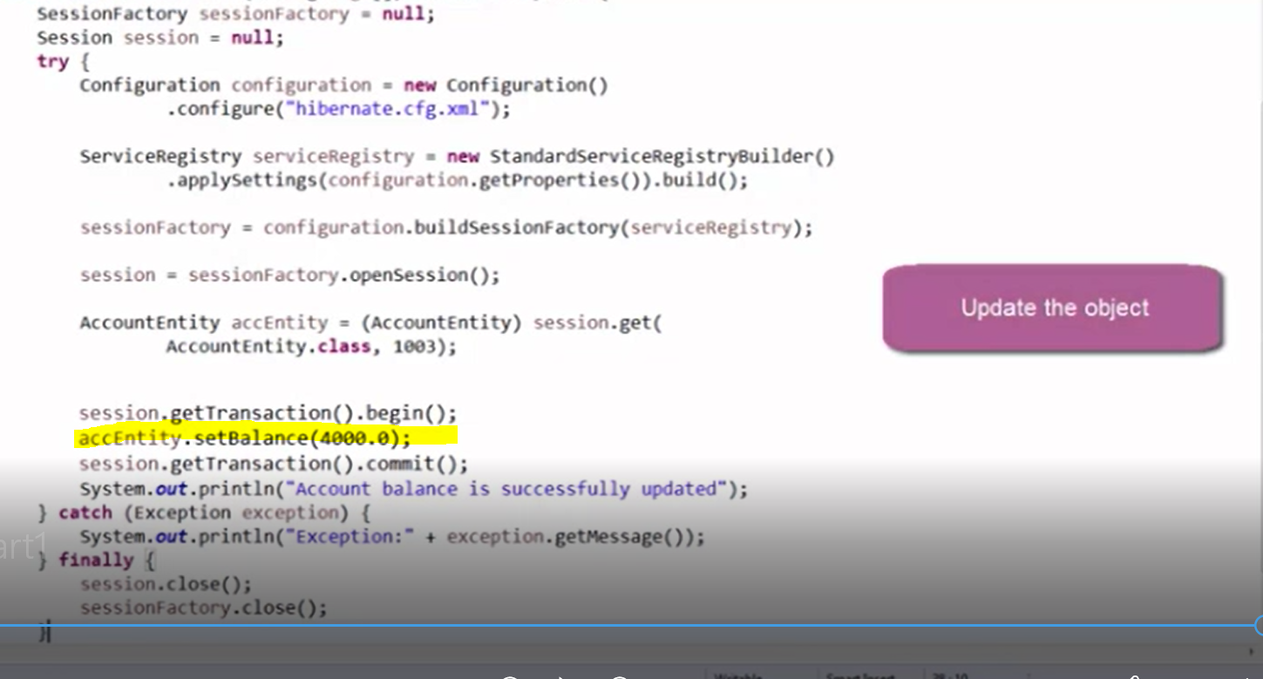

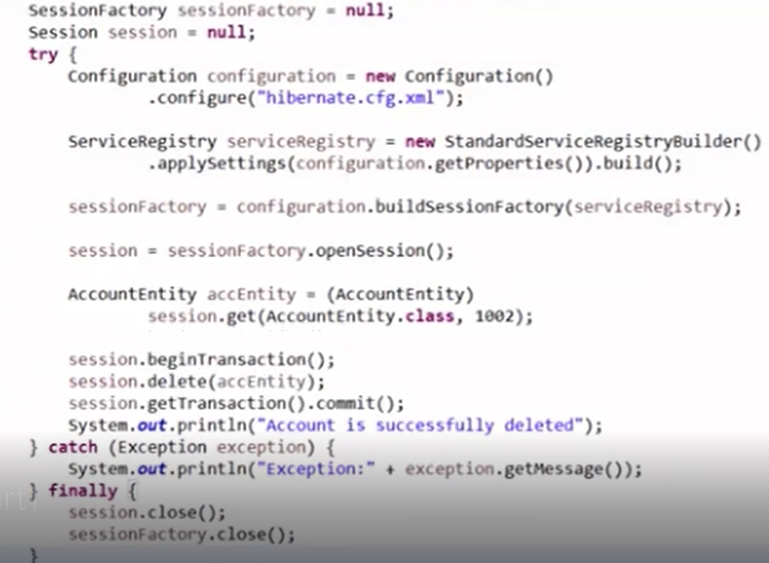

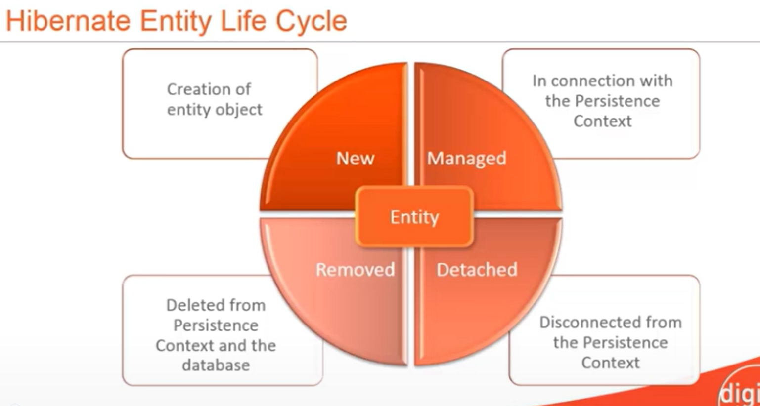

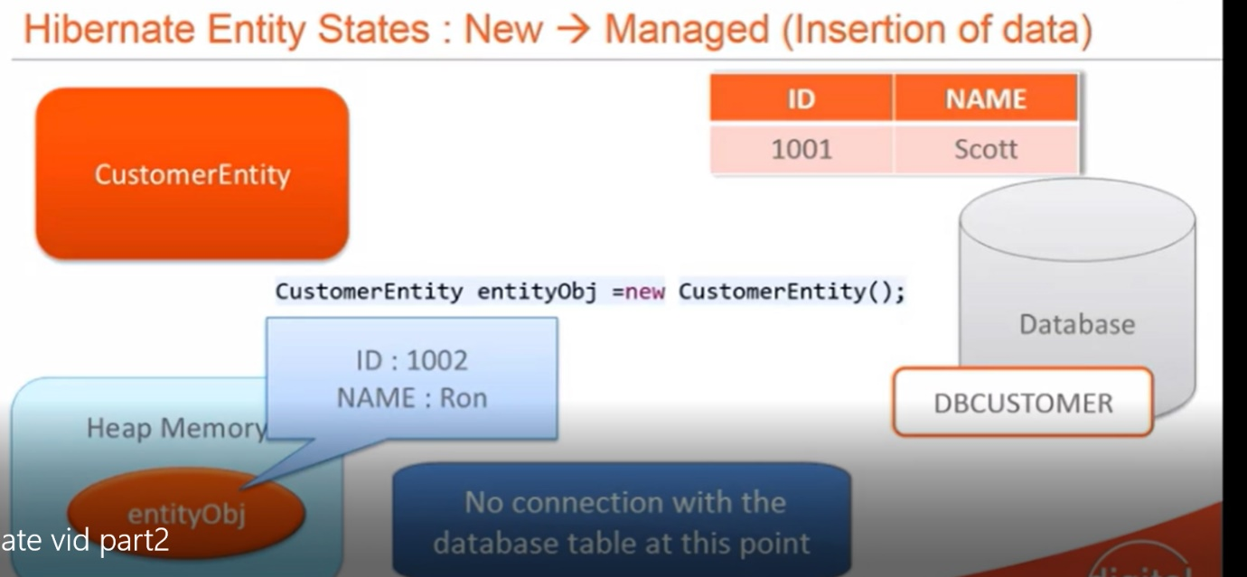

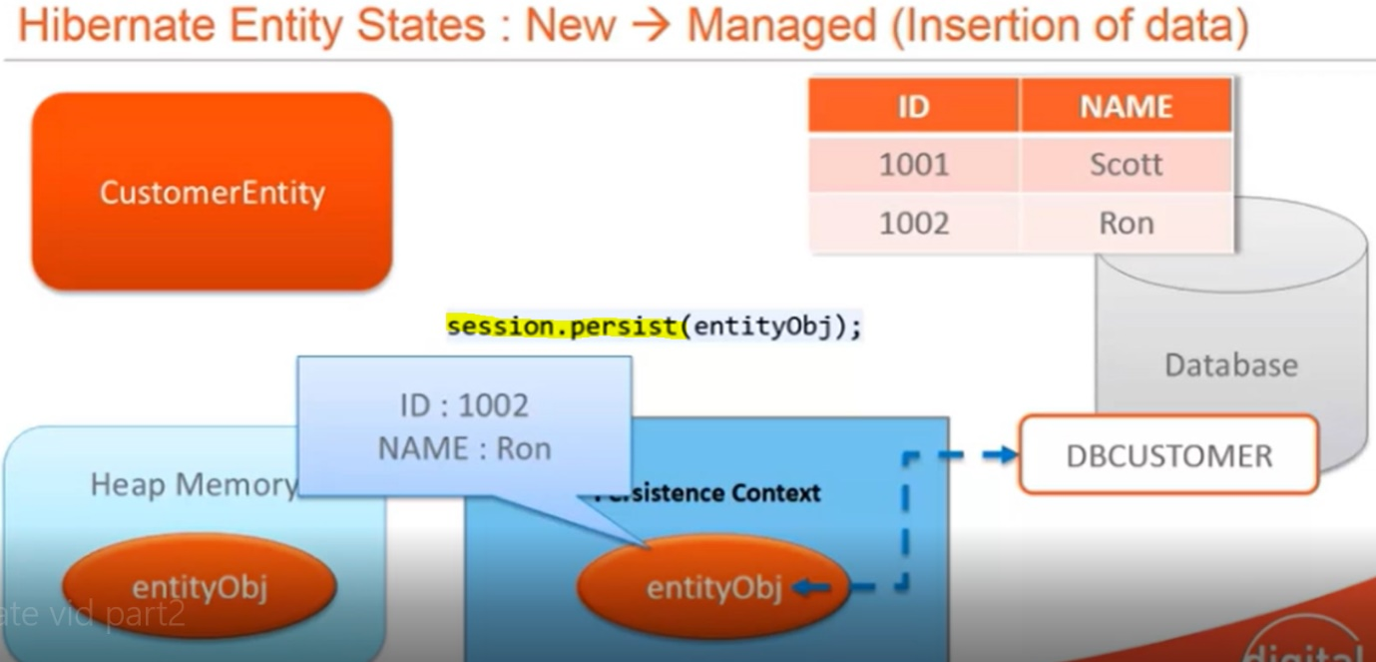

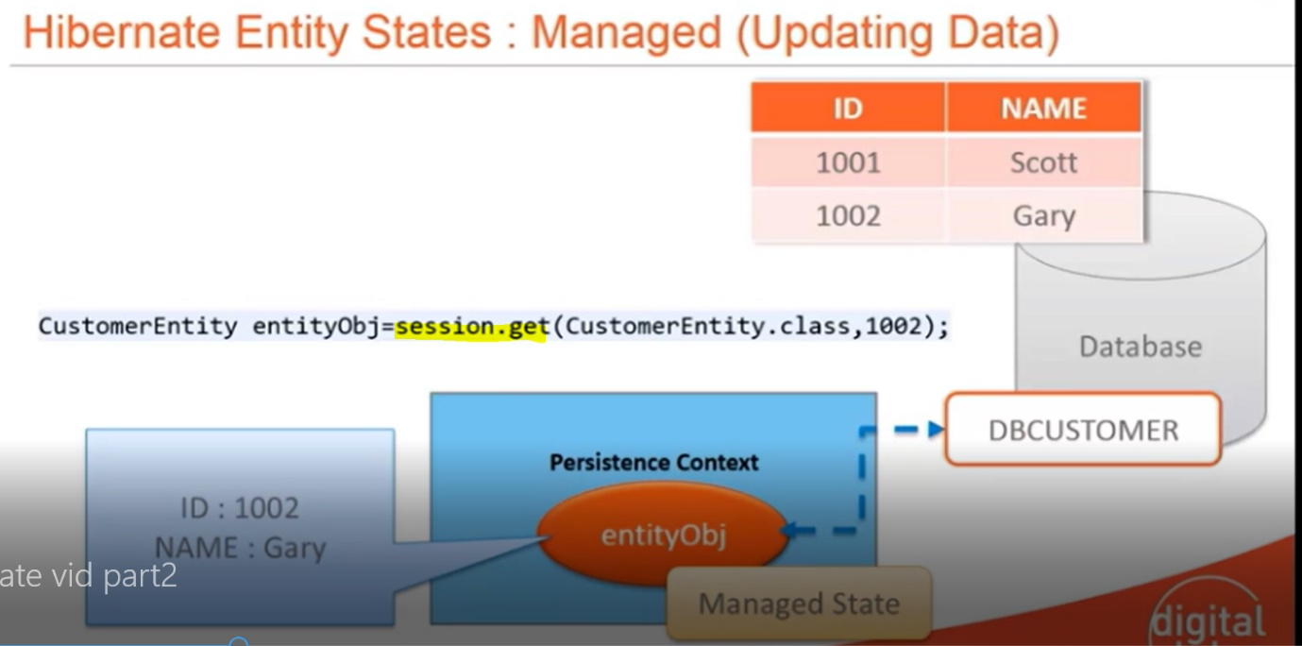

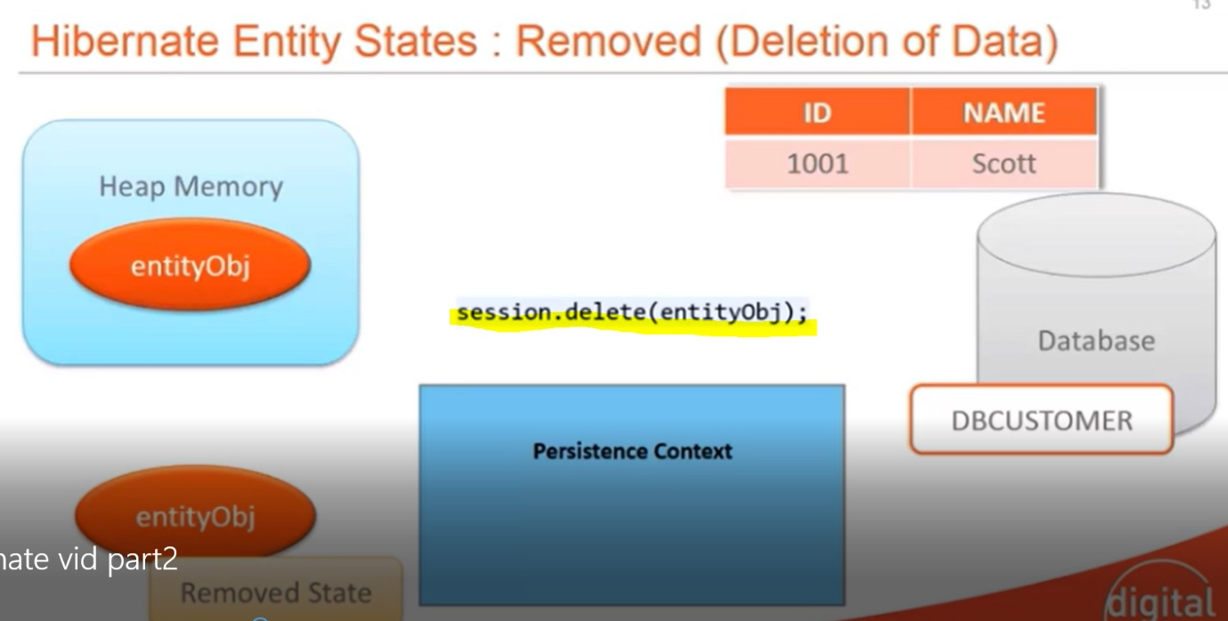

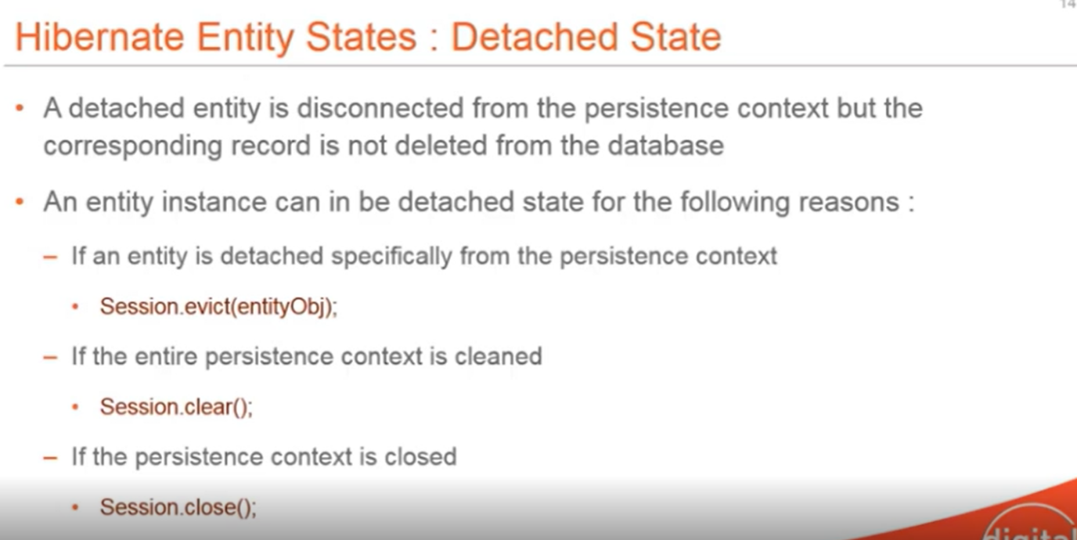

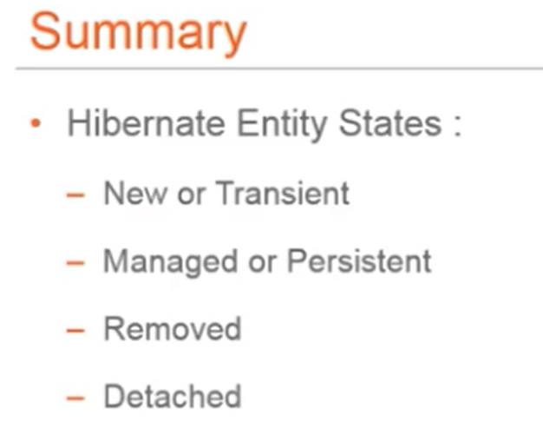

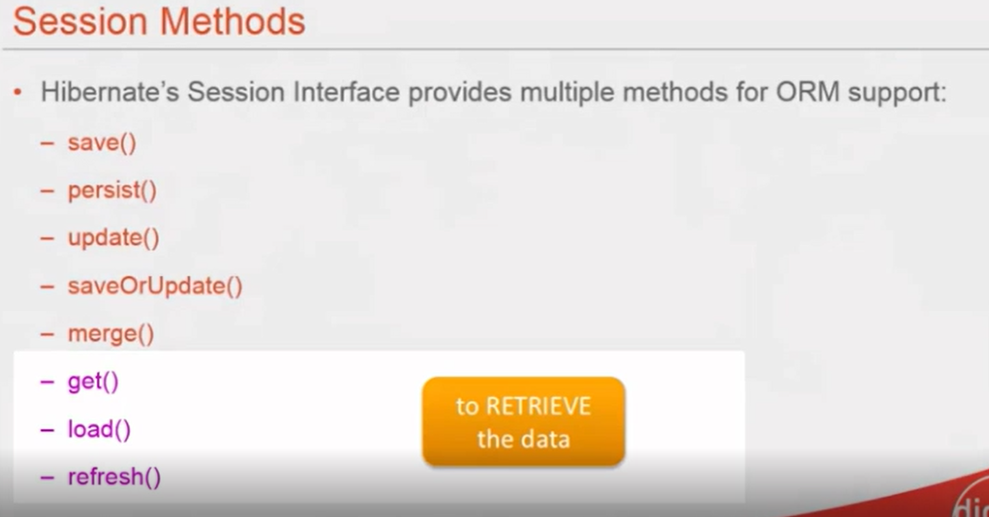

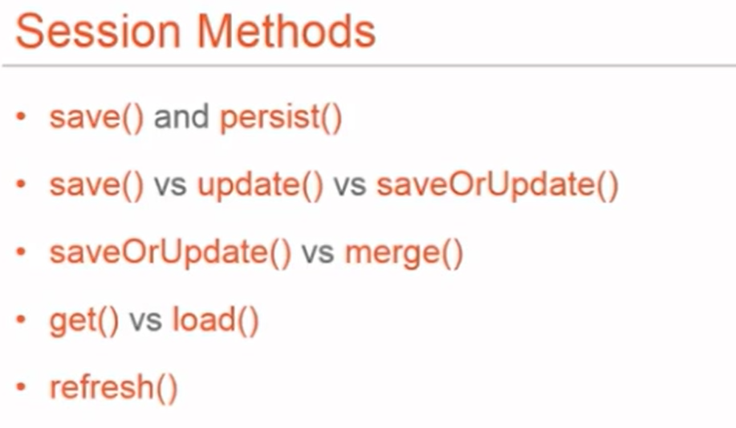

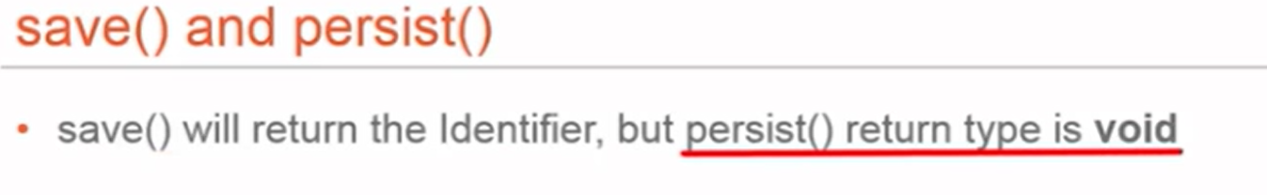

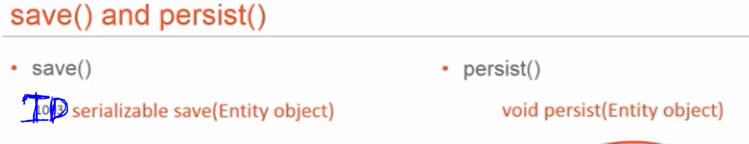

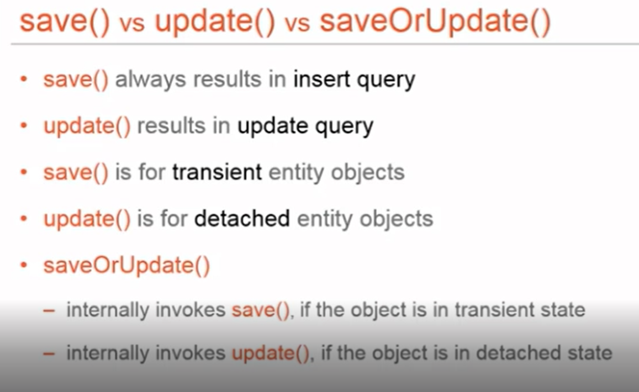

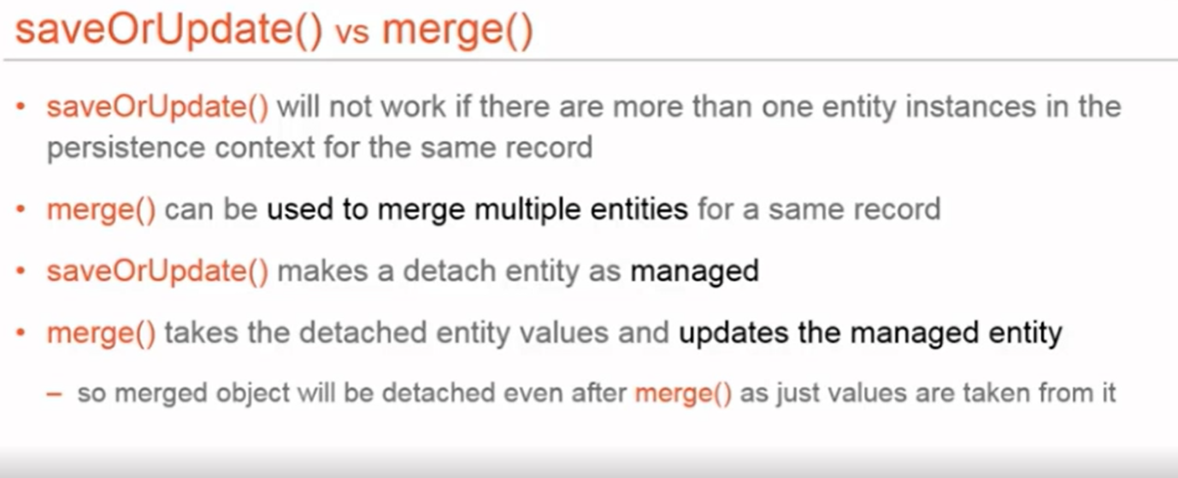

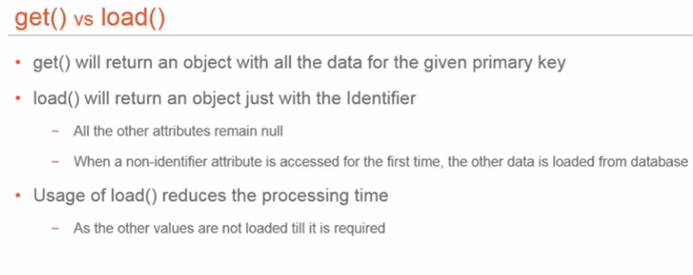

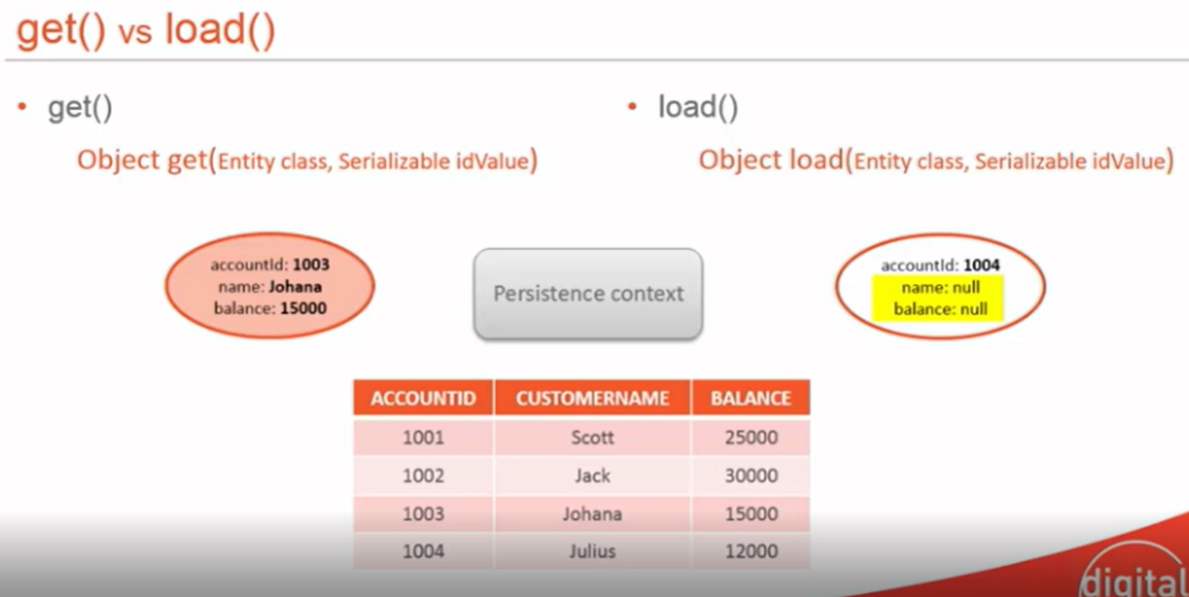

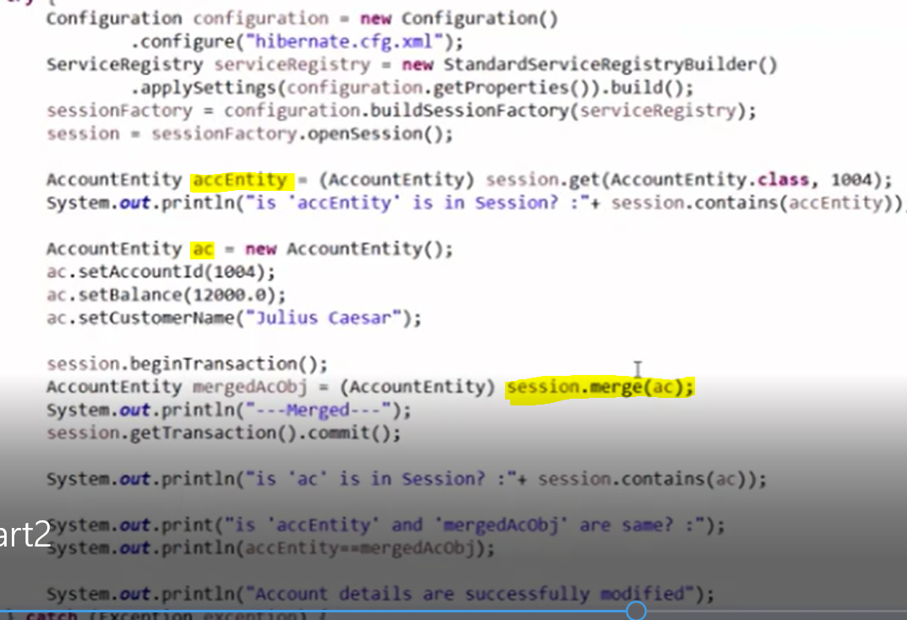

Explain about hibernate relationship annotations

By using hibernate we can map our java classes to data base tables and

Establish relationship between two or more database tables by using annotations like @onetoone,@onetomany,@manytoone,@manytomany

Refer same entity code with mappings

can establish either unidirectional or bidirectional relation

The main difference is that bidirectional relationship provides navigational access in both directions,

so that you can access the other side without explicit queries. Also it allows you to apply cascading options to both directions it means if we delete or update one side other side also gets effected.

More information about cascading: https://www.baeldung.com/jpa-cascade-types

https://www.baeldung.com/jpa-joincolumn-vs-mappedby

========================================================================================================

Transaction is a unit of work in which all the operations must be executed or none of them should be executed.

for example if you are trying to store a batch of huge records like 100 records if any case any failure or exception occurs while saving record at 99 it should completely rollback.

it should commit all the data when everything is fine and success.

we can manage transactions in spring by using @transcational annotation on top of a dao method. to enable transactions we can use @EnableTransactionManagement to our configuration class

More Information <https://dzone.com/articles/spring-transaction-management>

**Enum**

An enum type is a special data type that enables for a variable to be a set of predefined constants. The variable must be equal to one of the values that have been predefined for it

Because they are constants, the names of an enum type's fields are in uppercase letters.

In the Java programming language, you define an enum type by using the enum keyword. For example, you would specify a days-of-the-week enum type as:

public enum Day {

SUNDAY, MONDAY, TUESDAY, WEDNESDAY,

THURSDAY, FRIDAY, SATURDAY

}

You should use enum types any time you need to represent a fixed set of constants. That includes natural enum types such as the planets in our solar system and data sets where you know all possible values at compile time—for example, the choices on a menu, command line flags, and so on.

Here is some code that shows you how to use the Day enum defined above:

Enum declaration can be done outside a Class or inside a Class but not inside a Method

* First line inside enum should be list of constants and then other things like methods, variables and constructor.
* According to [Java naming conventions](http://www.oracle.com/technetwork/java/codeconventions-135099.html), it is recommended that we name constant with all capital letters

Every enum internally implemented by using Class.

* Every enum constant represents an **object** of type enum.
* enum type can be passed as an argument to **switch** statement
* Every enum constant is always implicitly **public static final**. Since it is **static**, we can access it by using enum Name. Since it is **final**, we can’t create child enums.
* We can declare **main() method** inside enum. Hence we can invoke enum directly from the Command Prompt.

**Enum and Inheritance :**

* All enums implicitly extend **java.lang.Enum class**. As a class can only extend **one** parent in Java, so an enum cannot extend anything else.
* **toString() method** is overridden in **java.lang.Enum class**,which returns enum constant name.
* enum can implement many interfaces.

**values(), ordinal() and valueOf() methods :**

* These methods are present inside **java.lang.Enum**.
* **values() method** can be used to return all values present inside enum.
* Order is important in enums.By using **ordinal() method**, each enum constant index can be found, just like array index.
* **valueOf() method** returns the enum constant of the specified string value, if exists.

**Hibernate**

**Difference between session and session factory**

**https://www.netsurfingzone.com/sessionfactory-and-session-in-hibernate/**

**Session**:

1.Session is an object which is used to maintain a relationship or connection between the java application objects and the database.

2.First level cache is available at the session by default.

3.we can have any number of sessions per database (whenever we try to interact with database session gets created)

4.session is not synchronized. So not thread safe.

**Session factory**

1.Session factory is created by the configuration object. which provides session based on the configuration properties to establish the relationship with database.

2.Second level cache is available at the session factory if we enable it.

3.we can have only one session factory per database. (If we have 2 or 3 databases, we can have 2 or 3 session factories)

4.session factory is synchronized and thread safe.

**Difference between first level cache and second level cache?**

**First level cache:**

1.We can maintain first level cache at the session.

2.by default session contains first level cache, and we can't disable it.

3.if we destroy session then first level cache also gets destroyed.

**Second level cache:**

1.We can maintain second level cache at the session factory

2.by default, second level cache is disabled at the session factory, we can enable it by doing the configurations.

3.second level cache is available throughout the application until we restart it.

**Difference between lazy loading and early loading?**

**Early loading:**

1.It is a process where one object or entity will load other relevant objects or entities associated with that data.

2. ManyToOne and OneToOne associations uses lazy loading strategy by default.

3. It can be enabled by using the annotation parameter :  
 fetch = FetchType.EAGER

**Lazy Loading:**

1.It is process where one object or entity will load other object or entity only when we specifically request for the data.

2. ManyToMany and OneToMany associations used lazy loading strategy by default.

3. It can be enabled by using the annotation parameter :  
 fetch = FetchType.LAZY

**Difference between get() and load() ?**

**Get()**

1.When you call get() method, it will hit the database immediately and returns the original object.

2.If record is not found you will get null.

3.better to use get() when you are not sure about the existence of record in the database.

**Load()**

1.When you call load() method, it will always return a proxy object. It hits the database only when data is really needed.

2.If record is not found you will get object not found exception.

3.better to use load(), when you are sure about existence of record in the database

**Difference between save() save&update() merge() ?**

**Save**()

Save method stores an object into the database. That means it insert an entry if the identifier doesn’t exist, else it will throw error. If the primary key already present in the table, it cannot be inserted.

***Update()***

Update method in the hibernate is used for updating the object using identifier. If the identifier is missing or doesn’t exist, it will throw exception.

**SavevsUpdate()**

This method calls save() or update() based on the operation. If the identifier exists, it will call update method else the save method will be called.

**Merge()**

If we want to do modifications to the object which is not connected to session then with the help of merge() we can do modifications and then save it to the database.

**What is meant by Auto dirty checking?**

It is a feature of Hibernate where if we do any changes to the persistent object then the changes are saved automatically into the database, no need to call save() or update() explicitly.

**SpringBoot**

**Difference between Spring and Springboot?**

**Spring:**

1.Spring is a framework to develop web-based applications with java as a language.

2.If we want to run the application, we need to add the server explicitly.

3.We need to do the configurations manually.

4.We require XML file to do the configurations.

5.We need to add the each and every dependency manually.

6.It takes time to develop any application when working with Spring.

**SpringBoot (features):**

1.SpringBoot is an extended feature of Spring framework which provides rapid application development, where we can develop stand-alone web-based applications.

2.We can run the application directly without adding any server, because it contains embedded server like tomcat, jetty etc.,

3.We don't need any XML file for configuration.

4.It provides a feature of Auto configuration.

5.It provides production ready features like bean info, health condition when you add actuator dependency.

6.It provides concept of starters where dependencies are added no need to add manually.

7.It reduces development time and increases production time when you develop a web-based application.

8.When we add devtool dependency in pom.xml, application is loaded automatically when we do any changes.

**AutoConfiguration and how it works internally?**

It is a feature of Springboot where it will automatically configure the beans with the application context based on the application related properties such as presence of certain classes in the class path, existence of beans and activation of some properties.

**Example:**

When we add SpringbootStarter Spring data Jpa, then in the auto configuration class based on the

@conditional on class, it will check whether DataSource class is available in class path or not.

@conditional on bean, it will check whether bean with same name created or not.

@conditinal on property it will check whether the database properties are there in the application.properties .

Like based on these conditions' configuration is done and is registered with the application context.

**Why Springboot is Opinionated?**

Springboot is opinionated, it means it takes its own decision for autoconfiguration based on the class path dependencies and properties.

**What are Starters?**

SpringBoot Starters are maven template, which contains collection of relevant dependencies that are needed to start any functionality, like we add springbootstarter spring data Jpa to do database operations, springbootstarter web to develop web-based applications etc.,